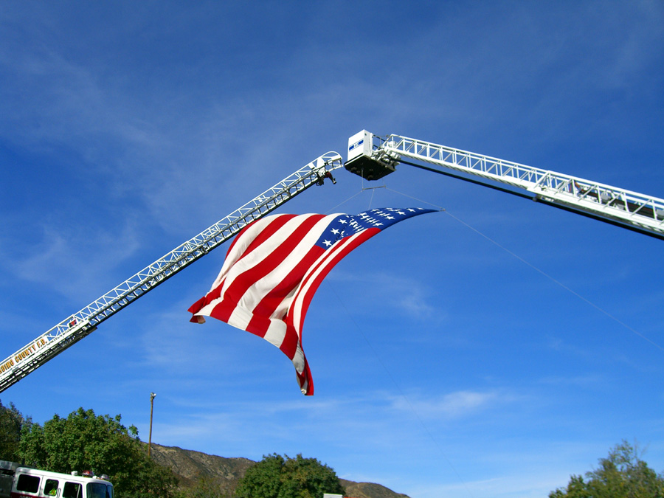

Caring for Our Own

A Serious Accident
And Fatality Support Guide

A Publication of the Wildland Fire Lessons Learned Center 2007

Introduction

In a paper titled “Co-Workers and Their Families,” 1991, Richard M. Gist, Ph.D. and Vickie Harris Taylor, LCSW, address some of the deeply-embedded truths in the profession of firefighting. They recognize that public safety work is more than an occupation: Our roles become a central element in our identity.
“Much of the stress inherent in the work of professional public safety personnel comes in the form of challenges. These stressors are elements of their jobs which, while often very taxing and sometimes even frankly harrowing, are also at the very core of their attraction to these callings. Those challenges call on the public safety responder to reach his or her highest levels of performance and to win control of situations and circumstances many people would never even approach.”
Gist and Taylor say that the most important factors in preparing personnel for the impact of critical incidents are not inherently psychological – personnel should instead be trained for the roles and tasks they will be required to perform. No single factor better prepares personnel to withstand intense and prolonged stress more than good physical and mental conditioning. The true predictor for recovery is our psychological well-being at the time the event occurs.
The work we’ve chosen is a clear indicator that our psychological well-being depends upon our ability to perform in congruence with our core values. If we are not allowed to fully engage in the response – no matter what the incident or mission entails – we feel robbed.
The serious injury or death of a firefighter has profound ramifications for co-workers because we identify so strongly with each other. We not only deal with loss, we also face the undeniable threats that exist in our regular working environment and their potential consequences.
It seems like firefighters do everything together. We drive to an incident together, we camp out together, we eat together, and we make decisions together. We face the same risky environment, together. We rely on each other’s situational awareness and experience to keep us safe. We expect the feedback we get from each other to help us frame and validate our experiences. When a tragedy occurs, we continue to hold onto our personal stake in our co-worker’s fate.
Our recent response to tragedy is at the core of this guide. On Oct. 26, 2006 four of the five firefighters of San Bernardino National Forest Engine 57 died on the line of duty. The engine’s fifth crewmember fought courageously for his life for five days before succumbing to his injuries. The home unit, the agency, and the entire fire service community mourned their loss. But more importantly, they cared for the fallen firefighters and their families. In many ways, the response was unprecedented, but long called for. Many of the home unit’s personnel and the supporting team members recognized the significance of the event and wanted to share what they learned in the wake of the tragedy and the response.
You should be prepared for some strong visual images from the BDF Engine 57 Support Mission contained in this guide. The success of the approaches taken, Gist and Taylor say, is not in the techniques we might select, but rather in the commitment of the agencies and their personnel to the process of recovery. The BDF Engine 57 Support Mission is a response that reverberates with commitment.
Compiled by Jonetta T. Holt

Table of Contents

Pre-Incident Planning Resources | Serious Accident & Fatality Support
Reviewing our past experiences:

- Support Mission Report Summary – 2 pages

- BDF E57 Support Mission Report final – 53 pages

- Lessons Learned Support During Fatality Accidents - 5 pages

On Incident Guides:

- Serious Accident Plan

- Incident Emergency Plan CnG

Home Unit Preparedness:

- Family Financial Diary

- Agency Administrator’s Guide to Critical Incident Management

- Safford Field Office Critical Incident Management Team Template

- A Resource Guide for Handling Firefighter Line-of-Duty Deaths

- Wildland Firefighter Foundation: Several resources

- Interagency Serious Accident Investigation

IMT Support Materials:

- Esperanza Support Priorities

  - Support Mission Objectives

  - Esperanza Support Org Chart 10/28/06

  - Esperanza Support Org Chart 11/04/06

  - Behavioral Health and Critical Incident Stress Management

  - Initial News Releases

  - Internal Communications

  - Incident Information Strategy

  - Sample JIC Org Chart

  - CISM, p1

  - CISM, p2

  - Logos, Certificates, Memorials

  - Crisis Leadership & Communication

Family Support Materials:

- A Resource Guide for Handling Firefighter Line-of-Duty Deaths

- The Wildland Firefighter Foundation’s LODD Toolkit

- Family Contingency Plan

- Organization Assignment List

- Family Support Team Phone List

- Family Support Team Delegated Tasks

- Briefing Funeral PIO’s

- Obituary or Death Notice Information Form

- Caring for the Deceased and Funeral Planning Checklist

- Memorial Order of Service

- Order of Service with Times

- Benefits Checklist and Information

- Short-Long-Term Family Support Plan

- Fatality Site Visit Video

- Caring for the Deceased and Funeral Planning Checklist

- Memorial Order of Service

Memorial Planning Materials:

- Engine 57 Memorial IAP Parking

- Engine 57 Memorial IAP Seating

- Engine 57 Memorial Media Plan

- Memorial Order of Service

- Procession Instructions

- Engine 57 Memorial Preparation Photos

- Engine 57 Memorial Video

Pre-Incident Planning

Support Mission Report Summary – This two-page summary outlines some of the most widely acknowledged experiences by home unit personnel and IMT members who responded to the BDF E57 Support Mission.

BDF E57 Support Mission Report final 31May2007 – This full report of the combined home unit and IMT response captures important lessons throughout the 19-day mission. The report places the events and decisions of those involved into a context from which we can derive value from the experience. Among the graphics included in this report is the adapted ICS organization chart. This picture helps those who have not experienced such a radical departure from fire ICS organization to visualize how roles and responsibilities can gain complexity and shift during event responses.

Lessons Learned Support During Fatality Accidents – Written by an Incident Commander, this document summarizes reverberating personal lessons and carries them into professional activities that will best assist home unit personnel coping with the loss of an employee.

On-Incident Guides:

Serious Accident Plan – This plan is designed to identify the initial actions that should be taken by the first arriving personnel on a serious accident. This person may be a single resource, engine boss, or crew boss. Accidents or incidents within an incident happen rapidly and require good, calm initial decisions. This checklist provides some key thoughts and actions.

Incident Emergency Plan – The primary goal of this IEP is to allow incident personnel the guidelines necessary to locate, triage, extricate, treat and transport all accident patients in as quick and safe a manner as possible. This checklist, organized by IMT function, will help guide the actions of each individual with responsibilities during an incident within an incident.

Home Unit Preparedness:

Family Financial Diary – This handbook was developed in November 1995 to be used as an educational tool for Concerns of Police Survivors’ national training sessions. It was planned with the specific intention of giving law enforcement officers and others who serve in a high-risk profession the opportunity to organize their financial business so that families will have this information in an organized fashion following an officer’s death.

Agency Administrator’s Guide to Critical Incident Management – Organized in a table format, this guide delineates the roles and duties of all personnel who will have responsibilities in the event of a serious accident or fatality. The guide, published by the NWCG, also includes a worksheet that will help personnel review the steps to take in the immediate aftermath of a serious home unit incident.

If you are looking for the fastest, easiest, most effective way to organize your home unit personnel into a CIMT, please review the next document. It offers key objectives, team positions and roles, liaison responsibilities and step-by-step guides for every area of organization required for this kind of effort. It’s as easy as downloading it, making copies, gathering your group and filling in the blanks!

Safford Field Office Critical Incident Management Team Template – In the interest of preparedness, the BLM Safford Field Office Arizona personnel organized themselves into a Critical Incident Management Team with 3-tiered response roles in 2003. They reviewed the two most pertinent documents at the time and built the notebook contained in this zip file. Mary Hayes, who coordinated the notebook, recently shared the files with the Lessons Learned Center. The key ingredient to success for this kind of team, Mary says, is commitment. The team, she says, has been on several call-outs.

A Resource Guide for Handling Firefighter Line-of-Duty Deaths – Published by the National Fallen Firefighters Foundation, this is one of the most comprehensive guides available:
- The Pre-Incident Planning section features 1) a superior template for Employee Emergency Contact Information and 2) A financial benefits checklist;
- The Notification section features a list of the five principles of notification;
- The Family Support section includes 1) How to help the Family at the Hospital or Morgue, 2) From time of death through the funeral, 3) On-going support, and 4) Recognizing the signs of grief.
- In the Department support section, simple guidance on how to prepare a eulogy is provided.

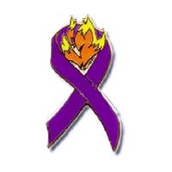

Wildland Firefighter Foundation – If you spend a little time browsing through the Wildland Firefighter Foundation website, http://www.wffoundation.org, you’ll find opportunities to connect to the mission, perhaps before you are asked to take on a supporting role in a serious accident or Line-of-Duty Death. Teams, crews, and whole home units have organized themselves into 52-Club members and begun sponsoring fund-raising events for this organization. What would YOUR team like to do? Have you asked? The WFF has also granted permission for several of the support tools available on their website to be included here as well:

WFF 52 Club Poster – this one-page poster can be printed and posted making 52 Club membership available to anyone who might want to join, turning “The Power of One into One Million.”

WFF Info Sheet with Tearoffs – Another poster that can be printed and posted. This example includes tear-offs at the bottom of the page so that readers can take the website address with them.

WFF Membership Form – This tri-fold membership form has registration and address information for anyone who would like to get more information about the organization.

LODD ToolKit (zip file) – This folder contains four documents that will serve those responding in the wake of a Line-of-Duty Death. Developed by the Wildland Firefighter Foundation, this kit contains “Procedures for Death Notification,” “The Family Liaison Role,” “Family Liaison Reference Sheet” and “Compassion Fatigue.”

US Forest Service Serious Accident Investigation – see the following website:
http://fsweb.mtdc.wo.fs.fed.us/pubs/htmlpubs/htm05672806/toc.htm -- One of the best sources for information regarding US Forest Service Serious Accident Investigations is the manual that is posted on this website.

Serious Accident and Fatality Support

IMT Support Materials:

Esperanza Support Priorities – Preparation by the home unit was noted as being foundational to the success of the support mission in the BDF E57 Support Mission Report . This document provides an outline for some of the initial planning.

Support Mission Objectives – Developing objectives for the BDF E57 Support Mission required team members to identify intent and focus areas for abstract concepts such as honor and compassion. These are the objectives that were identified for that mission.

Esperanza Support Org Chart 102806 – This organization chart is a reflection of the beginning of the mission and those who were in place. The extended Incident Management Team involved about 275 individuals total.

Esperanza Support Org Chart 110406 – One of the reasons cited for a large growth in personnel for this mission, was the complex needs for information in virtually every group and branch in addition to the information needs of the IMT. This chart is just one of three pages developed to track a large and complex organization using an adapted ICS structure. This kind of organizational tool is an excellent example of remaining sensitive to operations.

Behavioral Health and Critical Incident Stress Management – A Line of Duty Death challenges and impacts the integrity and resiliency of the entire system involved with the loss. The degree to which the organization is able to successfully navigate the demands of the situation depends greatly on the individual capacity of each member of the team. To advance the effectiveness of these participants, read the suggestions offered in this document.

Initial News Releases – This folder contains the initial news release confirming the names of the deceased and injured firefighters to the public. An October 30 news release updates the media and public on funeral services and donation opportunities. In a news release on October 31, Pablo Cerda’s death from his injuries is announced.

Meeting the Information needs of the Mission

In the BDF E57 Support Mission Report, it is noted that the IMT quickly realized that the information requirements of the mission would drive that function into a high degree of complexity and breadth. It’s even estimated that as many as 75 information officers were involved. That’s almost enough personnel to staff a division with four hand crews!
It was also noted that while the information officers were put into their own branch, it was not immediately recognized that out-of-the-ordinary organization would be required or span-of-control and coordination would be compromised.
Although the ICS organization structure framework has no existing template for how to organize within the information function to perform at such a high level, adding a planning section chief and resource unit leader to the branch resulted in better coordination within the function and with the IMT. In addition, the first three tools below may also assist in this effort.

Internal Communications – This folder has three examples of internal communication devices used during the support mission to keep all of the extended team members informed about the activities of the widely dispersed groups. Two examples summarize the activities and operations continuing and another example has instructions for team members joining forces during a specific activity.

Incident Information Strategy – This is what we face and this is what we’re going to do and why. This document, absent the traditional communication plan’s message, delivery method and audience strategies, is a step-by-step approach to building a basic strategy. Many of the most important messages to be delivered will be those that emerge naturally from the events. The best strategic response by information officers involves anticipation and planning in order to avoid “the mistake you can’t afford to make.”

Sample JIC Org Chart – While it may not be appropriate to use the full traditional Joint Information Center organization, this chart presents some clear visual cues for delineating responsibilities if you have an extraordinarily large and complex event. Adaptive use of this tool may help to overcome span-of-control and coordination issues quickly.

CISM-General, page 1 – This document was included in every Incident Action Plan for the BDF Engine 57 Support Mission, providing both information and reference material during the response.

CISM-General, page 2 – The second page of the Critical Incident Stress Management material provided daily in the IAP.

Logos, Certificates, Memorials – This folder contains several of the graphic images produced during the Engine 57 Support Mission.

Crisis Leadership & Communication – Crisis Leadership and Crisis Communication is a PowerPoint offered by Andrew Blum, PhD, in the Center for International Development and Conflict Management at the University of Maryland. Utilizing tools for managing and communicating information in a crisis is one of the objectives of this presentation.

Family Support Group Materials:

The next two resources listed in the Pre-Incident Planning section of this guide, will also be of assistance to those who are performing family support functions.

A Resource Guide for Handling Firefighter Line-of-Duty Deaths – Published by the National Fallen Firefighters Foundation, this is one of the most comprehensive guides available:
- The Pre-Incident Planning section features 1) a superior template for Employee Emergency Contact Information and 2) A financial benefits checklist;
- The Notification section features a list of the five principles of notification;
- The Family Support section includes 1) How to help the Family at the Hospital or Morgue, 2) From time of death through the funeral, 3) On-going support, and 4) Recognizing the signs of grief.
- In the Department support section, simple guidance on how to prepare a eulogy is provided.

LODD ToolKit (zip file) – This folder contains four documents that will serve those responding in the wake of a Line-of-Duty Death. Developed by the Wildland Firefighter Foundation, this kit contains “Procedures for Death Notification,” “The Family Liaison Role,” “Family Liaison Reference Sheet” and “Compassion Fatigue.”

Family Contingency Plan – In the event of a seriously injured firefighter whose family is with them at the hospital, this type of contingency calling plan for any type of significant difference in the firefighter’s condition may be helpful.

Organization Assignment List – This organization list is an example of one modified by the planning sections for family support groups during the BDF E57 Mission.

Family Support Team Phone List – This is a template developed by one of the family support teams during the BDF E57 Mission.

Family Support Team Delegated Tasks – This task list was developed by one of the family support groups during the BDF E57 Mission.

Briefing Funeral PIOs – This short, concise briefing paper instructs public information officers who are coming in to support the family and their designated support group during the funeral service. This is an excellent tool to use in delivering the same instructions to several people who are expected to mesh with your standing organization and helps incoming personnel by delineating their roles and what will be expected of them.

Obituary or Death Notice Information Form – This document was prepared by using several newspaper obituary information forms to compile a comprehensive list of the standard items covered. You can use this form to help family members collect their thoughts in the privacy of their home, instead of having them deal with it at the mortuary.

Caring for the Deceased and Funeral Planning Checklist – What information will the family need in order to complete the death certificate? Who is responsible for transporting the deceased and what permits will be needed for interment? In order to help family members ease through these processes, help them prepare.

Memorial Order of Service – This sample of a memorial order of service may help family members make decisions.

Order of Service with Times – Planning a service may also require getting a general estimate of the timing of the events, especially if the event will be captured on videotape.

Benefits Checklist and Information – This document was developed by the National Fallen Firefighters Foundation and is published here with permission from that organization. This guide, although not agency specific, is one of the most comprehensive resources for families of fallen firefighters. It begins with the advice of survivors and leads family members through the long, long process of collecting benefits due.

Short-Long-Term Family Support Plan – Those who become the closest to family members of fallen firefighters may find they will need to write a plan for short and long term support. This example may be of assistance.

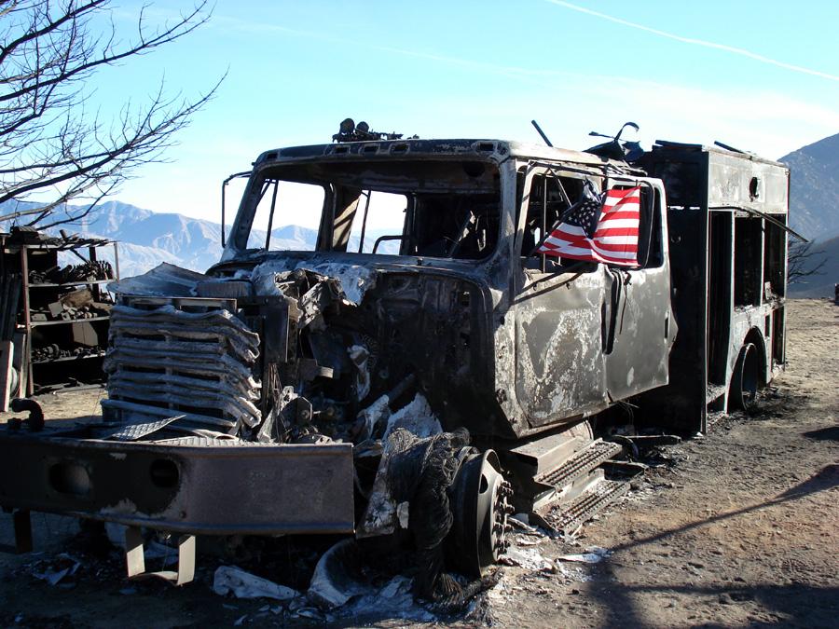Site Visit Video – (Please Note – File is large and will take a few moments to load into the player. Please be patient!) This footage was taken at the home where the firefighters of Engine 57 were overtaken. Fatality site visits were conducted for all of the families of the fallen firefighters and home unit employees. In the BDF E57 Support Mission Report, those conducting the visits for the families said the families responded strongly to the Engine when they saw it. For more on the site visit group, please read this Report.

Memorial Planning Materials:

Engine 57 Memorial IAP Parking – The memorial conducted for the Engine 57 firefighters was held at a large public stadium. It is estimated that more than 10,000 people attended. Planning for large audiences will usually include a plan like the one included here.

Engine 57 Memorial IAP Seating – Seating plans for the Engine 57 Memorial included designated areas for the families, home unit personnel, memorial staff, dignitaries, and the public. Diagramming a seating chart helps planners develop thoughtful accommodations for all of those who are expected to attend an event like this one.

Engine 57 Memorial Media Plan version 4 – This document was produced during the planning for the Engine 57 Memorial. It addresses all aspects of facilitating media at the memorial including designated parking and seating areas, event-issued identification and ground rules for how they are expected to conduct themselves during the event.

Memorial Order of Service – This memorial order of service was produced for the Engine 57 Firefighters’ Memorial in November 2006. It is an example of very high quality design and reproduction characteristics.

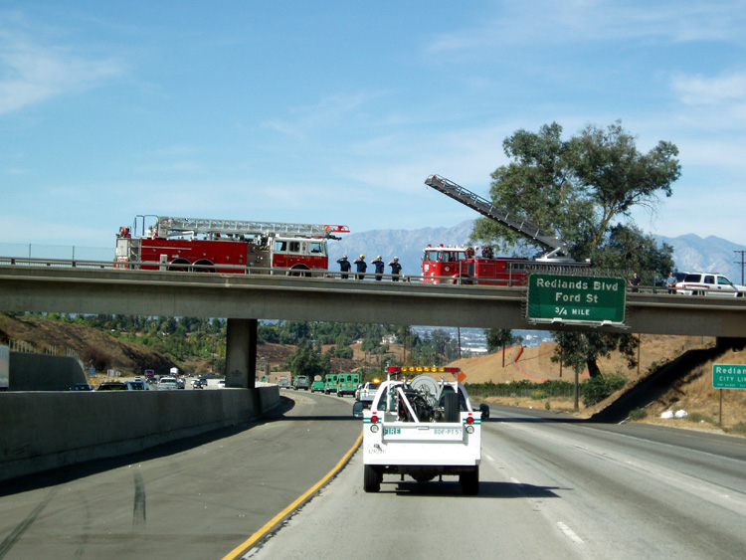
Procession Instructions – This is an example of procession instructions developed for the funeral of one of the Engine 57 firefighters. If there will be a procession to the memorial, this type of organization may be important in advanced planning.

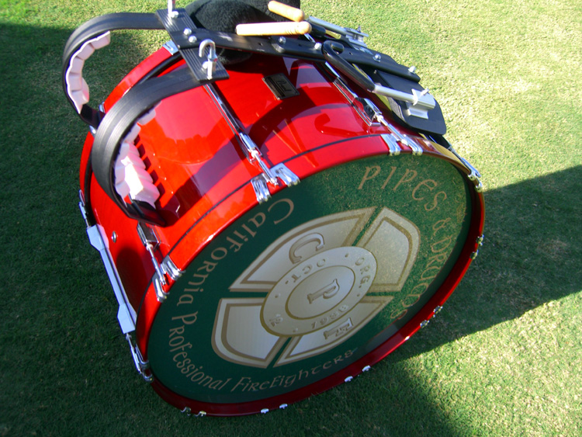
Engine 57 Memorial Preparation Photos – These are a few photos from the Engine 57 Memorial event. They may provide visual cues for options in planning.

Engine 57 Memorial Video – This footage was taken during several stages of the memorial event beginning with the procession in.

