Engine Operator
Facilitator Guide
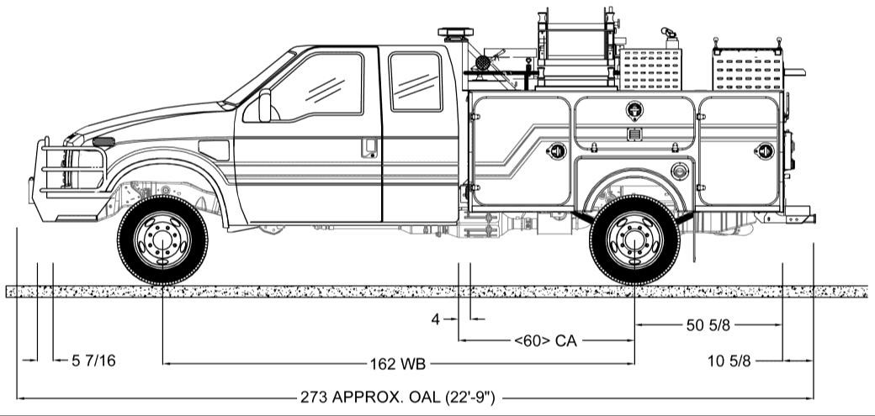
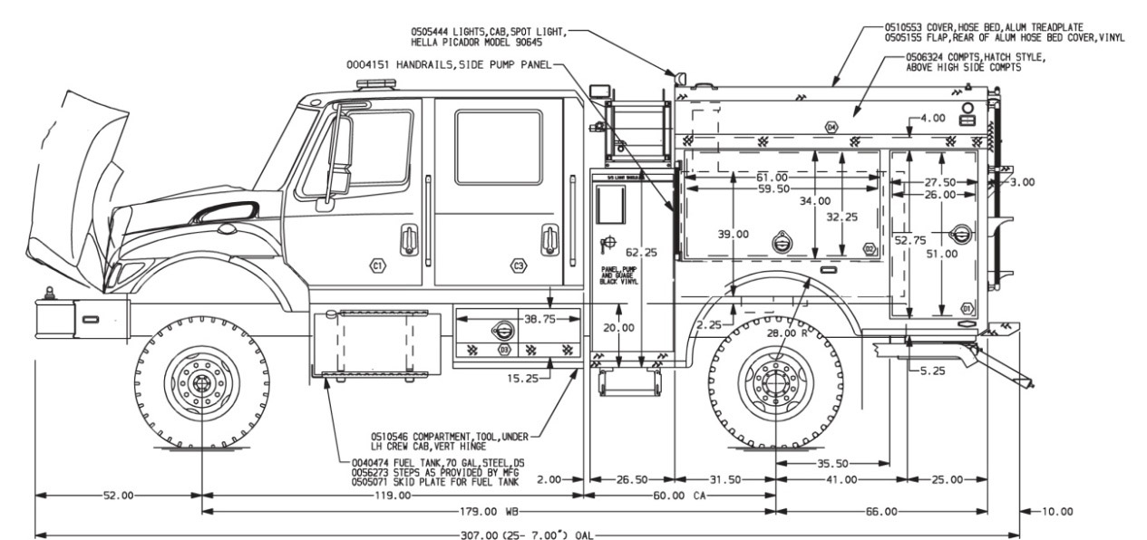
N9018
March 2019

PREFACE
The Engine Operator (ENOP) course was originally developed by the Bureau of Land Management (BLM) to meet agency training needs. The course is designed to provide students with the knowledge/skills necessary to perform the functions described in the Engine Operator BLM Position Task Book as well as address the standards, procedures, and techniques to be an engine operator on a wildland or prescribed fire.
While the engine operator position and skills are interagency in nature, the course predominately refers to BLM policy, engines, references, maintenance forms, etc. Therefore, ENOP training cadres should refer to and use appropriate agency-specific references when presenting this course.
Subject matter experts and course developers have transferred all distribution of the ENOP course in an electronic environment via the BLM National Fire Training and Workforce Development website (https://www.nifc.gov/training/training_main.html). Course coordinators must ensure they are using the most current course materials.
This course was developed by a group of BLM subject matter experts with direction from the BLM National Fire Training and Workforce Development. The primary participants in this development effort included:
Nate Kerschner High Plains District
Jade Martin Carson City District
Jesse Monzillo California Desert District
Matthew Norden Front Range
Mitch Silvester Twin Falls District
Jesse Turner North Central Montana District
Randy Turrill Color Country District
Brent Higbee BLM National Fire Equipment Program
Brian Williams BLM National Fire Equipment Program
Pam McDonald BLM Fire Training and Workforce Development
The National Fire Equipment Program appreciates the efforts of all contributors to the design and development of this product and the instructors who present this course.
Sponsored for publication by the National Fire Equipment Program and the BLM National Fire Training and Workforce Development Program. The use of trade, firm, or corporation names in this publication is for the information and convenience of the reader and does not constitute an endorsement by the Bureau of Land Management of any product or service to the exclusion of others that may be suitable.
Comments regarding the content of this publication should be directed to:
National Fire Equipment Program
3833 South Development Avenue
Boise, ID 83705
E-mail: nfep@blm.gov

Table of Contents
PREFACE i
Table of Contents i
OVERVIEW 1
Course Instructions 1
Course Purpose 1
Objectives 1
Course Objectives 1
Unit Objectives 1
Time Frame 1
Student Target Group 2
Student Prerequisites 2
Required Training 2
Qualifications 2
Instructor Qualifications and Expectations 2
Course Structure 3
Course Needs and Support Information 3
Space and Classroom Requirements 3
Course Instructional Materials 3
Instructor Materials 4
ENOP Facilitator Guide 4
Electronic Presentations 4
Case Studies 4
Student Materials 4
Pre-Course Package Materials 4
Pre-Course Work 4
ENOP Student Workbook 5
ENOP Vehicle Inspection Job Aid 5
Student Evaluation 6
Unit Quizzes 6
Engine Operator Training Evaluation 6
Becoming ENOP Qualified 6
UNIT 1 – FIRE ENGINE MAINTENANCE 7
Lesson A – Diesel Engine Operation and Maintenance 7
Instructor Preparation 7
UNIT 1 – FIRE ENGINE MAINTENANCE 9
Lesson B – Vehicle Inspections 9
Fire Engine Inspection Outside Exercise 9
Day One – Cab and Chassis 9
Exercise Intent 9
Materials/Equipment 9
Evaluator/Facilitator Information 9
Day Two – Cab, Chassis, and Pump Package 9
Exercise Intent 9
Materials/Equipment 9
Evaluator/Facilitator Information 10
Day Three – Cab, Chassis, and Pump package 10
Exercise Intent 10
Materials/Equipment 10
Evaluator/Facilitator Information 10
Tampering and Troubleshooting for Daily Fire Engine Inspection Exercises 10
Day Four – Cab, Chassis, and Pump Package 11
Exercise Intent 11
Materials/Equipment 11
Evaluator/Facilitator Information 11
Day Five – Cab, Chassis, and Pump Package 12
Exercise Intent 12
Materials/Equipment 12
Evaluator/Facilitator Information 12
Case Study 12
UNIT 1 – FIRE ENGINE MAINTENANCE 13
Lesson C – Pump Inspections and Maintenance 13
Pump Package Inspection Outside Exercise 13
Exercise Intent 13
Materials/Equipment 13
Evaluator/Facilitator Information 13
Field Winterization Outside Exercise 14
Exercise Intent 14
Materials/Equipment 14
Evaluator/Facilitator Information 14
Winterization Process 14
UNIT 2 – FLEET MANAGEMENT 17
Intent 17
Instructor Preparation 17
Determining Fund Code Exercise 17
Exercise Introduction 17
Scenario 1 18
Scenario 2 18
Scenario 3 18
Scenario 4 19
Scenario 5 19
Scenario 6 19
Scenario 7 20
Scenario 8 20
Scenario 9 20
Utilization Record Completion Exercise 21
Exercise Intent 21
Materials/Equipment 21
Evaluator/Facilitator Information 21
Exercise Introduction 21
Header – June 20XX 21
Scenario 1 – June 3 21
Scenario 2 – June 4 22
Scenario 3 – June 5 22
Scenario 4 – June 6 22
UNIT 3 – FIRE ENGINE DRIVING 25
Lesson A – Driving Policy and Procedures 25
Suggested Time 25
Training Aids 25
Instructions to the Instructor 25
Case Study 25
UNIT 3 – FIRE ENGINE DRIVING 27
Lesson B – Basic Driving Skills 27
Exercise Intent 27
Materials/Equipment 27
Facilitator Information 27
Case Study 27
UNIT 4 – WATER HANDLING OPERATIONS 35
Lesson A – Water and Hose Hydraulics 35
Suggested Time 35
Training Aids 35
Lesson Intent 35
Instructions to the Instructor 35

Friction Loss Calculation Exercises 36
Pre-Course Work Using The Friction Loss Calculator (Exercises 1 – 4) 36
Exercise 1 36
Exercise 2 36
Exercise 3 36
Exercise 4 36
Exercise 5 37
Exercise 6 37
Exercise 7 37
UNIT 4 – Water Handling Operations 39
Lesson B –Water Sources and Pumping Operations 39
Suggested Time 39
Training Aids 39
Lesson Intent 39
Instructions to the Instructor 39
Case Study 39
Outside Hydrant Exercise 40
Exercise Intent 40
Materials/Equipment: 40
Evaluator/Facilitator Information 40
UNIT 4 – WATER HANDLING OPERATIONS 41
Lesson C – Foam and Foam Proportioning Systems 41
Suggested Time 41
Training Aids 41
Lesson Intent 41
Instructions to the Instructor 41
UNIT 5 – FIELD EXERCISES 43
Intent 43
Materials and Equipment Needs 43
Evaluation Assignments 43
Lead or Unit Instructor 43
Unit Instructor 43
Strike Team Leader/Evaluator/Cadre Member 44
Strike Team Leader Information 44
Course Coordinator 44
Home Unit 44
Student/Strike Team Member 44
Field Exercise Site Selection And Setup 45
Field Exercise Site Selection Specifications 45
Conducting the Field Exercise 45
Strike Team Configuration 45
Personnel/Materials/Equipment 46
Stations 46
Day One –Strike Team A 47
Day One – Strike Team B 48
Day Two –Strike Team B 48
Day Two – Strike Team A 48
Time Fillers 53
Day One 53
Day One –Strike Team B 54
Day One –Strike Team A 54
Discussion Points 61
Time Fillers 67
Hose Lay Specifications 77
Engine 1 77
Engines 2 and 3 77
ENGINE OPERATOR TRAINING EVALUATION 99

Notes

OVERVIEW

Course Instructions
This section contains instructions and information essential to coordination and delivery of an effective course. Cadre members must read this section and be thoroughly familiar with course procedures and content prior to instruction. General instructions on course presentations can be found in the Course Coordinator’s Guide which can be found at https://www.nwcg.gov/sites/default/files/publications/pms907.pdf.

Course Purpose
The purpose of this course is to provide the knowledge and skills necessary to operate and maintain a wildland fire engine during presuppression, suppression, and post-fire operations.

Objectives

Course Objectives
Course objectives are stated in broad terms and define what the students will be able to do upon successful completion of this course.
Given Type 3, 4, and/or Type 6 engines, policy, Engine Operator Position Task Book, Interagency Standards for Fire and Fire Aviation Operations, Fire Equipment Maintenance Procedure and Record (FEMPR), fire management operations, project site conditions, and safety standards:
- Perform the correct vehicle and pump maintenance procedures on a wildland fire engine.
- Document vehicle and pump maintenance and repair issues correctly in the FEMPR.
- Identify tasks to be considered by ENOPs during presuppression, suppression, and post-fire operations.
- Describe pump theory and demonstrate pump operation.
- Discuss the various tactical operations in which engines will be involved.
- Troubleshoot various mechanical problems encountered on engines.
- Conduct ongoing risk assessment to identify hazardous situations and identify corrective actions to mitigate risk.
Identify equipment limitations and capabilities.

Unit Objectives
Unit objectives are stated in more specific terms which define what the students will be able to do at the completion of a particular unit/lesson of instruction. Specific unit objectives are designed to meet the broader course objectives and should be presented at the beginning of each unit/lesson.

Time Frame
The course has been designed to be completed within 40 hours. However, the outside and field exercises may increase the time required to complete the course.

Student Target Group
The student target group for this course includes engine module members involved in engine operations in the wildland fire environment as a part of their regular job. The target group includes engine personnel who need to acquire additional skills and knowledge related to engine operations at the Firefighter 1 (FFT1) trainee level.

Student Prerequisites

Required Training
Students must have satisfactorily completed the following courses prior to attending this training:
- S-130
- S-131
- S-190
- S-211
- I-100

Qualifications
Students must be fully qualified at the FFT2 level.

Instructor Qualifications and Expectations
As with any course, the key to successful presentation of the materials for this course is to use knowledgeable, experienced instructors who are fully prepared to teach the material and answer the questions raised by the students in a stimulating learning environment.
Instructors should have had recent experience as an engine captain or engine operator on wildland fires. This experience must deal with presuppression, suppression, and post-fire duties and responsibilities. The lead instructor should be qualified as an engine captain and Incident Commander Type 4 (ICT4). The other cadre members should be qualified as engine operators and Firefighter Type 1 (FFT1).
The following units require the use of a more experienced instructor.
- Unit 4A – Hydraulics: The instructor chosen for this unit needs to be familiar with the pump hydraulic formulas and the pre-course work on hydraulics. The instructor needs to spend some time digesting the information in this unit.
- Unit 4C – Foam and Foam Equipment: The instructor chosen for this unit needs to have a good understanding of the FoamPro® 1601/Waterous Aquis™ 1.5 proportioners, foam nozzles, foam concentrates, and foam.
- Unit 5 – Field Exercises: The instructor chosen for this unit needs to become familiar with the field exercise site and have the ability to assemble a good, supportive cadre. This unit is where students obtain hands-on experience and will be evaluated on skills and knowledge gained in the classroom.

Course Structure
The course incorporates the use of classroom lecture, class exercises, outside exercises, and field exercises to meet course objectives.
- Classroom Instruction – Classroom instruction utilizes lecture, discussion, and question/answer formats.
- Outside Exercises – Outside exercises employ the use of hands-on demonstrations relating to wildland firefighting engines and associated equipment.
  - The student-to-instructor ratio should be small for these exercises.
- Field Exercises – Field exercises utilize a site where a realistic 4X4 driving course and other practical exercises can be set up and conducted.
  - In order to reduce commute time, course coordinators/lead instructors should choose a suitable area located near the classroom that will provide the students with a safe, yet challenging, learning opportunity.
  - The number of engines needed for the course is determined by the number of students who will be attending the course.
- Three students should be assigned to each engine.
- If the course is being done on a regional basis, consider linking personnel and equipment from various units to meet the engine-personnel ratio.
- See Unit 5 for specific information regarding the field exercises.

Course Needs and Support Information
Refer to “Course Needs and Support Information” in the ENOP Facilitator Toolkit for a list of equipment and materials required to present this training. These lists are a course minimum; other items may be necessary.

Space and Classroom Requirements
Classroom characteristics and support facilities have a great impact on the learning environment and the instructor’s success or failure.
The classroom should be well-lit, quiet, spacious, and free from outside interruptions.
Tables should be arranged so that students in groups of three or four can work together on classroom exercises. Extra tables and chairs should be available for cadre and visitors.
Equipment including computer, multi-media projectors, screens, flip charts/pens, and adjustable lighting should be in place before the classes begin.
A cadre breakout room (approximately 400 sq/ft) is desired for cadre meetings and instructor preparation.

Course Instructional Materials
All course instructional materials are available electronically via the BLM National Fire Training and Workforce Development website (https://www.nifc.gov/training/trainingFireVehicle.html) within the ENOP Facilitator Toolkit. Materials include the ENOP Facilitator Guide, electronic presentations, case studies, ENOP Student Workbook, ENOP Vehicle Inspection Job Aid, and student evaluation forms.
Electronic availability of course materials allows course developers to update content as needed. Therefore, course coordinators must ensure they are using the current version.

Instructor Materials

ENOP Facilitator Guide
The ENOP Facilitator Guide contains information specific to course coordination and instruction. This includes sample agendas and timelines, items needed for each lesson, how to conduct exercises, answers to exercises and quizzes. This document does not have course content included. All course content is located in the ENOP Student Workbook. Some instructor notes are included in the ENOP Student Workbook.

Electronic Presentations
Electronic presentations are located under “ENOP Electronic Presentations” in the ENOP Facilitator Toolkit.
Instructors are encouraged to supplement course material with local references, slides, videos, graphics, etc.

Case Studies
Instructors are encouraged to select case studies that pertain to the various course topics as appropriate. Recommended case studies for each unit are identified in the ENOP Facilitator Guide; case study documents are located the ENOP Facilitator Toolkit.

Student Materials

Pre-Course Package Materials
The course coordinator will ensure each student receives the following items at least one month prior to the course start date:
- Formal course acceptance letter (sample located in the ENOP Facilitator Toolkit)
  - Date for and instructions for returning pre-course work
  - Items to bring to class
- Pre-course work
Fire stream/friction loss calculator, NFES 0897

Pre-Course Work
The pre-course work (located in the both the ENOP Facilitator Toolkit and the ENOP Student Toolkit) is used to determine who may have the prerequisite experience and training to successfully complete the class. Experience has shown that students who do not meet the prerequisites for the course or who have trouble with the pre-course work often do not perform well in class.
Course coordinators should notify students of the importance of the pre-course work, including timelines for completion and submission to the course coordinator; course starting date, time, and location; and items students should bring to the course. Non-compliance or unsatisfactory performance in completing the pre-course work should automatically disqualify a person from course attendance.

ENOP Student Workbook
The ENOP Student Workbook is intended to become a reference text for students while they are in the class and long after they leave. Ample space has been provided for taking notes.
Instructors should become familiar with the layout and content of the ENOP Student Workbook prior to presenting units of instruction. Slide references are not included. Instructors may want to write in the references as needed.

Course Icons
This icon alerts an instructor of action or information.

This icon alerts the instructor to show a video.

This icon indicates unit or lesson objectives.

This icon indicates instructor-led review, demonstration, and/or student observation.

This icon alerts students to critical content or requirement.

This icon alerts students to a link or reference for further information.

This icon indicates a classroom activity, exercise, or case study.

This icon indicates a student performance/knowledge check during classroom training.

This icon indicates student performance or evaluation during outside exercises or field training.

ENOP Vehicle Inspection Job Aid
The ENOP Vehicle Inspection Job Aid is a hard-copy version of all slides from “Lesson 1B – Vehicle Inspections.” This pictorial aid is intended to be a quick reference to help students gain proficiency in performing vehicle inspections.

Student Evaluation
ENOP student success is measured through unit quizzes and the “ENOP Training Evaluation” form as described below. Students who pass all quizzes and the evaluation will receive their course certificate at the end of the training. Students who experience deficiency in specific areas will receive immediate feedback from their instructor(s); their course certificate and evaluations will be returned to the home unit for remediation. Supervisors will determine the proper course of action—take the course again, work with a coach or mentor, etc. Supervisors will present the certificate when the student has mastered the knowledge, skill, or ability.

Unit Quizzes
Students must pass each unit quiz with a 70%. Instructors may work with students as time allows or refer the student to the home unit for additional training.

Engine Operator Training Evaluation
The “Engine Operator Training Evaluation” form is used to measure the student’s ability to meet course objectives. Satisfactory completion of all 25 tasks is needed to certify successful completion of this course. The form is located in this guide, the ENOP Student Workbook, and in both the ENOP Facilitator Toolkit and the ENOP Student Toolkit.

Becoming ENOP Qualified
Individuals desiring certification as an engine operator are required to complete the tasks found in the ENOP Position Task Book. Completion of the position task book is a function of the home unit. No tasks will be signed off while attending the ENOP course.

UNIT 1 – FIRE ENGINE MAINTENANCE
Lesson A – Diesel Engine Operation and Maintenance

Instructor Preparation
Instructors need to be well-versed on diesel engine operation and maintenance.
Videos are a great way to enhance this lesson. Online video sources have videos instructors can use or refer students to in order to give students an “inside” look at diesel engine operations. The following video is included for reference:
- “How a Common Rail Diesel Injector Works and Common Failure Points” – Engineered Diesel (https://youtu.be/NUvWnOd5lFw).

Notes

UNIT 1 – FIRE ENGINE MAINTENANCE
Lesson B – Vehicle Inspections

Fire Engine Inspection Outside Exercise

Day One – Cab and Chassis

Exercise Intent
The intent of this five-day exercise is to introduce students to the Fire Engine Maintenance Procedure and Record (FEMPR) and the process of completing a fire engine inspection in order to better understand the “Daily Fire Engine Inspection Checklist” and its importance.

Materials/Equipment
- Fire Engine Maintenance and Procedure Record (FEMPR)—one per student
Type 3, 4, and 6 engines—number of engines depends on class size

Evaluator/Facilitator Information
- Assign at least two instructors who are engine boss-qualified and familiar with the FEMPR.
- Set up engines to be inspected in the outside exercise area.
- Ask students to bring their FEMPR to the outside exercise.
- Divide the class into small groups; the number of groups depends on class size and number of Type 3, 4, and 6 engines available.
- Have the qualified instructors perform the engine inspections on the cab and chassis with explanations of various components and items.
- Brief students on the evaluation process instructors will use to rate student performance during daily inspections conducted during the course.
- Instructors should encourage students to ask questions during the inspection process.
- After completion of the fire engine inspection walk through, have the groups switch to the other engine type.
- On the second engine, instructors should perform the inspection covering only the parts that were not covered in the first engine inspection.
Instructors and evaluators need to know how the “Engine Operator Training Evaluation” form fits into these exercises. Some of the evaluation tasks can be signed off on days two through five. The evaluation form is found in the ENOP Facilitator Toolkit, the ENOP Student Toolkit or on page 101.

Day Two – Cab, Chassis, and Pump Package

Exercise Intent
The intent of this exercise is to allow students to perform a fire engine inspection on their own engine using the “Daily Fire Engine Inspection Checklist.”

Materials/Equipment
- Fire Engine Maintenance and Procedure Record (FEMPR)—one per student
Type 3, 4 and 6 engines—students will be working on or with their own engines

Evaluator/Facilitator Information
- This exercise is to be done first thing in the morning. See the sample “Course agenda.”
- In their module groups, have students perform an inspection on their engine’s cab, chassis, and pump package.
- Ensure that all module members use the “Daily Fire Engine Inspection Checklist” in the FEMPR to document their inspections and findings. Each module member must document the inspection.
- Evaluators need to circulate among the engines being inspected to answer questions.
Return to the classroom and have students discuss their findings.

Day Three – Cab, Chassis, and Pump package

Exercise Intent
The intent of this exercise is to allow students to perform a fire engine inspection on another module’s engine using the “Daily Fire Engine Inspection Checklist.”

Materials/Equipment
- Fire Engine Maintenance and Procedure Record (FEMPR)—one per student
- Type 3, 4 and 6 engines—each student will be working on another module’s engine
“Tampering and Troubleshooting” form (located in the ENOP Facilitator Toolkit)

Evaluator/Facilitator Information
- This exercise is to be done first thing in the morning. See the sample “Course agenda.”
- In their module groups, have students perform an inspection on another module’s engine. Students will compare and contrast their findings during the classroom discussion after inspections are completed.
- Ensure that all module members use the “Daily Fire Engine Inspection Checklist” in the FEMPR to document their inspections and findings. Each module member must document the inspection.
- Return to the classroom and have students discuss what problems they have found when inspecting another module’s engine. Discussion may occur between the modules regarding inspection findings; keep the exchange short and constructive.
After the students have left on the third day, the cadre needs to tamper with all the engines. Instructors should write down what was done to each engine on the “Tampering and Troubleshooting” form. Tampering should not include anything that might cause harm to the students. To ensure safe operations, only minor tampering should occur and repairs must be made prior to attending the field exercises.

Tampering and Troubleshooting for Daily Fire Engine Inspection Exercises
Listed below are some ideas that instructors can do to tamper with engines. Instructors should limit the tampering to two or three items per engine and document what they have done to the engines on the “Tampering and Troubleshooting” form (located in the ENOP Facilitator’s Toolbox).
- Put coins in nozzles.
- Switch good fuses with blown ones.
- Switch good light bulbs with blown ones.
- Remove the pump starter wire.
- Let the air out of the spare tire.
- Put a sock in the pump strainer.
- Unplug the back-up alarm.
- Remove the license plate.
- Place some liquid (cooking oil or soap) under the engine to resemble a small leak.
Loosen the suction line to the pump.
In addition to the examples above, feel free to use your own. Provide for safety first; do not do anything that could hurt or injure a student.
In addition to tampering by instructors, students may find additional things that are wrong with the engine. Instructors and students should ensure all items are found and fixed daily.
Tampering and Troubleshooting
(Sample Form)
Date | Engine # | Tampering  (What was done to the engine?) | Correction Made

Day Four – Cab, Chassis, and Pump Package

Exercise Intent
Allow students to perform an inspection on their fire engine. Tampering should be limited to issues students have not come across during past exercises.

Materials/Equipment
- Fire Engine Maintenance and Procedure Record (FEMPR)—one per student
- Type 3, 4 Type 6 engines
“Tampering and Troubleshooting” form

Evaluator/Facilitator Information
- This exercise is to be done first thing in the morning. See the sample “Course agenda.”
- In their module groups, have students perform an inspection on their own engine.
- All tampered items must be found and corrected by the students prior to attending the field exercises.
- Ensure all module members use the “Daily Fire Engine Inspection Checklist” in the FEMPR to document their inspections and findings. Each module member must document the inspection.
- Return to the classroom and have students discuss their findings.
The instructor needs to address missed tampered items during the class discussion before going to the field. Instructors and students should ensure all items are found and fixed daily.

Day Five – Cab, Chassis, and Pump Package

Exercise Intent
Allow students to perform a fire engine inspection with a few lesson learned experiences clear in their minds.

Materials/Equipment
- Fire Engine Maintenance and Procedure Record (FEMPR)—one per student
Type 3, 4 and 6 engines

Evaluator/Facilitator Information
- This exercise is to be done first thing in the morning. See the sample “Course Agenda.”
- In their module groups, have students perform an inspection on their own engine.
- Ensure all module members use the “Daily Fire Engine Inspection Checklist” in the FEMPR to document their inspections and findings. Each module member must document the inspection.
Return to the classroom and have students discuss their findings.

Case Study
Select a case study from the ENOP Facilitator Toolkit that applies to this topic. The recommended case study is the “Type 6 Engine Wheel Stud Malfunction and Torque Requirements RLS.”

UNIT 1 – FIRE ENGINE MAINTENANCE
Lesson C – Pump Inspections and Maintenance
PUMP PACKAGE INSPECTION AND
FIELD WINTERIZATION OUTSIDE EXERCISES

Pump Package Inspection Outside Exercise

Exercise Intent
Introduce students to the use of the Fire Engine Maintenance Procedure and Record (FEMPR) and the process of completing a fire engine inspection in order to better understand the “Daily Fire Engine Inspection Checklist” and its importance. This walk-through exercise on the pump package will be done as a part of the engine operator’s daily routine.

Materials/Equipment
- Fire Engine Maintenance and Procedure Record (FEMPR)—one per student

Type 4 and 6 engine(s)—number depends on class size

Evaluator/Facilitator Information
- Assign at least two instructors who are engine boss-qualified and familiar with the FEMPR and pump packages.
- Set up engines to be inspected in the outside exercise area.
- Have the class form the same groups that they were in during the “Cab and Chassis Exercise” in Unit 1A.
- Split group(s) evenly among the Type 3, 4, and 6 engine(s).
- Have qualified instructors perform the inspections on the pump package with explanations of various components and items.
- Brief students on the evaluation process instructors will use to rate student performance during daily inspections conducted during the course.
- Instructors should encourage students to ask questions during the inspection process.
- After completion of the pump package inspection, have groups switch engine types.
Instructors should perform the inspection on the new engine type covering only the parts that were not covered in the first inspection.

Field Winterization Outside Exercise
Field Winterization Outside Exercise

Exercise Intent
Introduce students to the reasons for, and process of, performing a field winterization.

Materials/Equipment
- Outside environment (parking lot or field)
- Fire-ready engine modules with NUS items
- Personal protective clothing
- Environmentally-safe antifreeze

Type 3, 4 and 6 engine(s)—number depends on class size

Evaluator/Facilitator Information
- Assign at least two instructors who are engine boss-qualified and familiar with performing a field winterization.
- Divide the class evenly into groups with one instructor and engine per group.
  - Use multiple engines and allow everyone to perform the exercise if possible.
- Students may use air hoses on engines that have air compressors.
- Instructors should ask students the following questions:
  - What is field winterization? (Allow for group discussion.)
Answer: This is a process to keep hard lines, pumps, and other small hoses from freezing during the crew’s off shift. When the crew starts their next shift, they are ready for an assignment.
  - When is a field winterization required? (Allow for group discussion.)
Answer: A field winterization is required during field operations below 32 degrees Fahrenheit, usually at the end of each day shift in the field.
  - How is a field winterization performed? (Allow for group discussion.)
Answer: Demonstrate the field winterization procedure listed below. (Allow for group discussion.)

Winterization Process
- Make sure foam system is flushed.
- Unroll and drain all hard lines; remove as much water as possible. If your engine has the capability, use an air hose to blow out the hard lines.
- The hard lines are the first place that will freeze and the hardest to thaw.
- Shut the tank-to-pump valve.
- Drain strainer and pump head. If equipped with a pump drain valve, open to drain. Use environmentally-safe antifreeze and put some in the pump head until it runs into the strainer.
- Open all discharge valves. Make sure you get as much water out of the valves as possible. An air hose can be used if available.
- On bladder foam proportioners, release the petcock valve on the bladder and drain out the water; leave it open. It will usually not freeze hard enough to hurt the bladder itself even if it is loaded with foam.
Note: This is usually enough for unexpected cold weather on the line. This process is relatively simple and can be done in approximately 10-15 minutes. Once this process is complete, ENOPs can easily reverse the steps the following morning to make pump package functional for the next shift.
Generally, direct injection proportioners are not affected by off-shift freezing temperatures.
Notes

UNIT 2 – FLEET MANAGEMENT

Intent
The intent of this lesson is to brief students on fleet management issues that pertain to the ENOP’s daily engine job duties.

Instructor Preparation
Prior to delivering this unit, instructors should determine current fixed ownership rates (FORs). Current FORs can be obtained from the local Fleet Manager, National Fire Equipment Program, or the BLM Fire Operations website (http://web.blm.gov/internal/fire/fire_ops/nfep_policy.htm).
Instructors may want to consider having the local Fleet Manager or BLM National Fire Equipment Program personnel assist with presenting this unit.
Instructors for this lesson must have read the H-1525-1 Fleet Management Handbook (http://web.blm.gov/internal/wo-500/directives/dir-manu/1525.pdf) and have a good working knowledge of the material in the handbook before teaching this unit.
Instructors need to be well-versed on the Working Capital Fund (WCF) and understand which equipment expenditures should be made to the Working Capital Fund versus those that should be made to the incident or program/benefitting activity code.
Prior to instruction, instructors should review the Interagency Standards for Fire and Fire Aviation Operations, determine which chapter addresses the WCF, and be prepared to refer students to that chapter during presentation of this unit.
This is an interactive lesson. Instructors should encourage students to get involved with discussion, share problems, ask questions, make comments, and contribute ideas.

Determining Fund Code Exercise

Exercise Introduction
Review each scenario with your instructor and determine the proper fund code—Working Capital Fund (WCF), program fund code, incident fund code—that should be used when documenting equipment problems. Common sense, agency policy, local policy, and experience should be considered when selecting the proper fund code.
Some of the scenarios have a clear answer while others are open to interpretation by the Incident Commander, Finance Section Chief, Agency Administrator, line supervisor, and local supervisor (FMO). BLM fireline personnel have experienced all of the scenarios presented in this exercise.
Answers should reflect honesty and good stewardship when choosing the proper fund code.

Scenario 1
You are assigned to a Type 4 engine and are traveling to an incident. While en route to the incident, the air conditioning unit in the engine goes out. You pull into a service shop and have the unit repaired.
- What fund code would you use to repair the air conditioning unit?
The correct answer is Working Capital Fund and is not open for interpretation. The Working Capital Fund code is used for “normal wear and tear” mechanical issues related to the engine or equipment.
- Who would you notify that you are having this mechanical problem repaired?
Answers may vary but may include the local FMO and/or Fleet Manager (local policy comes into play) and the Dispatch Center.
The Dispatch Center should inform the incident of the breakdown and the engine’s new estimated time of arrival (ETA).

Scenario 2
Using the same scenario as above, you decide to proceed to the fire without fixing the air conditioning unit. At the end of the incident assignment, you want to obtain an S-number to repair the air conditioning unit.
- Is this the correct procedure?
No. S-numbers should not be used for WCF expenditures.
- What fund code would you use to repair the air conditioning unit?
The correct answer is the Working Capital Fund and is not open for interpretation. The Working Capital Fund code is used for “normal wear and tear” mechanical issues related to the engine or equipment. A fire fund code should not be used.
Using the Working Capital Fund code does not take dollars out of program funds (preparedness, project, etc.). The WCF has a separate budget for such expenditures.

Scenario 3
You are assigned to a Type 6 engine and are traveling to an incident. While en route, the transmission goes out. You are towed to a service shop and a new transmission is installed.
- What fund code would you use to fix the transmission?
The correct answer is the Working Capital Fund and is not open for interpretation.
- What fund code would you use to pay for the towing service?
The correct answer is the Working Capital Fund.
However, if the engine was in an accident or got stuck and towing was required, those charges would be charged to a program fund code or incident depending on the assignment.
- Who would you notify that you are having this mechanical problem fixed?
Answers may vary but include the local FMO and/or Fleet Manager (local policy comes into play) and Dispatch Center.
The Dispatch Center should inform the incident of the breakdown and the engine’s new ETA.

Scenario 4
You are assigned to a Type 3 engine and are traveling to an incident. While en route to the incident, you stop for a rest break. During the rest break, a private vehicle backs into the side of the engine and causes superficial damage (estimated cost to repair: $1,000). The engine still can perform safe fireline duties. After the sheriff writes up the accident report and you notify all parties that need to be notified of the accident, you proceed to the fire.
- What fund code would you use to get this fixed at your home unit?
The correct answer is the incident fund code and is not open for interpretation.
Advise students of the following:
After checking in with Ground Support and showing them the sheriff’s documentation and getting the engine inspected, you would visit the Finance Section. They would make sure that the “Operator’s Report of Motor Vehicle Accident” (SF-91) and “Statement of Witness” (SF-94) have been completed. They would make sure that you notify all parties that need to be notified and have you fill out any required incident documentation. The Finance Section should refer you to the Logistics Section for an S-number; this incident fund code will be used for damage repair.

Scenario 5
You are assigned to a Type 4 engine and are on the incident. While traveling to the fireline on a narrow road, another government vehicle sideswipes your engine. No one is hurt and a complete accident investigation occurs. The other driver is found to be at fault. Both vehicles are drivable.
- What fund code should be used to repair the damages to the engine?
The correct answer is the incident fund code and is not open for interpretation.
Advise students of the following:
In the previous scenario, a sheriff was involved; however, a sheriff may or may not have jurisdiction in this scenario. A Safety Officer, agency representative, and/or a federal law enforcement officer (LEO) will undoubtedly handle this situation.
The same paperwork will be completed.

Scenario 6
You are assigned to a Type 6 engine and are on the incident. While en route to your division assignment, you blow a tire. You change the tire and proceed to your assignment.
- Should you inform your line supervisor of what happened?
Yes. The ENOP needs to document this event in his/her “Unit Log” and have a line supervisor write a statement that the incident event caused the tire blowout. At the end of shift, you proceed to Ground Support so that they can get you a spare tire.
- What fund code should be used to purchase this new tire?
The answer to this question will be determined on a case-by-case basis by the division supervisor, Finance Section, Agency Administrator, and the Logistics Section.
If the determination is made that the incident event is responsible for the blowout, then an S-number should be obtained and the new tire charged to the incident fund code.
If the determination is made that the incident event is not responsible for the blowout, the Working Capital Fund or the preparedness fund could be used. The determination will be made by the local FMO or Fleet Manager.

Scenario 7
You are assigned to a Type 3 engine and are on the incident. While en route to your division, a passing vehicle going the opposite way flips a rock onto the windshield. The damage to the windshield is a large star chip and crack in the lower area of the driver’s side that does not impede your view. After assessing the damage, you proceed to your assignment.
- Should you inform your line supervisor of what happened?
Yes. The ENOP needs to document this event in his/her “Unit Log” and have a line supervisor write a statement that the incident event is or is not responsible for the chip and crack.
- What fund code should be used to purchase a new windshield at your home unit?
The answer to this question will be determined on a case-by-case basis.
The line supervisor will determine whether or not the damage is the result of an incident event. If the chip and crack is deemed an incident event, then an S-number should be obtained and the new windshield charged to the incident fund code.
If the line supervisor determines this is not an incident event, the Working Capital Fund will be used.

Scenario 8
You are assigned to a Type 4 engine and are on the incident. While pumping a hose lay on a fire, the pump motor quits. All your troubleshooting tips do not get the motor running. Upon return to camp, the ground support mechanic looks it over and informs you that the pump motor is blown.
- What fund code should be used to purchase a new pump motor?
The answer to this question will be determined on a case-by-case basis.
If the determination is made that the blown pump motor is the result of an incident event, then an S-number should be obtained and repair charged to the incident fund code.
If the determination is made this is not a result of an incident event, the Working Capital Fund will be used.

Scenario 9
You are assigned to a Type 6 engine and are on the incident. While performing a mobile attack, your engine breaks a tie rod. You are able to secure the engine in a safe area. You notify the fire overhead of your situation and ask for a towing service to get you to a service shop.
- What fund code should be used to pay for the towing?
The correct answer is the incident fund code and is not open for interpretation.
- What fund code should be used to fix or replace the tie rod?
The correct answer is the incident fund code and is not open for interpretation.

Utilization Record Completion Exercise

Exercise Intent
Provide students an opportunity to complete a “Utilization Record” and reconcile the record with fleet charge card receipts.

Materials/Equipment
- Nothing additional required. All materials (“Utilization Record” and receipts) are included in Student Workbook and Facilitator Guide.

Evaluator/Facilitator Information
- As funding codes change regularly, instructors should review the proper funding codes structure for preparedness, incident, program/benefitting activity, and working capital.
- Instructors should walk students through Scenario 1 then allow students to quickly complete the remaining scenarios. Ensure students write the correct fund code on their receipts when reconciling with their “Utilization Records.”
- This exercise should take no longer than 20 minutes—10 minutes for exercise completion and 10 minutes for review.

Exercise Introduction
You are assigned to a Type 4 engine in Elko, NV. Before you begin the scenarios, complete as much of the header information on the “Utilization Record” as possible. When completing the exception cost center information, select from incident fund code, program fund code (the benefitting activity), preparedness fund code, or Working Capital Fund code.

Header – June 20XX
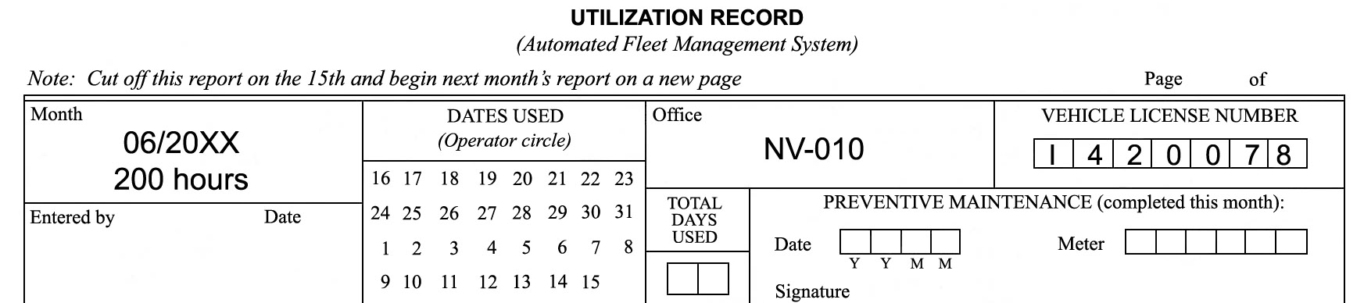

Scenario 1 – June 3
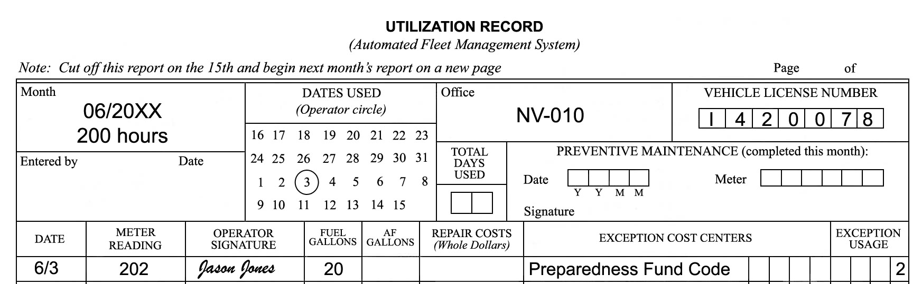

Scenario 2 – June 4
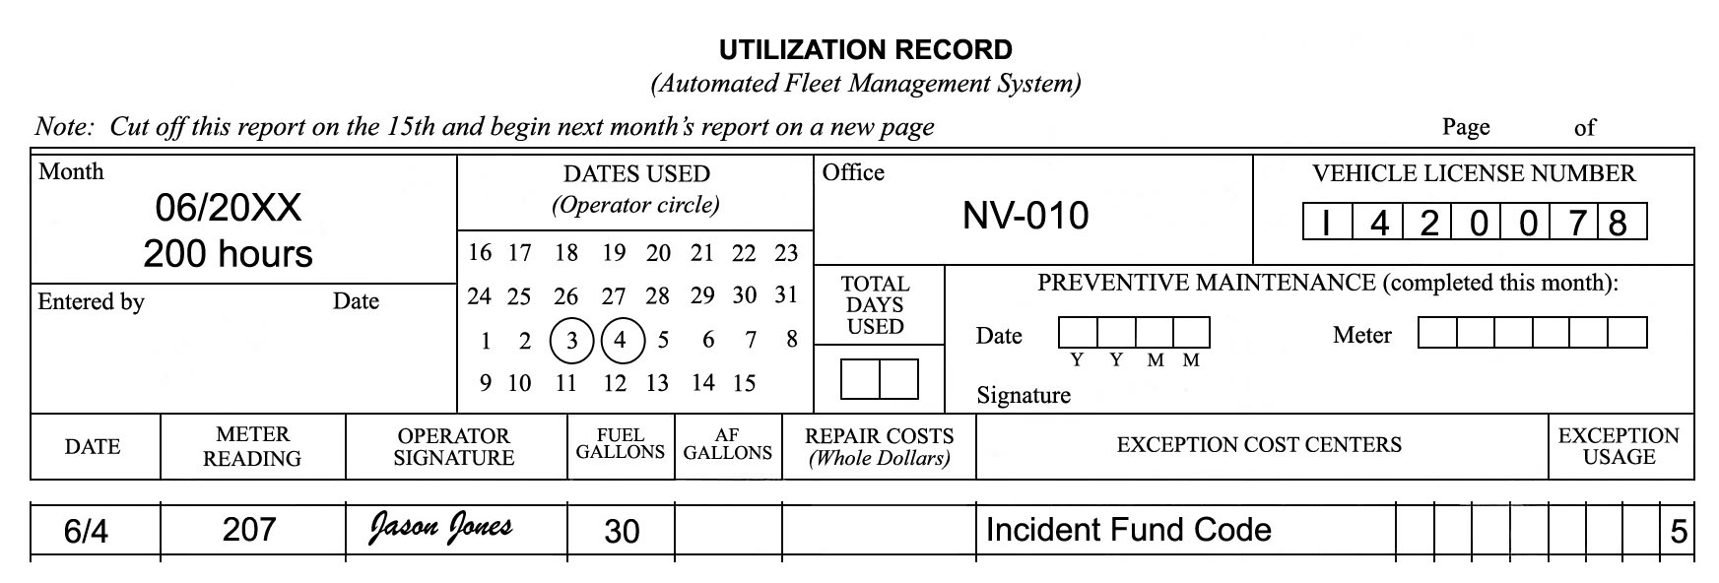

Scenario 3 – June 5
The students should ask about whether this is an incident fund code purchase or a Working Capital Fund purchase. Either one can be used, depending on your local policy. Using the preparedness fund code is not a proper answer.
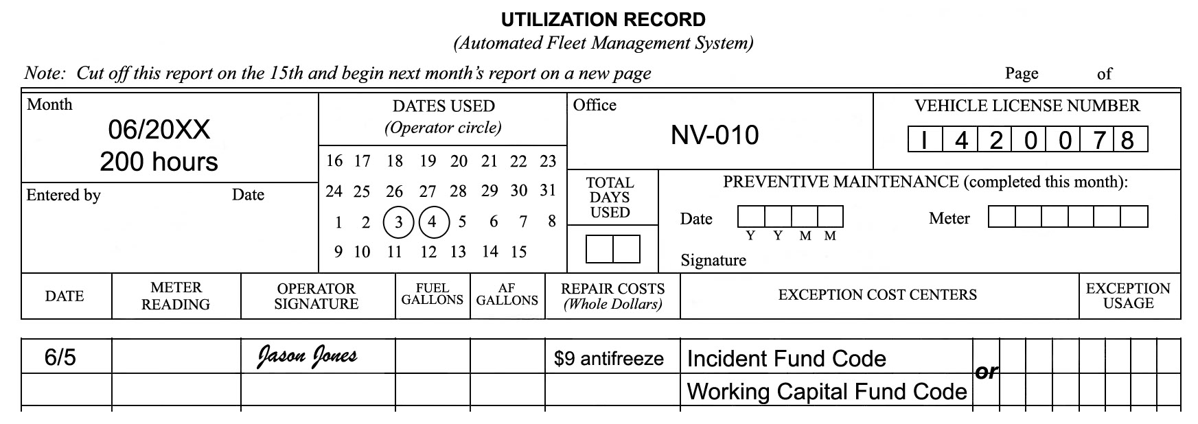

Scenario 4 – June 6
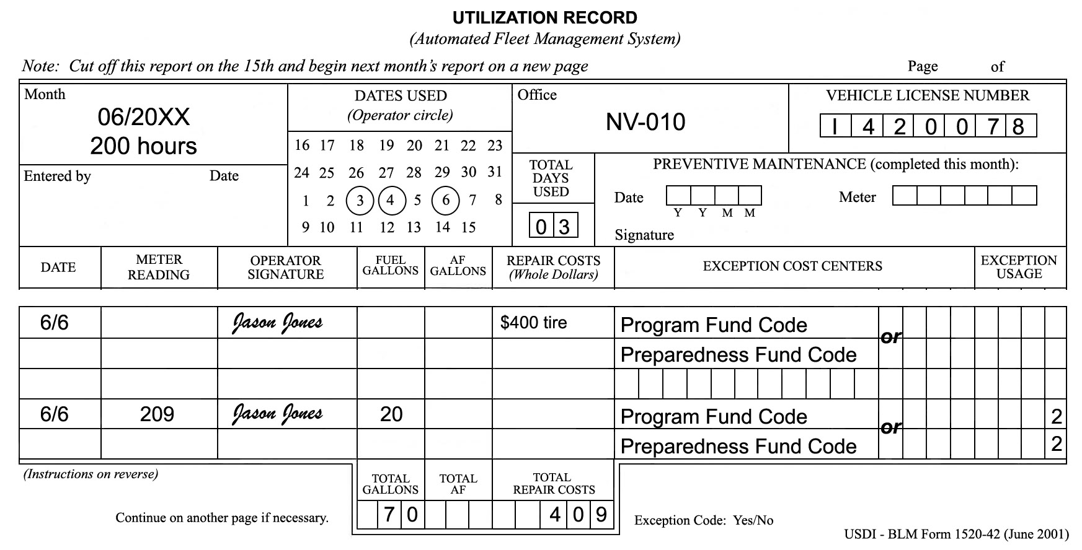

FOUR ACES MINI-MART  Preparedness Fund Code  123 High Roller Avenue  Jackpot, NV 89825  Pump # 03 Diesel  Gallons 20.000  Price/Gal $4.40  Fuel Sale $88.00  Debit $88.00  MC *****************  Auth: AA  Approval: 3479  Ref: 706 354937  06/03/2008 07:42PM  THANK YOU AND HAVE A NICE DAY | BENNY’S TRUCK STOP  Incident Fund Code  615 WEST MAIN  ELKO, NV 89801  Pump # 02 Diesel  Gallons 30.000  Price/Gal $4.37  Fuel Sale $131.10  Debit $131.10  MC *****************  Auth: CJ  Approval: 62587562  Ref: 159686456358  06/04/2008 08:22PM  Thank You For Your Patronage!
JACK’S PARTS AND ACCESSORIES
1002 NORTH CHERRY
ELKO, NV 89801

QTY ITEM UNIT PRICE TOTAL
1 Gal Antifreeze 9.00 $9.00
GRAND TOTAL $9.00
Incident Fund Code
or
Working Capital Fund
Method of Payment:
MC *****************
Authorization: 867504
Reference: 1678905479
06/05/2008
10:58AM
MICKEY’S TIRE SHOP  1416 EAST 5TH  ELKO, NV 89801  Qty. Item No. Description Unit Total  1 16534 Radial Tire 400.00 $400.00  Subtotal: $400.00  Tax: Exempt  GRAND TOTAL: $400.00  MC *****************  Program Fund Code  or  Preparedness Fund Code  Authorization: 785  Reference: 6598356  06/06/2008  09:47AM |  | STOP-ON-IN  543 NORTH STAR  ELKO, NV 89825  Program Fund Code  or  Preparedness Fund Code  Pump # 06 Diesel  Gallons 20.000  Price/Gal $4.39  Fuel Sale $87.80  Debit $87.80  MC *****************  Auth: KT  Approval: 4132  Ref: 950 635985  06/06/2008 05:15PM  Need a car wash?

Notes

UNIT 3 – FIRE ENGINE DRIVING
Lesson A – Driving Policy and Procedures

Suggested Time
Lecture – 1 hour; Case Study – ½ hour

Training Aids
- Computer with CD-ROM/DVD drive
- Multi-media projector
- Projection screen
- Flip charts and markers
- Interagency Incident Business Management Handbook
- Interagency Standards for Fire and Fire Aviation Operations
- Department of Transportation’s Emergency Response Guidebook

Instructions to the Instructor
The intent of this lesson is to provide students with an understanding of the policies and regulations that influence fire engine driving operations. The lesson also addresses the procedure of completing a risk assessment (RA) in order to present a tailgate safety session.
Prior to presenting the lesson, the instructor must review current policies and regulations relating to fire engine driving operations. The information presented in this lesson plan came from various policies (work/rest, length of assignment, and days off – Interagency Incident Business Management Handbook, the Interagency Standards for Fire and Fire Aviation Operations, and official agency directives). Instructors should review present policies, make note of any changes, and relay the information to students during the lecture.
When discussing hazardous materials, instructors should refer to the Department of Transportation’s Emergency Response Guidebook which can be found at http://phmsa.dot.gov/hazmat/library/erg.
Instructors for this unit should review the work/rest driving scenarios so they can explain them to students. The scenarios begin on page 26.
Instructors should also be familiar with the concept of an RA. A RA example is provided in the ENOP Student Toolkit and in the ENOP Student Workbook.

Case Study
Select a case study from the ENOP Facilitator Toolkit that applies to this topic. The recommended case study is the “Burn Damage to Engine RLS.”

WORK/REST EXERCISE
Work/Rest Scenario 1
You (the ENOP with a CDL) and a module member (non-CDL driver) are traveling to another state in a Type 4 engine. The trip length is estimated at 26 hours.
How many days will it take to reach your destination?
The trip will take three days to complete. Policy states, “No driver will drive more than 10 hours (behind the wheel) within any duty day.” The non-CDL driver is not allowed to drive the engine.
Work/Rest Scenario 2
You (the ENOP with a CDL) and a module member (non-CDL driver) are traveling to another state in a Type 6 engine. The trip length is estimated at 26 hours.
How many days will it take to reach your destination?
The trip will take two days to complete. Policy states, “Multiple drivers in a single vehicle may drive up to the duty-day limitation provided no driver exceeds the individual driving (behind the wheel) time limitation of 10 hours.” The non-CDL driver is allowed to drive the engine, but both drivers are subject to the 16-hour duty day.
Work/Rest Scenario 3
While on assignment on a 200,000-acre fire and working 12-hour shifts, the division group supervisor asks your crew to work an extra 8-hour shift to monitor a line.
Is this something your crew can do?
No. This will exceed the 2:1 work-to-rest ratio. However, the Incident Commander could write a justification authorizing the action.

UNIT 3 – FIRE ENGINE DRIVING
Lesson B – Basic Driving Skills
CONE COURSE EXERCISE

Exercise Intent
The intent of the cone course exercise is to provide students with an opportunity to demonstrate vehicle driving procedures on an established cone course.

Materials/Equipment
- 50 traffic cones
- Large area to facilitate course
- Chalk or paint
- 120’ reel measuring tape
- Cone course exercise diagrams—offset alley, curve backing (left and right), dock parking, and serpentine

Facilitator Information
Prior to beginning the course, the course coordinator and/or instructor need to identify an area large enough to accommodate the cone course exercise and secure approximately 50 cones to run the exercise. These cones are readily available from power companies, gas companies, construction companies, state highway departments, or other resources you may have in your community.
The cone course should be set up on the first day of the course in order for students to become familiar with the cone course and practice driving as time allows prior to the actual cone course exercise. Consider pre-marking cone locations with chalk or paint to save setup time between drivers and when cones are knocked over. If there are both Type 4 and Type 6 engines in the course, two sets of markings can be used at each station.
Be advised that newer suspension systems on engines may help the driver accomplish the cone courses easier than engines with older suspensions. Be sure to keep this in mind if a driver is having problems completing the course.
Upon completion of each exercise, the instructor should talk to each driver and verbally critique the driver’s performance providing ways to improve.

Case Study
Select a case study from the ENOP Facilitator Toolkit that applies to this topic. The recommended case study is the “Balance Rock Rollover Accident Investigation.”

NARRATIVE | DRIVING COURSE
OFFSET ALLEY  Type 4 Engine  The student will drive between two sets of cones as on a road, taking a sharp left turn followed by a sharp right turn. Once the turns are completed the student will align the engine and come to a complete stop. Next the student will reverse and back the engine through the course, stopping at the start line. | 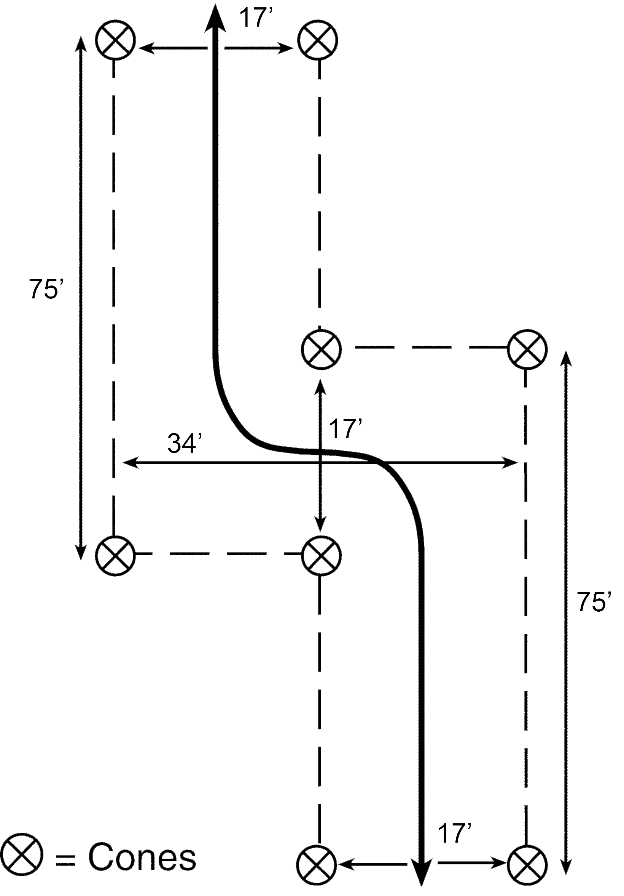
OFFSET ALLEY  Type 4 Engine – Six Pack  The student will drive between two sets of cones as on a road, taking a sharp left turn followed by a sharp right turn. Once the turns are completed the student will align the engine and come to a complete stop. Next the student will reverse and back the engine through the course, stopping at the start line. | 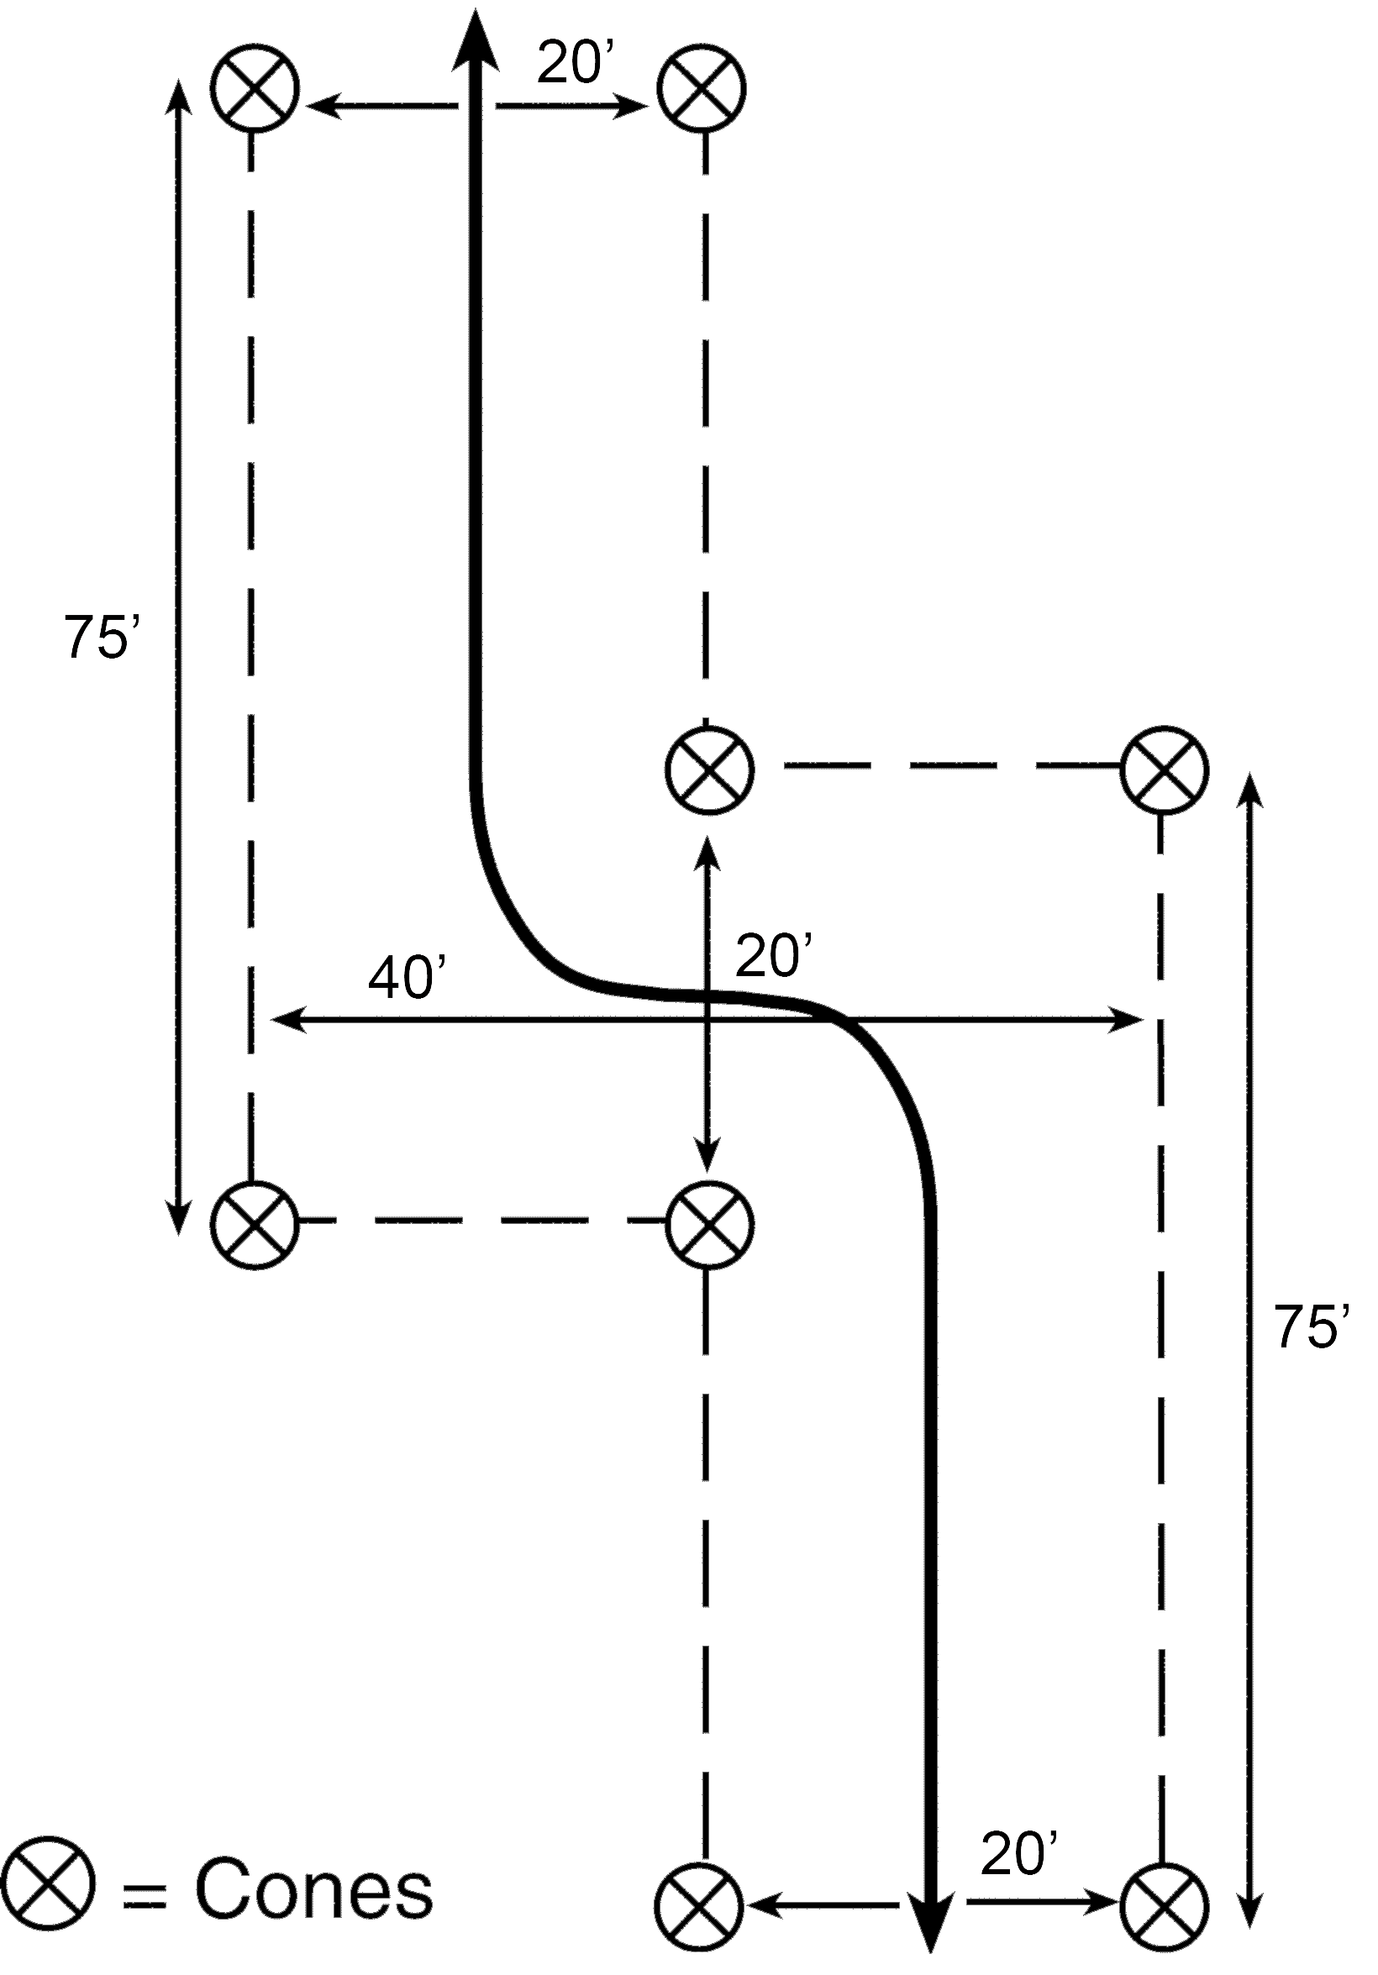
OFFSET ALLEY  Type 6 Engine  The student will drive between two sets of cones as on a road, taking a sharp left turn followed by a sharp right turn. Once the turns are completed the student will align the engine and come to a complete stop. Next the student will reverse and back the engine through the course, stopping at the start line. | 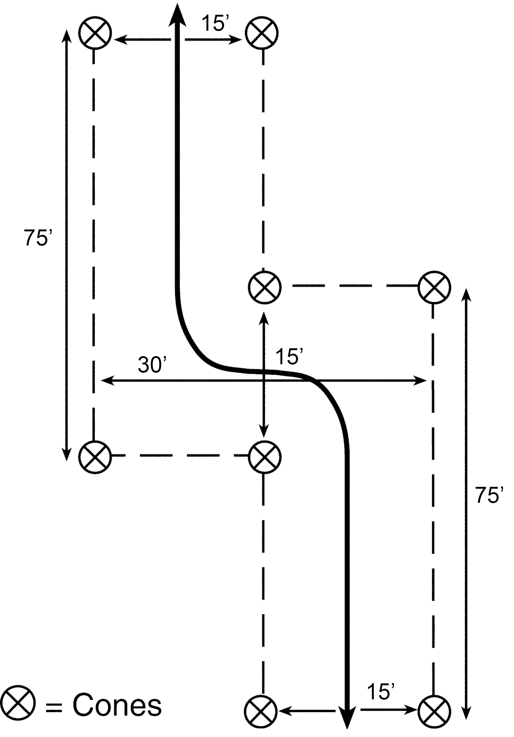
CURVE BACKING LEFT AND RIGHT  Type 4 Engine  For this exercise, the student will back the engine to the left through the curve. The student will then turn the engine around and back through the curve to the right. The curve should be 325-feet long. Eleven cones should be used on the inside of the curve. The radius dimension to the inside curve is 104 feet. | 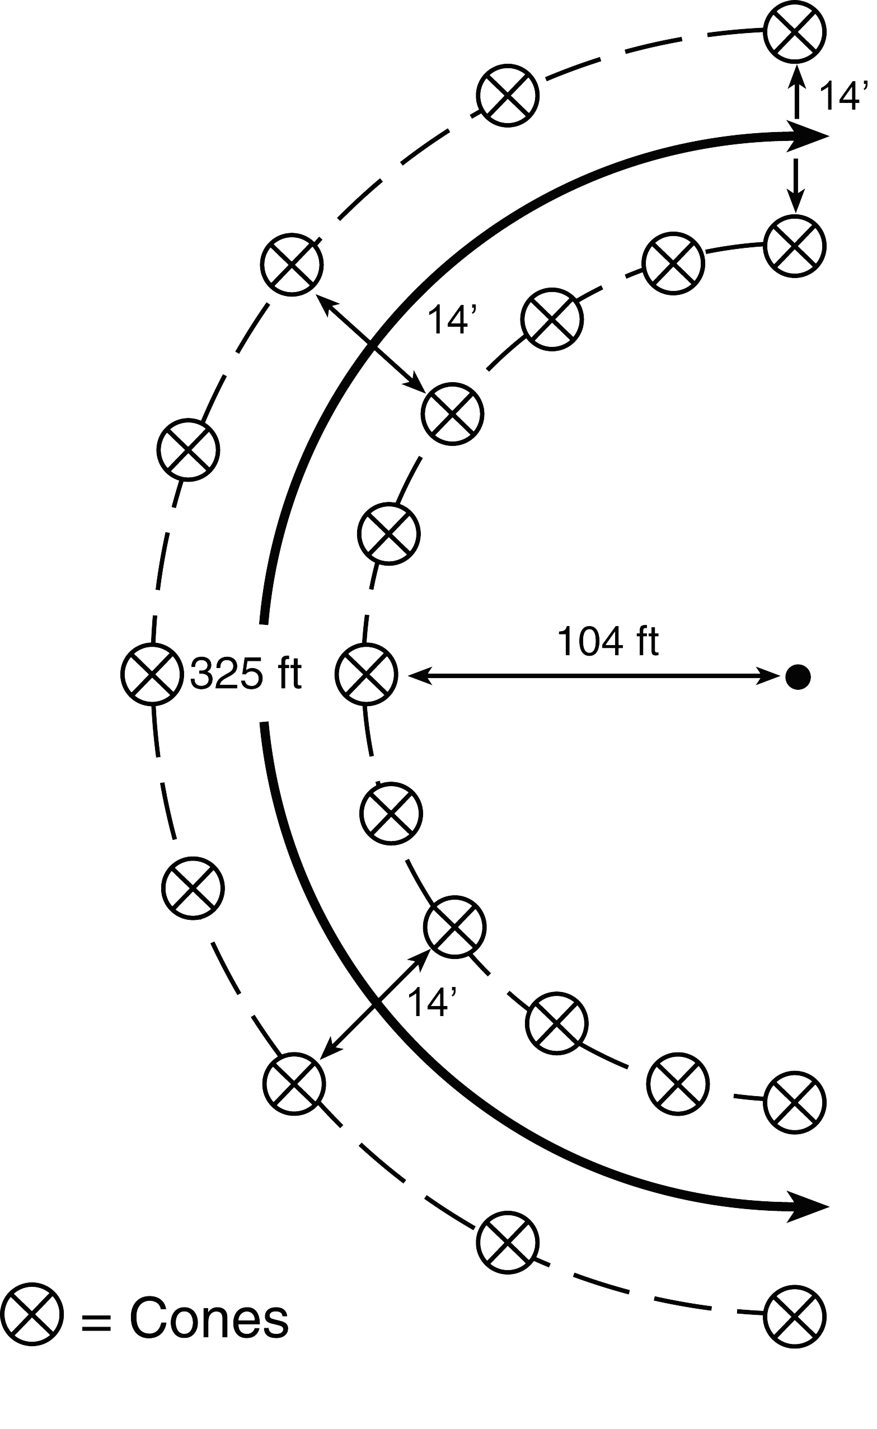
CURVE BACKING LEFT AND RIGHT  Type 4 Engine – Six Pack  For this exercise, the student will back the engine to the left through the curve. The student will then turn the engine around and back through the curve to the right. The curve should be 325-feet long. Eleven cones should be used on the inside of the curve. The radius dimension to the inside curve is 104 feet. | 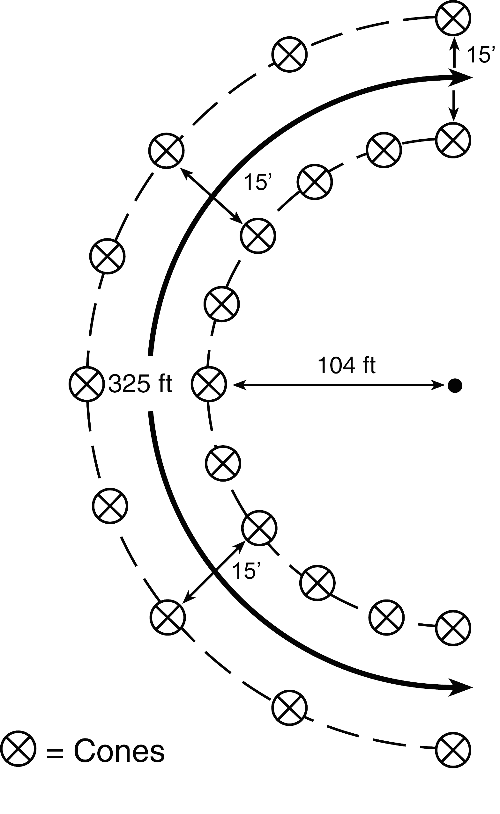
CURVE BACKING LEFT AND RIGHT  Type 6 Engine  For this exercise, the student will back the engine to the left through the curve. The student will then turn the engine around and back through the curve to the right. The curve should be 325-feet long. Eleven cones should be used on the inside of the curve. The radius dimension to the inside curve is 104 feet. | 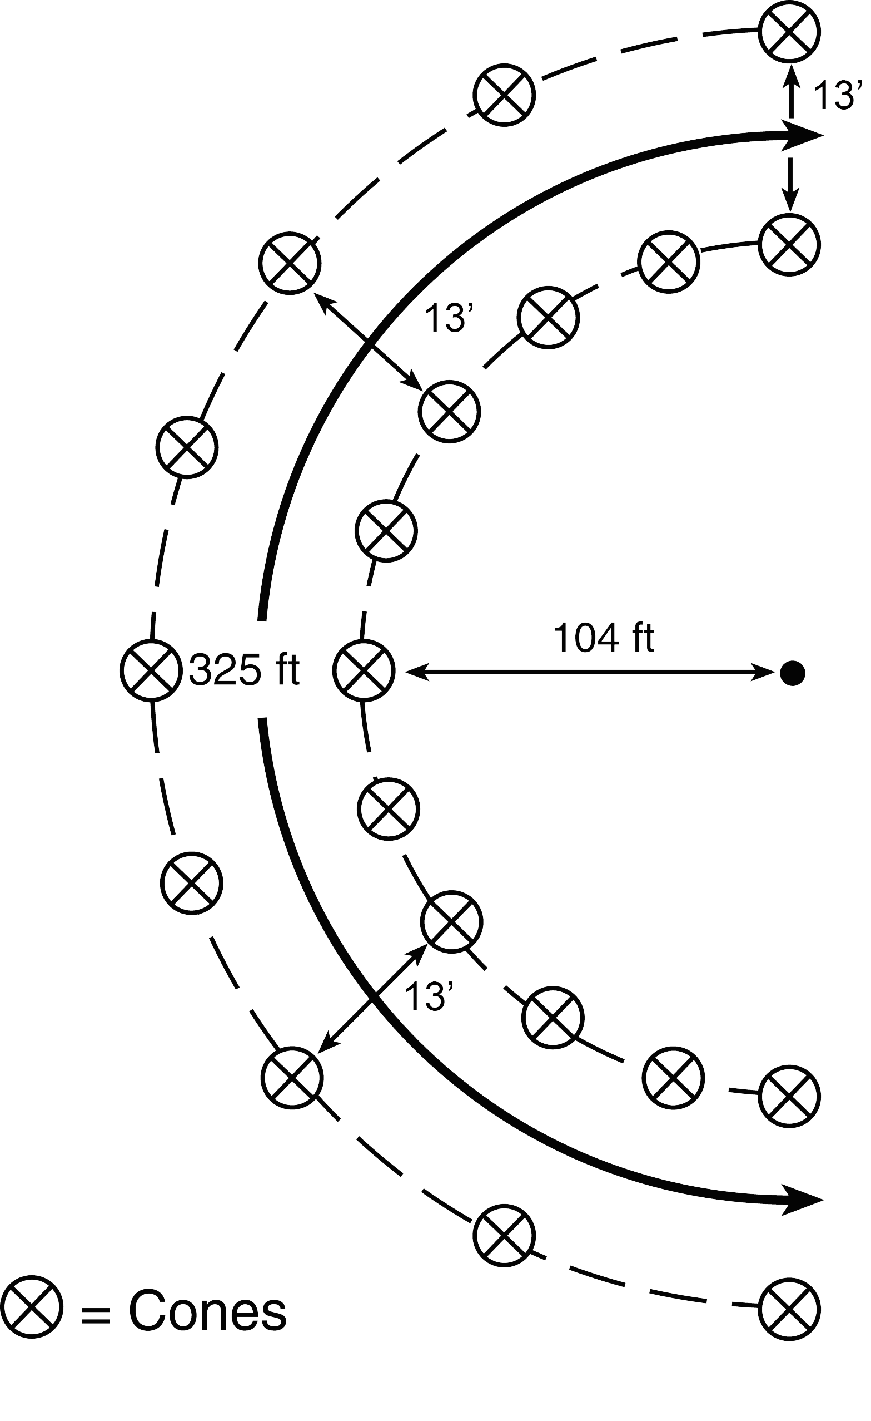
DOCK PARKING  Type 4 Engine  The student will back the engine between two rows of cones, as from a street to a dock. The student will stop the engine so that the rear bumper is within 12 inches of the dock. | 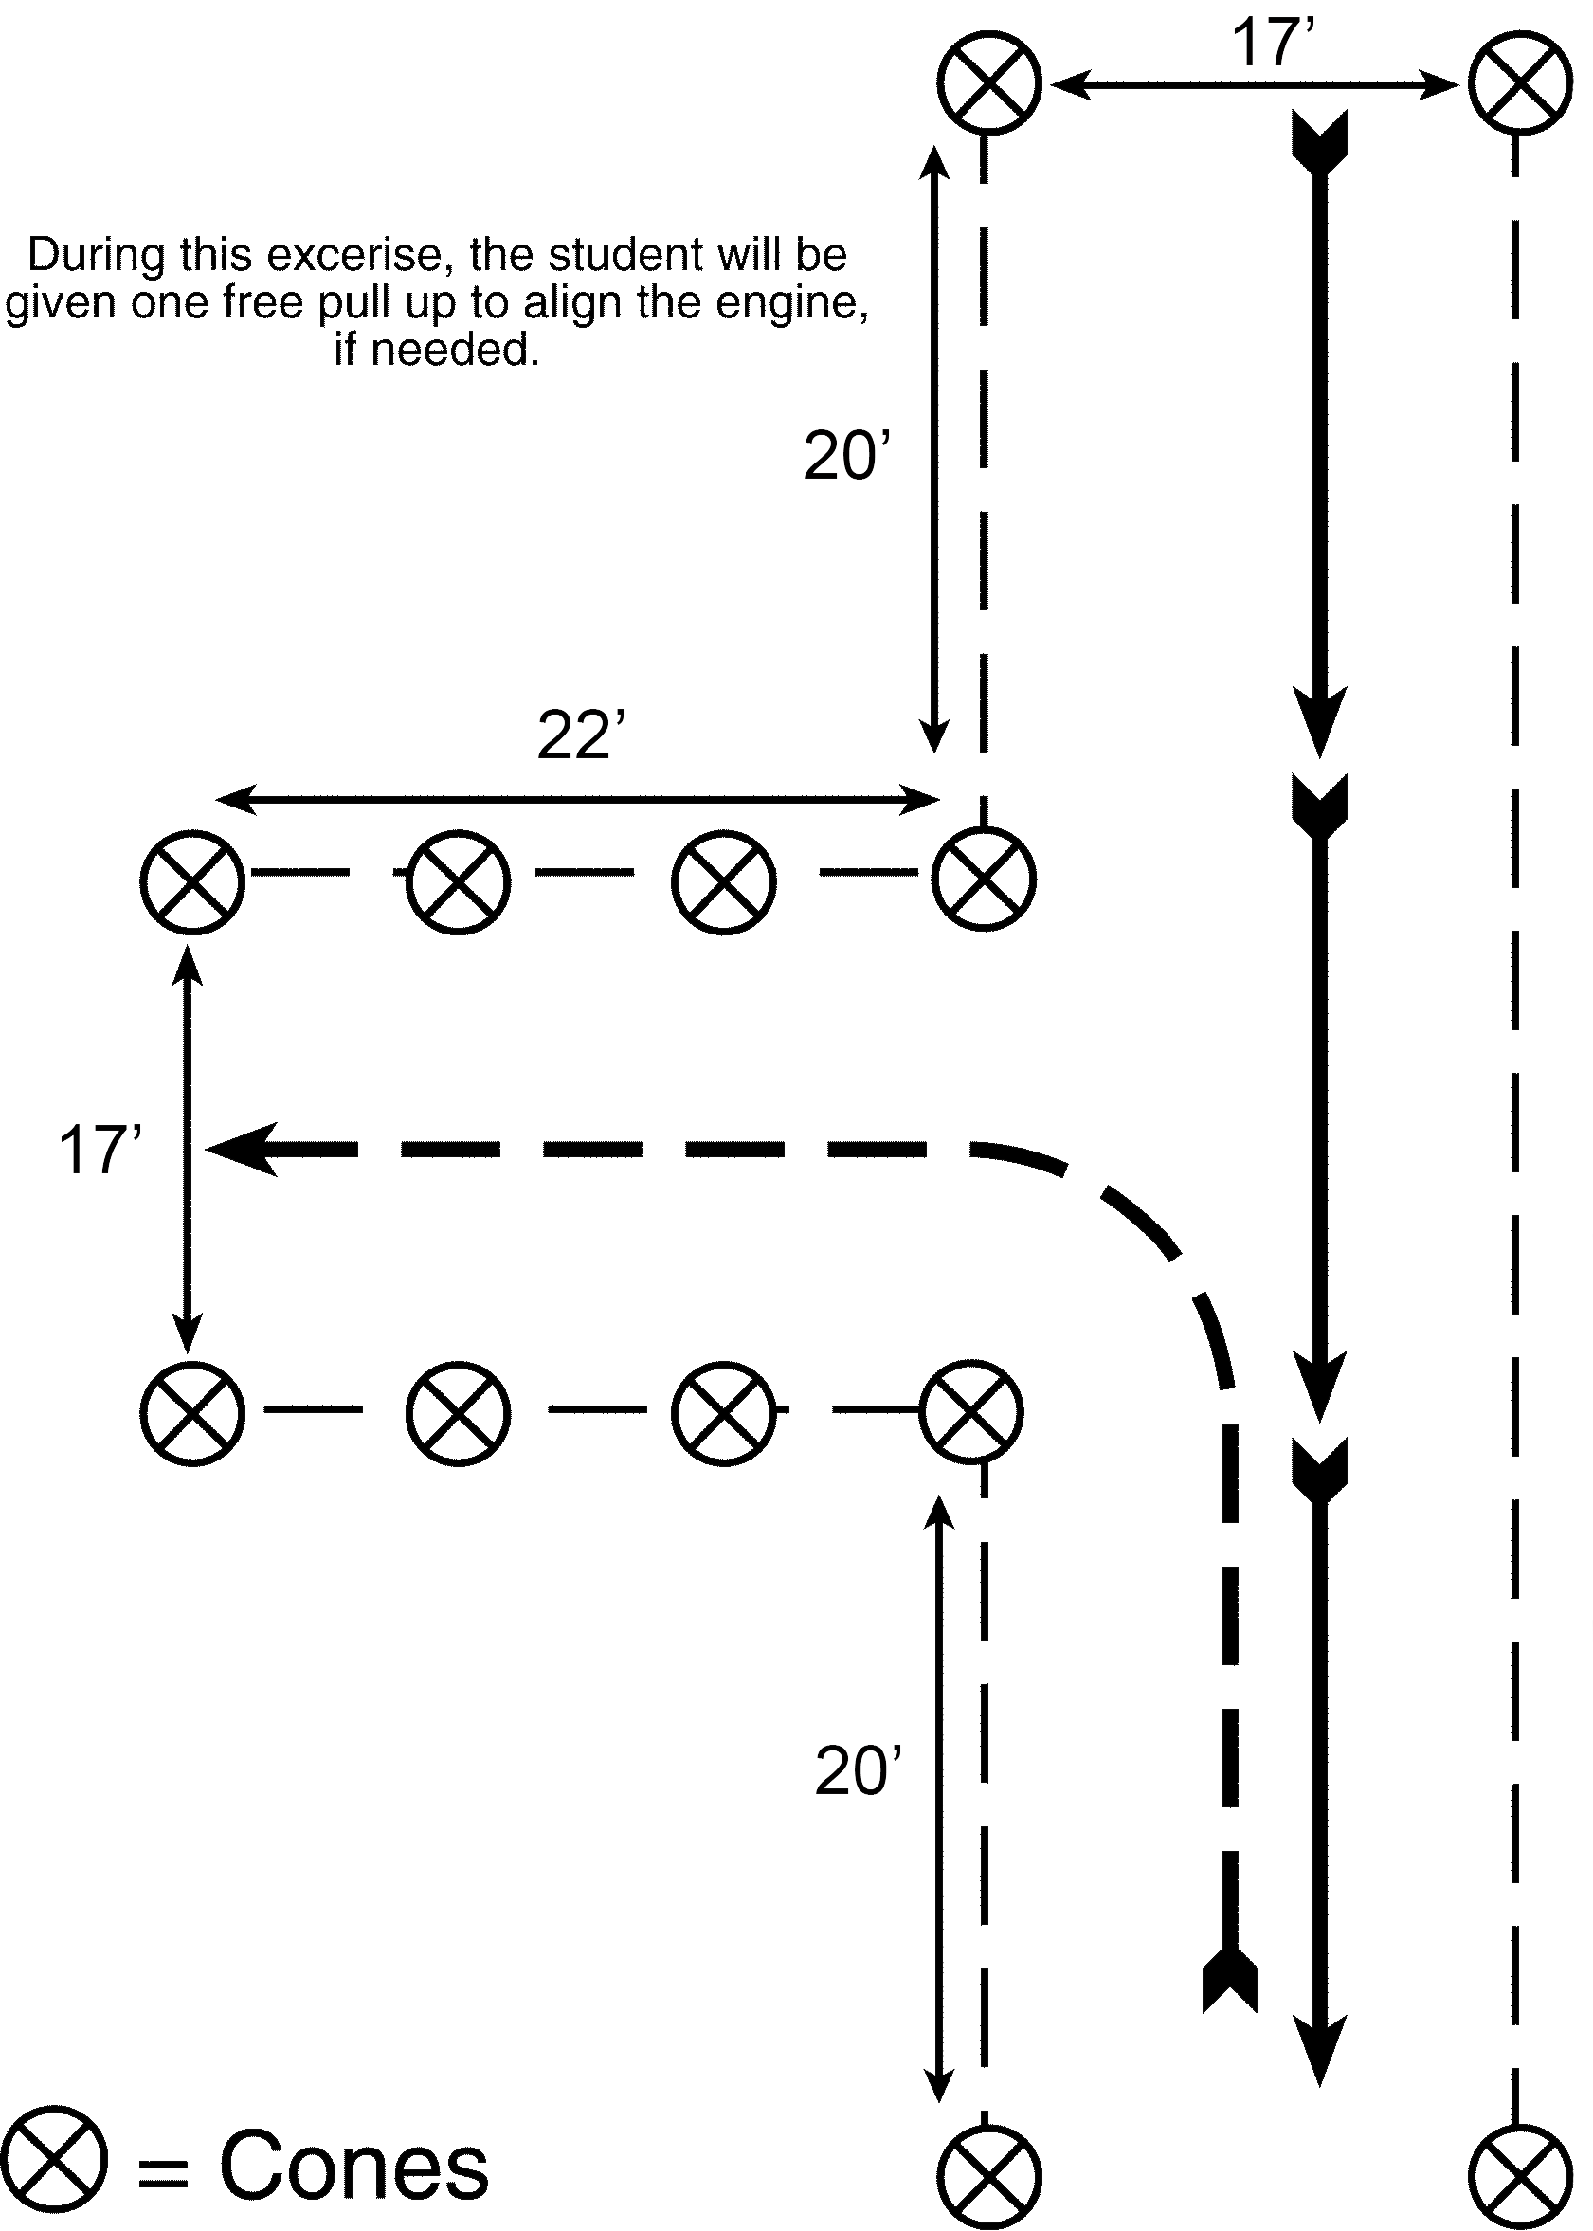
DOCK PARKING  Type 4 Engine – Six Pack  The student will back the engine between two rows of cones, as from a street to a dock. The student will stop the engine so that the rear bumper is within 12 inches of the dock. | 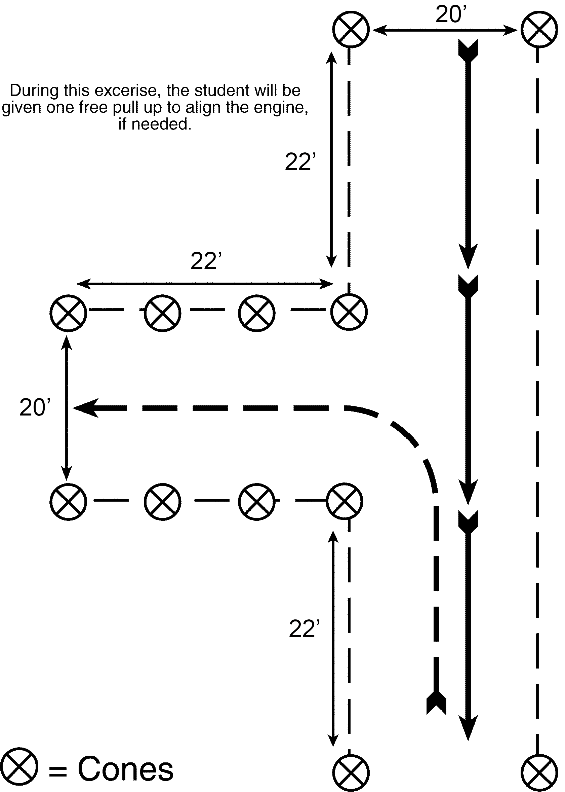
DOCK PARKING  Type 6 Engine  The student will back the engine between two rows of cones, as from a street to a dock. The student will stop the engine so that the rear bumper is within 12 inches of the dock. | 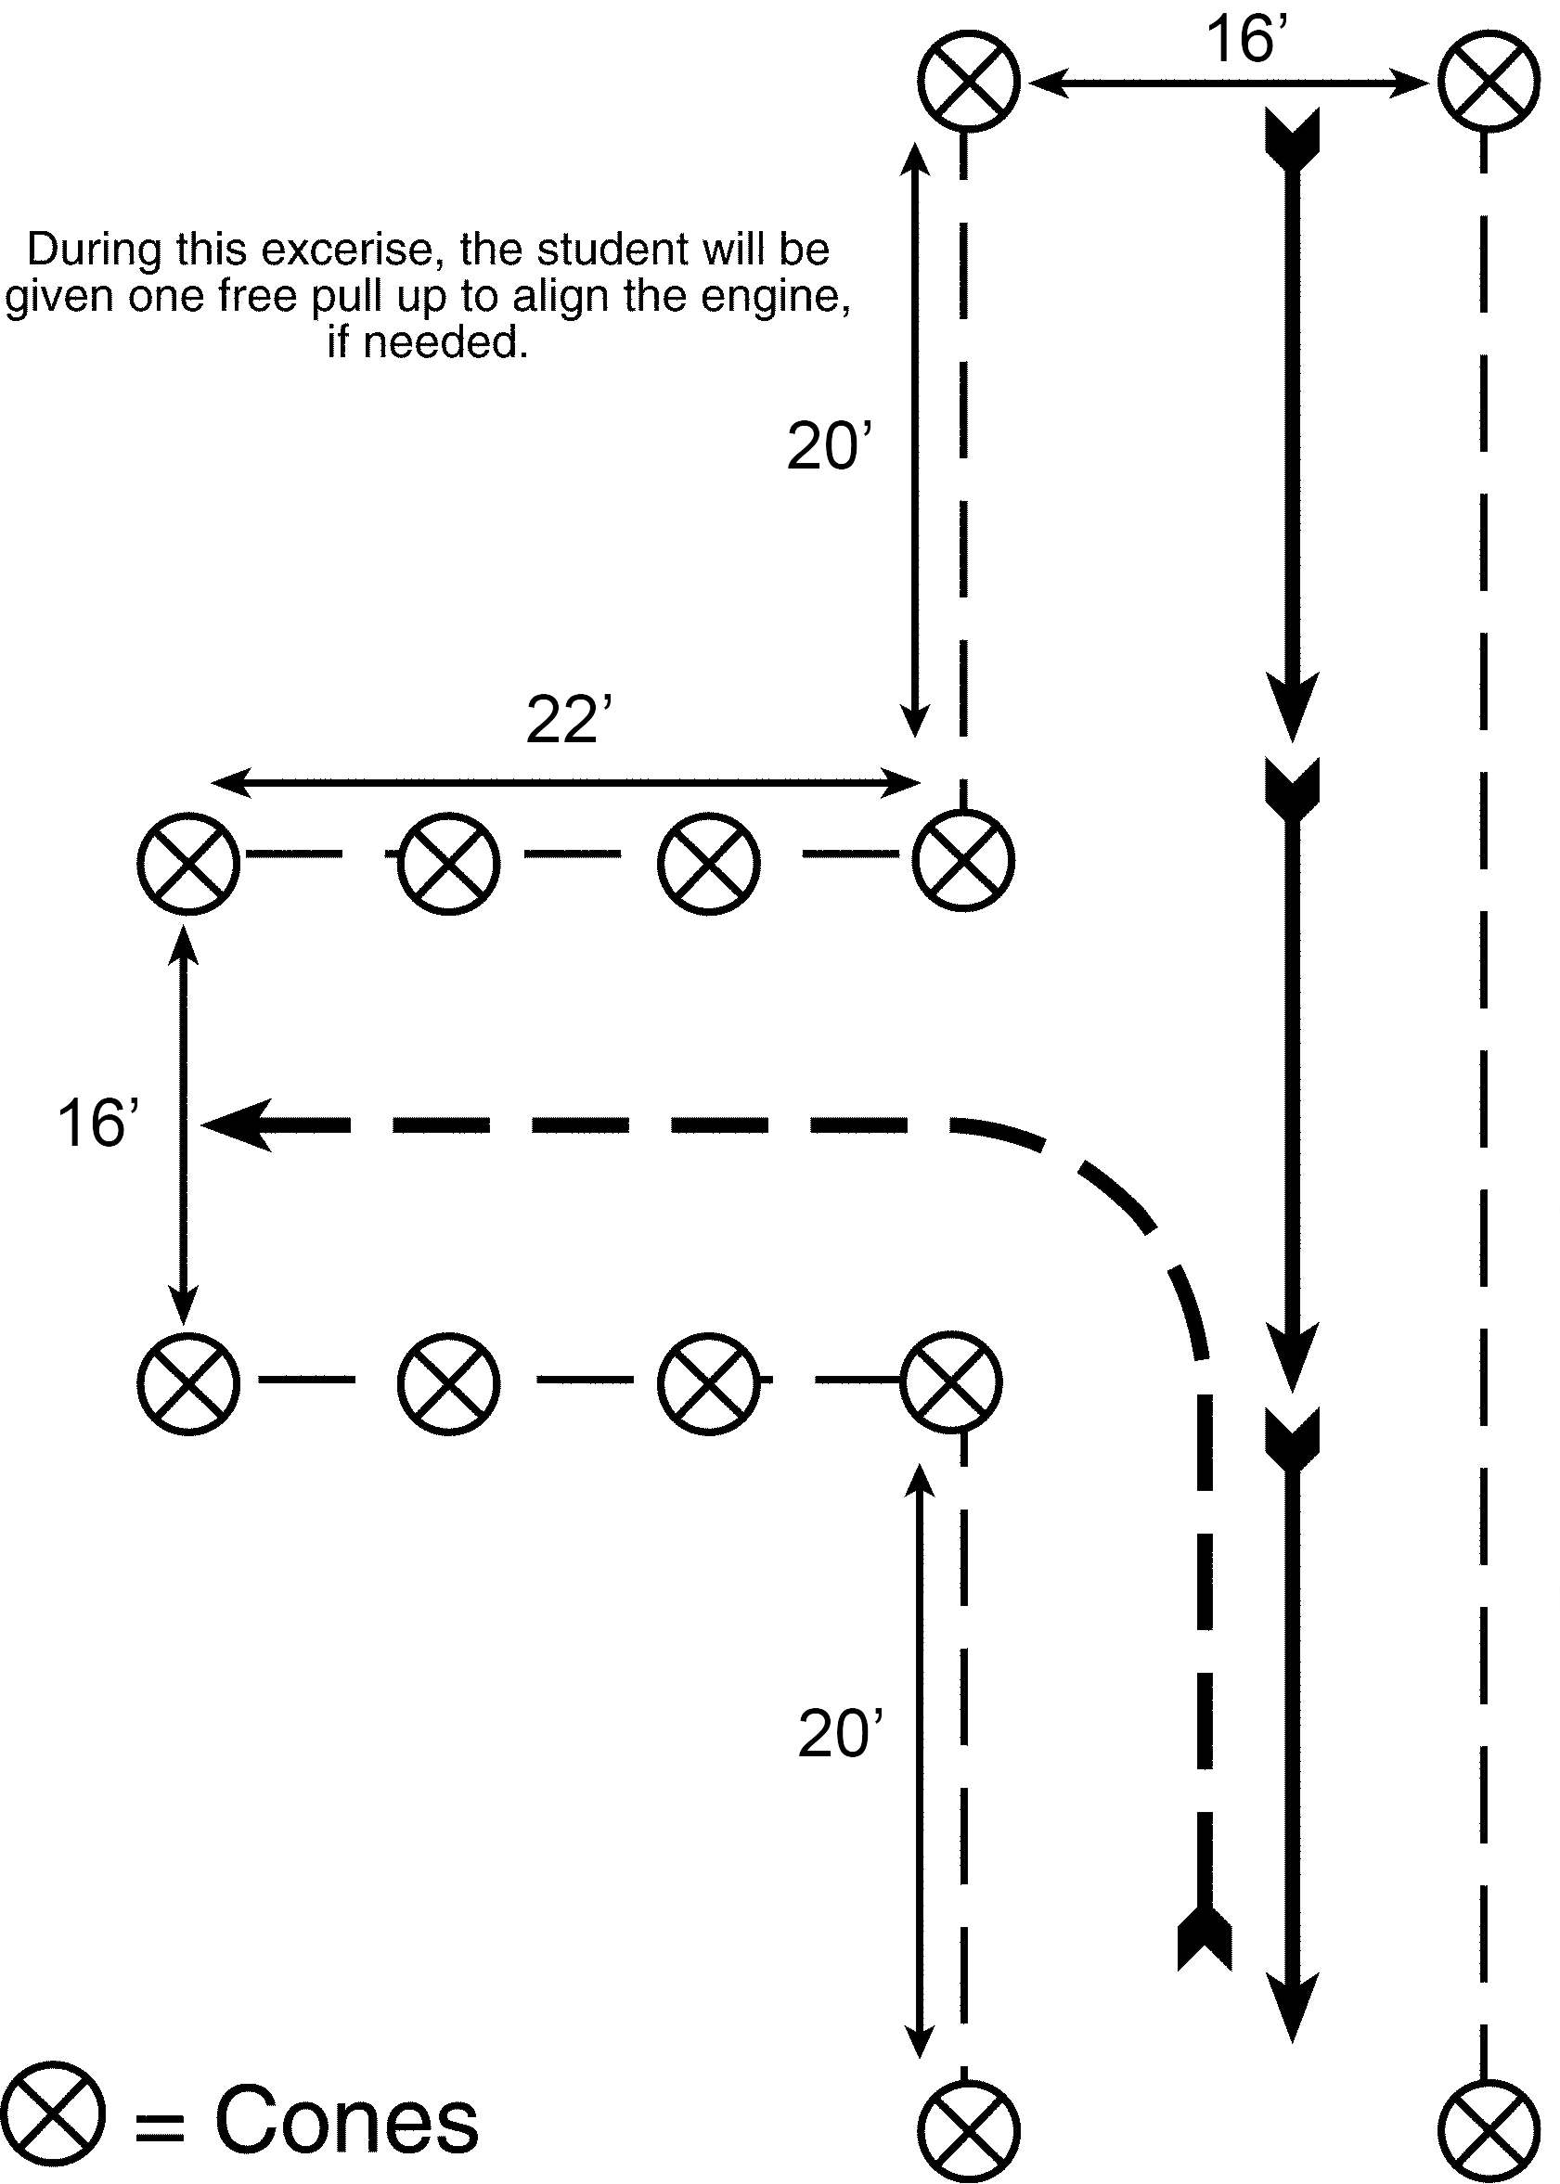
SERPENTINE  Type 4 Engine  The student will begin at the start point that the evaluators have set up. They will proceed up the right side of the row of cones. At the first cone while driving forward, the student will alternate passing to the left of the first cone, then right of the second cone and so forth past the last cone. The student will then align the engine and reverse through the course, backing to the right of the first cone, left of the second cone, etc. The student is allowed to stop and align the engine only at the stop/start points. The student should not run over any cones. | 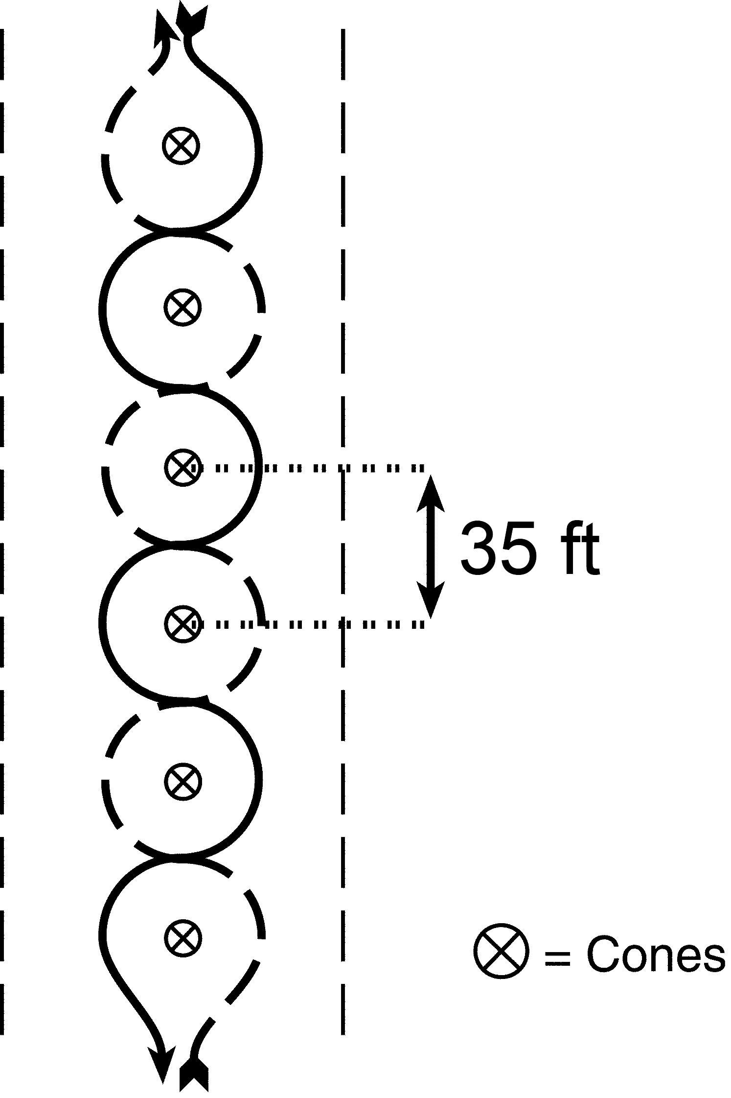
SERPENTINE  Type 4 Engine – Six Pack  The student will begin at the start point that the evaluators have set up. They will proceed up the right side of the row of cones. At the first cone while driving forward, the student will alternate passing to the left of the first cone, then right of the second cone and so forth past the last cone. The student will then align the engine and reverse through the course, backing to the right of the first cone, left of the second cone, etc. The student is allowed to stop and align the engine only at the stop/start points. The student should not run over any cones. | 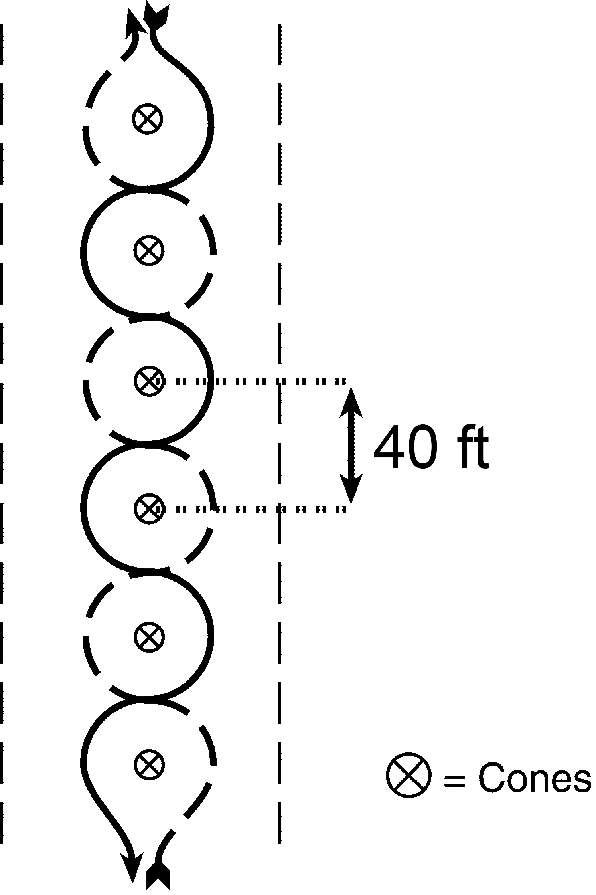
SERPENTINE  Type 6 Engine  The student will begin at the start point that the evaluators have set up. They will proceed up the right side of the row of cones. At the first cone while driving forward, the student will alternate passing to the left of the first cone, then right of the second cone and so forth past the last cone. The student will then align the engine and reverse through the course, backing to the right of the first cone, left of the second cone, etc. The student is allowed to stop and align the engine only at the stop/start points. The student should not run over any cones. | 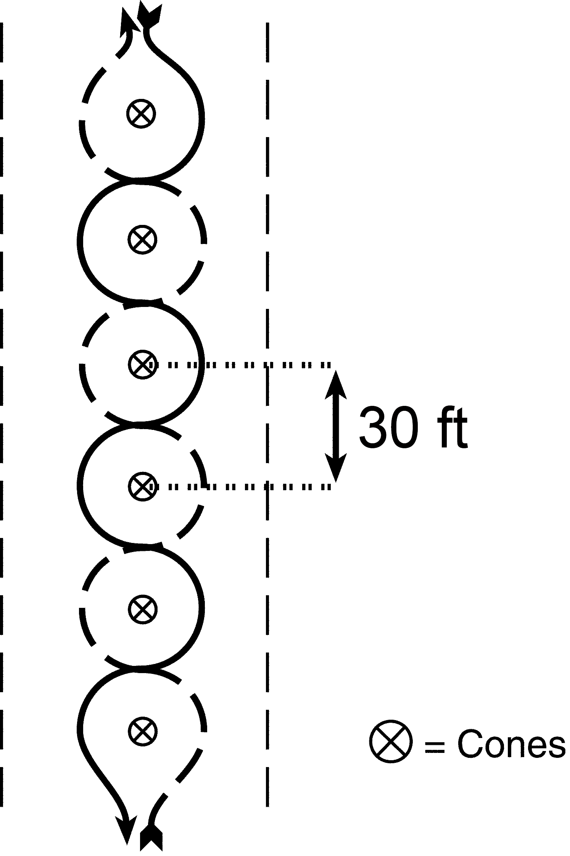

Notes

UNIT 4 – WATER HANDLING OPERATIONS
Lesson A – Water and Hose Hydraulics

Suggested Time
Lecture – 2½ hours

Training Aids
- Computer with CD-ROM/DVD drive
- Multi-media projector
- Projection screen
- Flip charts and markers
- Water Handling Equipment Guide (NFES 1275)
- Incident Response Pocket Guide (NFES 1077)
- Firefighting equipment fire stream/friction loss calculator (NFES 0897)
- Graded student pre-course work

Lesson Intent
The intent of this lesson is to provide a review of hydraulics and friction loss calculations. Students should have a firm grasp of the concepts since the information was covered well in Portable Pumps and Water Use (S-211) and in their pre-course work.

Instructions to the Instructor
Instructors teaching this unit should work through all exercises to ensure friction loss calculation answers are correct for the particular calculator that is available through the National Fire Equipment System Catalog (NFES# 0362). Calculations for this unit were performed using the Cascade fire stream/friction loss calculator. If a different calculator is used, the instructor may need to update the PowerPoint presentation since slight differences and instructor preference may necessitate change.
Prior to teaching the course, instructors should review the students’ hydraulics pre-course work and identify weaknesses in student responses. If students had trouble completing the pre-course work, more time should be spent on reviewing Exercises 1-4 before advancing to Exercises 5-7 in class. If students had few problems with the pre-course work, only a brief overview of this information is needed.
Exercises 1-7 will also be performed using the Principles of Hydraulics—“Rule of 5s” and these values will be compared to the friction loss calculations that were done with the calculator. Instructors have the option of using PowerPoint presentation software and associated annotation tools within the software or overhead transparencies and pens to complete the exercises. Later versions of PowerPoint presentation software allow users to keep their ink annotations upon ending the show. If instructors want to use the annotations at a later time, they should save the presentation to their hard drives.
Videos are a great way to enhance this lesson. Instructors have permission to use Bellingham Technical College’s “Cavitation in a Water Pump” video (https://youtu.be/eMDAw0TXvUo).

Friction Loss Calculation Exercises

Pre-Course Work Using The Friction Loss Calculator
(Exercises 1 – 4)
At this point in the course, you will review the friction loss calculations that you performed and submitted as pre-course work.

Exercise 1
 | Friction Loss Calculator | “Rule of 5s”
+ NP | + 50 PSI Forester nozzle | + 50 PSI Forester nozzle
± H | + 0 PSI no change | + 0 PSI no change
+ FL | + 10 PSI 1½” hose @ 20 GPM  (500’) 2 PSI per 100’ (2 x 5) | + 25 PSI 1½” hose @ 20 GPM  (500’) 5 PSI per 100’ (5 x 5)
PDP = | 60 PSI | 75 PSI

Exercise 2
 | Friction Loss Calculator | “Rule of 5s”
+ NP | + 50 PSI Forester nozzle | + 50 PSI Forester nozzle
± H | + 25 PSI 50’ gain  (50 x .5) or (50 ÷ 2) | + 25 PSI 50’ gain  (50 x .5) or (50 ÷ 2)
+ FL | + 18 PSI 1½” hose @ 30 GPM  (500’) 3 PSI/100’ (3 x 6) | + 30 PSI 1½” hose @ 30 GPM  (600’) 5 PSI/100’ (5 x 6)
PDP = | 93 PSI | 105 PSI

Exercise 3
 | Friction Loss Calculator | “Rule of 5s”
+ NP | + 50 PSI Forester nozzle | + 50 PSI Forester nozzle
± H | + 0 PSI no change | + 0 PSI no change
+ FL | + 5 PSI 1” hose @ 13 GPM  (100’) 5 PSI/100’ (5 x 1) | + 10 PSI 1” hose  (100’) 10 PSI/100’ (10 x 1)
+ FL | + 9 PSI 1½” hose @ 26 GPM  (300’) 3 PSI/100’ (3 x 3) | + 15 PSI 1½” hose < 60 GPM  (300’) 5 PSI/100’ (5 x 3)
PDP = | 64 PSI | 75 PSI

Exercise 4
 | Friction Loss Calculator | Rule of 5s
+ NP | +100 PSI variable flow nozzle | +100 PSI variable flow nozzle
± H | +0 PSI no change | +0 PSI no change
+ FL | +15 PSI 1” hose @ 25 GPM  (100’) 15 PSI/100’ (15 x 1) | +10 PSI 1” hose  (100’) 10 PSI/100’ (10 x 1)
+ FL | +3 PSI 1½” hose @ 25 GPM  (100’) 3 PSI/100’ (3 x 1) | +5 PSI 1½” hose < 60 GPM  (100’) 5 PSI/100’ (5 x 1)
+ FL | +135 PSI 1½” hose @ 50 GPM  (1,500’) 9 PSI/100’ (9 x 15) | +75 PSI 1½” hose < 60 GPM  (1,500’) 5 PSI/100’ (5 x 15)
= PDP | 253 PSI | 190 PSI

Exercise 5
 | Friction Loss Calculator | Rule of 5s
+ NP | +100 PSI variable flow nozzle | +100 PSI variable flow nozzle
± H | +0 PSI no change | +0 PSI no change
+ FL | +23 PSI 1” hose @ 30 GPM  (100’) 23 PSI/100’ (23 x 1) | +10 PSI 1” hose @ 30 GPM  (100’) 10 PSI/100’ (10 x 1)
+ FL | +3 PSI 1½” hose @ 30 GPM  (100’) 3 PSI/100’ (3 x 1) | +5 PSI 1½” hose @ 30 GPM  (100’) 5 PSI/100’ (5 x 1)
+ FL | +26 PSI 1½” hose @ 60 GPM  (200’) 13 PSI/100’ (13 x 2) | +30 PSI 1½” hose @ 60 GPM  (200’) 15 PSI/100’ (15 x 2)
+ FL | +28 PSI 1½” hose @ 90 GPM  (100’) 28 PSI/100’ (28 x 1) | +15 PSI 1½” hose @ 90 GPM  (100’) 15 PSI/100’ (15 x 1)
+ FL | +42 PSI 1½” hose @ 90 GPM with 2 Siamese lines  (600’) 7 PSI/100’ (7 x 6) | +30 PSI 1½” hose @ 90 GMP with 2 Siamese lines  (600’) 5 PSI/100’ (5 x 6)
= PDP | 222 PSI | 190 PSI

Exercise 6
 | Friction Loss Calculator | Rule of 5s
+ NP | +100 PSI variable flow nozzle | +100 PSI variable flow nozzle
± H | +30 PSI 60’ gain (60 ÷ 2) | +30 PSI 60’ gain (60 ÷ 2)
+ FL | +23 PSI 1” hose @ 30 GPM  (100’) 23 PSI/100’ (23 x 1) | +10 PSI 1” hose @ 30 GPM  (100’) 10 PSI/100’ (10 x 1)
+ FL | +6 PSI 1½” hose @ 30 GPM  (200’) 3 PSI/100’ (3 x 2) | +10 PSI 1½” hose @ 30 GPM  (200’) 5 PSI/100’ (5 x 2)
+ FL | +13 PSI 1½” hose @ 60 GPM  (100’) 13 PSI/100’ (13 x 1) | +15 PSI 1½” hose @ 60 GPM  (100’) 15 PSI/100’ (15 x 1)
+ FL | +12 PSI 1½” hose @ 60 GPM with 2 Siamese lines  (400’) 3 PSI/100’ (3 x 4) | +20 PSI 1½” hose @ 60 GPM with 2 Siamese lines  (400’) 5 PSI/100’ (5 x 4)
= PDP | 184 PSI | 185 PSI

Exercise 7
 | Friction Loss Calculator | Rule of 5s
+ NP | +100 PSI variable flow nozzle | +100 PSI variable flow nozzle
± H | -10 PSI 20’ of total elevation drop (20 ÷ 2) | -10 PSI 20’ of total elevation drop (20 ÷ 2)
+ FL | +15 PSI 1” hose @ 25 GPM  (100’) 15 PSI/100’ (15 x 1) | +10 PSI 1” hose @ 25 GPM  (100’) 10 PSI/100’ (10 x 1)
+ FL | +3 PSI 1½” hose @ 25 GPM  (100’) 3 GPM/100’ (3 x 1) | +5 PSI 1½” hose @ 25 GPM  (100’) 5 GPM/100’ (5 x 1)
+ FL | +27 PSI 1½” hose @ 50 GPM  (300’) 9 PSI/100’ (9 x 3) | +15 PSI 1½” hose @ 50 GPM  (300’) 5 PSI/100’ (5 x 3)
+ FL | +15 PSI 1½” hose @ 50 GPM with 2 Siamese lines  (500’) 3 PSI/100’ (3 x 5) | +25 PSI 1½” hose @ 50 GPM with 2 Siamese lines  (500’) 5 PSI/100’ (5 x 5)
= PDP | 150 PSI | 145 PSI

DIFFERENCES BETWEEN FRICTION LOSS CALCULATION AND “RULE OF 5S” SOLUTIONS
Why are there differences between the friction loss calculator and “Rule of 5s” solutions?
  - Answer: Friction loss calculations are derived from a mathematical equation while the “Rule of 5s” are estimated.
Are the differences in the answers significant enough to cause problems in building hose lays?
  - Answer: Though the differences in the equations seem large in some cases, the actual practicality of the hose lay does not change; neither method is exact. The goal of supplying the adequate amount of water to the nozzle operator(s) remains the constant.
Why are we using the friction loss calculator and the Principles of Hydraulics—“Rule of 5s”?
  - Answer: While the friction loss calculator provides us with a means to find solutions for hose lays on paper with consistency and validation (the theory behind hydraulics), field use of it proves to be slow and tedious.

What will happen if the water pressure safety shutdown switch is in the down (on) position and the operator opens the draft-to-tank valve?
  - Answer: The pump will shut down and stop. This is a watch out when troubleshooting a pump that is not starting.

UNIT 4 – Water Handling Operations
Lesson B –Water Sources and Pumping Operations

Suggested Time
Lecture – 1 hour
Hydrant Use Exercise – ½ hour

Training Aids
- Computer with CD-ROM/DVD drive
- Multi-media projector
- Projection screen
- Flip charts and markers
- Exercise materials
- Local area hose pack examples

Lesson Intent
The intent of this lesson is to provide students with an understanding of water source selection for refill operations and the associated concerns with such selections. Students will also gain an understanding of preparing and using the engine during pumping operations.

Instructions to the Instructor
A section regarding aquatic invasive species is included in this unit. Formal policy direction has not been issued at the time of course revision. A set of operational guidelines that were developed by the Southwest Coordinating Group is provided. Instructors should work with local subject matter experts regarding specific policies and procedures.
This lesson includes a hands-on, outside hydrant exercise that is done at the end of the lesson. While each engine module is performing the outside hydrant exercise, the other modules can be demonstrating hose packs or practicing on the cone course. The instructor and students should have an understanding of local water source options as well as local fire hydrant regulations and procedures.
Instructors should share with students their knowledge and experiences of using hose packs in the field. Examples of local hose packs should be available for student viewing and discussion. Students should also build hose packs for use during the field exercises. Encourage students to ask questions and talk about hose packs from their local area. As time allows, consider showing students various types of hose packs.

Case Study
Select a case study from the ENOP Facilitator Toolkit that applies to this topic. The recommended case study is the “Crescent Fire Scald Injury FLA.”

Outside Hydrant Exercise

Exercise Intent
The intent of this exercise is to introduce students to the process of refilling an engine using a fire hydrant.
Students will be able to perform an engine refill using a hydrant. Students will be evaluated on following guidelines established in the classroom lecture portion of this unit. Exercise will be performed by students in groups of three.

Materials/Equipment:

- Access to charged hydrant
- Type 3, 4, or Type 6 engine
- Hydrant wrench
- Reducer 2½” NH-F to 1½” NH-M
- 200’ of 1½” CJRL hose
- Spanner wrench
- 1½” gated wye

1½” ball valve

Evaluator/Facilitator Information
- If the local area requires the use of an anti-siphon device, have students incorporate it into the exercise.
- All local requirements and protocols will be followed in this exercise.
Have students follow the following steps when refilling an engine using a fire hydrant:
- Make sure the hydrant is closed before removing caps.
- Attach thread adapters and reducers as needed.
- Attach 1½” ball valve or 1½” gated wye.
- Open hydrant completely using five-sided hydrant wrench.
- Approximately 13 complete turns
- Open ball valve or gated wye to bleed off any rust/debris/air from hydrant.
- Close ball valve or gated wye.
- Attach anti-siphon device to hydrant using appropriate hose and fittings.
- Place hose in engine; provide for air gap, if necessary.
- Slowly open ball valve or gated wye and fill engine.
- Slowly close ball valve or gated wye.
- Remove all fittings and devices and recap hydrant.
- Do not over tighten.

UNIT 4 – WATER HANDLING OPERATIONS
Lesson C – Foam and Foam Proportioning Systems

Suggested Time
Lecture – 1 hour

Training Aids
- Computer with CD-ROM/DVD drive
- Multi-media projector
- Projection screen
- Flip charts and markers
- Exercise materials

Lesson Intent
The intent of this lesson is for students to develop an understanding of foam and foam proportioning systems and demonstrate the ability to setup, run, and shut down a foam proportioner.

Instructions to the Instructor
Instructors for this module need to determine the types of foam proportioning equipment that will be demonstrated. The BLM standard foam proportioner is the Waterous Aquis™ 1.5. Many BLM engines may be equipped with the FoamPro® 1600; therefore, images may refer to the FoamPro® 1600. Procedures are similar for both systems.
All procedures discussed in this lesson are included in the ENOP Student Workbook. Instructors should reiterate to students that the ENOP Student Workbook is to be used as a reference upon finishing the course.
Instructors for this unit need to become familiar with the exercise for this lesson and be prepared to demonstrate the process for setting up, running, and shutting down a foam proportioning system.
Foam proportioning system Exercise
Exercise Intent
The intent of this exercise is to introduce students to the process of properly priming, starting up, running, shutting down, and winterizing the foam proportioner.
Materials/Equipment
- 1 each – Type 3, 4, or 6 engine
- 1 each – 100’ of 1½” hose
- 1 each – 1” twin tip nozzle (NFES 0024)
- 1 each – ¾” fire foam nozzle (NFES 0627)
- 1 each – reducer 1½” to 1” (NFES 0009)

2 pails – foam concentrate (NFES 1145)
Evaluator/Facilitator Information
Instructors for this exercise will demonstrate the proper procedures for starting, running, and shutting down the foam proportioning system. Instructors should discuss but not demonstrate the procedures for winterizing the system.
Students will demonstrate and be evaluated on their ability to start up the foam proportioning system, have foam solution pumped to a nozzle person, and shut down the foam proportioner. Instructors should subjectively determine if a student successfully demonstrates this ability.

UNIT 5 – FIELD EXERCISES
Preparation for this unit starts several weeks before the course begins. The course coordinator and unit instructor will need to order the necessary supplies and materials to run the various field exercise stations.

Intent
The intent of this lesson is to guide the instructor cadre in the field exercise portion of the course and not for actual instructional purposes. Students will perform the role of the engine operator (ENOP) in a controlled field environment. The overall concepts of effective communication and engine module interaction should be reinforced during this unit. Instructors should modify this unit to cover local issues pertinent to engine operations and the ENOP position.

Materials and Equipment Needs
- “Engine Operator Training Evaluation” forms collected from students on the first day
- Radio with compatible frequency with other strike team members

Vehicle (4X4) for each strike team leader/trainee

Evaluation Assignments

Lead or Unit Instructor
- Break the class into strike teams and assign qualified strike team leaders/trainees, if necessary.
- Recruit and assign evaluators to the various field exercise stations.
  - The daytime off-road driving station will require several (three to five) evaluators to keep it on schedule.
  - The other stations will require one or two evaluators each.
- Ensure “Engine Operator Training Evaluation” forms prepared during the course introduction are taken to the field exercises.
- Remind students that they are responsible for getting all tasks on the “Engine Operator Training Evaluation” form signed off and submitted to the lead instructor by the end of the course.
- Review all student evaluation forms for completeness and necessary corrective actions.
- Submit all student evaluation materials to the course coordinator.
Debrief students at the end of each day.

Unit Instructor
- Review the field exercises and “Engine Operator Training Evaluation” form thoroughly.
- Schedule a time with the evaluators to meet and discuss how the field exercise and evaluation will be done, including their roles and responsibilities and answering any questions they may have about the field exercises.

Strike Team Leader/Evaluator/Cadre Member
- Provide coaching/mentoring to each student throughout the field exercises.
- Sign off the various tasks on the “Engine Operator Training Evaluation” form for each student being evaluated.
- Make specific recommendations regarding the student’s performance in the field exercises.
Submit all student evaluation materials to the lead instructor.

Strike Team Leader Information
- Perform the duties of a strike team leader/trainee.
- Maintain communication with the instructors, evaluators, and ENOPs throughout the field exercises.
- Be familiar with the location of each field exercise and the route of each driving course. Drive the course and routes before any of the exercises actually start to determine the driving course time.
- Escort students to the various stations.
- Provide direction to the students so that the field exercises can be accomplished efficiently, on time, and with each student having the opportunity to perform the ENOP duties.
- Provide maps and brief the students as a group (strike team).
- Ensure that instructions are clear and understood (who, what, when, where, why, and how).
- Assist as instructors or evaluators, if needed.
- Periodically review strike team members’ “Engine Operator Training Evaluation” forms to ensure no student is falling behind.

Course Coordinator
- Collect all student evaluation materials.
Send all evaluations, and course certificates, to the student’s supervisor or designated agency official.

Home Unit
- Initiate and encourage the completion of the ENOP Position Task Book for each student that has gone through the course.
Provide students the opportunity for further home unit training or practice on evaluation tasks that were not signed off, if necessary.

Student/Strike Team Member
- Ensure that all tasks on the “Engine Operator Training Evaluation” form are signed off and form is submitted to the lead instructor by the end of the course.
Complete the ENOP Position Task Book after finishing the course at the home unit.

Field Exercise Site Selection And Setup
In order to develop a challenging and useful tool for the students, the instructor cadre should devote time and effort selecting and preparing the field exercise site prior to beginning the course. A quality course will allow students to develop driving skills, get comfortable with their vehicles, and gain an understanding of their engine’s capabilities and limitations.

Field Exercise Site Selection Specifications
- The site should be large enough to be separated into two areas—one for the daytime off-road driving course and another for exercises that will be occurring simultaneously. If the instructor cadre decides to do the nighttime off-road driving course on another course, then an even bigger area will be needed.
- Locate the site as close to the classroom as possible to reduce travel time from the classroom to the field site location.
- Lay out enough space between the different stations to avoid congestion and noise.
- Fuels and site topography should represent the conditions students will be exposed to during the fire season.
- Terrain should be varied enough to address all evaluation criteria.
Ensure areas and stations are prepared prior to student arrival.

Conducting the Field Exercise

Strike Team Configuration
Depending on the size of the class and the number of engines at the course, it may be necessary to organize engines and module members into two strike teams (e.g., Strike Team A and Strike Team B) to facilitate coordinated movements between stations.
- Assign the Type 6 and Type 4 engines as evenly as possible between the groups.
- Each engine will have no more than three people assigned to it so that every person can participate in the various stations.
- If two-person engines exist, times on the driving course will be quicker.
- Assign one qualified strike team leader/trainee to each strike team.
Notify students of their strike team assignments.
Strike Team A | Strike Team B
Engine 1 | Engine 7
Engine 2 | Engine 8
Engine 3 | Engine 9
Engine 4 | Engine 10
Engine 5 | Engine 11
Engine 6 | Engine 12

Note: For the sake of illustration, 12 engines with 3-person crews each were used to construct daytime rotations and time tables.

Area 1
DAYTime OFF-ROAD DRIVING Course

Exercise Intent
The intent of the daytime off-road driving course is to prepare the student for situations they will encounter while driving off-road. This exercise introduces the students to off-road driving situations in which they will have to make decisions regarding vehicle speed, which routes to take, and avoiding obstacles or hazards on the course.

Pre-Course Station Preparation and Layout
Lay out the daytime off-road driving course.
Lay out the nighttime off-road driving course, if applicable.
Drive the course in a Type 4 engine to obtain a feel for the technical aspects of the course.
Consider the experience level of the students. If the course is too difficult for the majority of the students, then safety issues may be compromised.
Flag the course at least two days in advance to allow the evaluators to learn the course.
Prepare a course map for use by evaluators and instructors during the pre-exercise briefing.

Personnel/Materials/Equipment
- Engine captain-qualified and CDL-certified instructor/evaluator (To keep this exercise on time, there should be several evaluators for large groups.)
- Engines with appropriate water level for course
- Flagging for marking the course
- Students dressed in full PPE
- Course map (one for each day)
- Clipboards and pens for evaluator
- Briefing (prepared by the instructor/evaluator)
- Time fillers, as needed

“Engine Operator Training Evaluation” forms

Stations
Day | Type | Description
Day One | Daytime Off-Road Driving Course | Full tank of water
Day One – Optional | Nighttime Off-Road Driving Course | Full tank of water  Course layout in reverse of day course
Day Two | Daytime Off-Road Driving Course | Half tank of water  Course layout in reverse of Day One day course

Time Allotment
The success of the field exercise depends on adhering to the established time schedules for the various stations.

Day 1 and Day 2
Activity | Allotted time
Pre-exercise briefing | 5 minutes
Actual driving time per student | 40 minutes
Spacing between drivers | 5 minutes
Accumulated station running time after Rotation 1 | 1 hour and 5 minutes
Accumulated station running time after Rotation 2 | 2 hours and 15 minutes
Accumulated station running time after Rotation 3 | 3 hours and 25 minutes
Post-exercise debriefing | 15 minutes
Total station running time | 4 hours
Time does not include driving to and from the field exercise site.

Time Fillers
Employ the use of time fillers as needed when module members complete stations before the allotted times.
- Attempts should be made to avoid repetition of time fillers at the various stations.
- In order to maintain the time schedule, students should drop out of time fillers when it is their time to perform a station activity.
Each evaluator should have reviewed the time fillers before the field exercises. Some of these require certain supplies or props to run the time filler exercises.

Driving Course Rotations and Sample Time Tables

Day One – Strike Team A
0800-0805: Pre-Exercise Briefing
Time | Rotation 1  ENOP 1 | Time | Rotation 2  ENOP 2 | Time | Rotation 3  ENOP 3
0805 - 0845 | Engine 1 | 0915 - 0955 | Engine 1 | 1025 - 1105 | Engine 1
0810 - 0850 | Engine 2 | 0920 - 1000 | Engine 2 | 1030 - 1110 | Engine 2
0815 - 0855 | Engine 3 | 0925 - 1005 | Engine 3 | 1035 - 1115 | Engine 3
0820 - 0900 | Engine 4 | 0930 - 1010 | Engine 4 | 1040 - 1120 | Engine 4
0825 - 0905 | Engine 5 | 0935 - 1015 | Engine 5 | 1045 - 1125 | Engine 5
0830 - 0910 | Engine 6 | 0940 - 1020 | Engine 6 | 1050 - 1130 | Engine 6
1130-1145: Post-Exercise Debriefing

Day One – Strike Team B
1300-1305: Pre-Exercise Briefing
Time | Rotation 1  ENOP 1 | Time | Rotation 2  ENOP 2 | Time | Rotation 3  ENOP 3
1300 - 1345 | Engine 7 | 1415 -1555 | Engine 7 | 1525 - 1605 | Engine 7
1310 - 1350 | Engine 8 | 1420 - 1600 | Engine 8 | 1530 - 1610 | Engine 8
1315 - 1455 | Engine 9 | 1425 - 1605 | Engine 9 | 1535 - 1615 | Engine 9
1320 - 1500 | Engine 10 | 1430 - 1610 | Engine 10 | 1540 - 1620 | Engine 10
1325 - 1505 | Engine 11 | 1435 - 1615 | Engine 11 | 1545 - 1625 | Engine 11
1330 - 1510 | Engine 12 | 1440 - 1620 | Engine 12 | 1550 - 1630 | Engine 12
1630-1645: Post-Exercise Debriefing
After the Area 1 station has been completed, all strike team members will move to Area 2.

Day Two –Strike Team B
0800-0805: Pre-Exercise Briefing
Time | Rotation 1  ENOP 1 | Time | Rotation 2  ENOP 2 | Time | Rotation 3  ENOP 3
0805 - 0845 | Engine 7 | 0915 - 0955 | Engine 7 | 1025 - 1105 | Engine 7
0810 - 0850 | Engine 8 | 0920 - 1000 | Engine 8 | 1030 - 1110 | Engine 8
0815 - 0855 | Engine 9 | 0925 - 1005 | Engine 9 | 1035 - 1115 | Engine 9
0820 - 0900 | Engine 10 | 0930 - 1010 | Engine 10 | 1040 - 1120 | Engine 10
0825 - 0905 | Engine 11 | 0935 - 1015 | Engine 11 | 1045 - 1125 | Engine 11
0830 - 0910 | Engine 12 | 0940 - 1020 | Engine 12 | 1050 - 1130 | Engine 12
1130-1145: Post-Exercise Debriefing

Day Two – Strike Team A
1300-1305: Pre-Exercise Briefing
Time | Rotation 1  ENOP 1 | Time | Rotation 2  ENOP 2 | Time | Rotation 3  ENOP 3
1300 - 1345 | Engine 1 | 1415 - 1555 | Engine 1 | 1525 - 1605 | Engine 1
1310 - 1350 | Engine 2 | 1420 - 1600 | Engine 2 | 1530 - 1610 | Engine 2
1315 - 1455 | Engine 3 | 1425 - 1605 | Engine 3 | 1535 - 1615 | Engine 3
1320 - 1500 | Engine 4 | 1430 - 1610 | Engine 4 | 1540 - 1620 | Engine 4
1325 - 1505 | Engine 5 | 1435 - 1615 | Engine 5 | 1545 - 1625 | Engine 5
1330 - 1510 | Engine 6 | 1440 - 1620 | Engine 6 | 1550 - 1630 | Engine 6
1630-1645: Post-Exercise Debriefing
After the Area 1 station has been completed, all strike team members will move to Area 2.

Evaluation Criteria
- Conduct the station individually with one student per evaluator.
- Ensure that the water level in the tank of the engine is full on Day 1 and half full on Day 2.

Incline
- The student will drive up an incline and at mid-slope, stop the vehicle completely, apply the parking brake, and turn off the engine.
- The student will then restart the engine and proceed to the top of the incline.
- After reaching the top, the student will back the engine down the incline.
Spotter use is required.

Side Hill
- The student will drive the engine along an incline at mid-slope, judging slope steepness and the capability of the engine to safely maneuver on the slope.

Rocks
- The student will maneuver the engine through rocks using his/her best judgment to determine the safest route.

Sand/Soft Dirt
The student will demonstrate driving through sand or soft dirt without getting stuck.
Students should stop any time they feel the driving course is too difficult or unsafe.

Evaluator/Facilitator Information
- Assign one engine captain-qualified instructor/evaluator per student.
- Provide students with a pre-exercise briefing which includes:
  - Objectives
  - Safety points
  - Hazards that may be encountered
  - Course map
  - Timelines to meet
  - Exercise evaluation
- The “Engine Operator Training Evaluation” form is used to document how well students safely handle obstacles and other conditions. (See “Evaluation Criteria for Daytime Off-Road Driving Exercise” below.)
- The difference between the Day One and Day Two daytime off-road driving courses is the engine water tank level and direction of travel (the opposite direction).
  - Ensure that the water level in the tank of the engine is full on the first day and half full on the second day.
  - Ensure that the students know that they should stop any time they feel the driving course is too difficult or unsafe.
Sign off on the “Engine Operator Training Evaluation” forms as appropriate for each student. Instructors will evaluate student performance of numbered tasks 9, 10, 11, 12, 13, and 14.

Area 1 – Day One
NIGHTTime OFF-ROAD DRIVING COURSE (OPTIONAL)

Exercise Intent
The intent of the nighttime off-road driving station is to prepare the student for situations they will encounter while driving off-road at night. This exercise introduces the students to off-road driving situations during nighttime operations in which they will have to make decisions regarding vehicle speed, which routes to take, and avoidance of obstacles or hazards on the course.

Pre-Course Station Preparation and Layout
- Use the daytime off-road driving course with the following changes:
  - Reverse course direction.
  - Add a 500-yard driving section that provides the students a place to back the engine along a two-track road.
  - Add a 500-yard driving section that provides the students a place to go off-road driving where the students have not been.
- Drive the course in a Type 4 engine to obtain a feel for the technical aspects of the course.
- Consider the experience level of the students. If the course is too difficult for the majority of the students, then safety issues may be compromised.
- Flag the course at least two days in advance to allow the evaluators to learn the course.
- Prepare a course map for use by evaluators and instructors during the pre-exercise briefing.
Determine various points on the course where students can switch to be a driver.

Personnel/Materials/Equipment
- Engine captain-qualified and CDL-certified instructor/evaluator to coordinate this exercise (To keep this exercise on time, there needs to be several evaluators for large groups on the course.)
- One engine with a full tank of water per module
- Flagging for marking the course
- Full PPE
- Flashlights
- Course obstructions (old tires, cones from the cone course, etc.)
- Course map (opposite direction from the day course)
- Clipboards and pens for each evaluator
- Instructor-prepared briefing

“Engine Operator Training Evaluation” forms

Time Allotment
The success of the field exercise depends on adhering to the established time schedules.
- Limit each engine modules actual course driving time to 60 minutes.
- Limit each module member’s actual course driving time to 20 minutes.
- Alleviate course congestion by spacing student driving start times five minutes apart.
Time does not include driving to and from the field exercise site and needs to be factored in.
Activity | Allotted time
Pre-exercise briefing | 5 minutes
Actual driving time per module | 60 minutes
Time to switch drivers | Minimal
Post-exercise briefing | 15 minutes
Total course running time | 2 hours
Time does not include driving to and from the field exercise site.

Driving Course Rotations and Sample Time Tables*
2100-2105: Pre-Exercise Briefing
Time | Rotation 1  ENOP 1 | Time | Rotation 2  ENOP 2 | Time | Rotation 3  ENOP 3
2105 - 2125 | Engine 1 | 2125 - 2145 | Engine 1 | 2145 - 2205 | Engine 1
2110 - 2130 | Engine 2 | 2130 - 2150 | Engine 2 | 2150 - 2210 | Engine 2
2115 - 2135 | Engine 3 | 2135 - 2155 | Engine 3 | 2155 - 2215 | Engine 3
2120 - 2140 | Engine 4 | 2140 - 2200 | Engine 4 | 2200 - 2220 | Engine 4
2125 - 2145 | Engine 5 | 2145 - 2205 | Engine 5 | 2205 - 2225 | Engine 5
2130 - 2150 | Engine 6 | 2150 - 2210 | Engine 6 | 2210 - 2230 | Engine 6
2230-2245: Post-Exercise Debriefing
*Adjust times to the number of engines participating.

Evaluator/Facilitator Information
- Assign qualified instructors/evaluators to various sites along the course.
- Evaluators will not be riding in the engines but will have radio contact with the engines.
- All (two or three) module members will ride in the engine.
- All engines will participate at this station together.
- Have students switch drivers throughout the course at predetermined points.
- Ensure students know that they should stop any time they feel the driving course is too difficult or unsafe.
- Students should call an evaluator if they need some guidance during driving.
- All engines in both strike teams will participate at this station together.

- Provide students with a pre-exercise briefing which includes:
  - Objectives
  - Safety points
  - Hazards that may be encountered
  - Course map
  - Timelines to meet
- Sign off on the “Engine Operator Training Evaluation” forms as appropriate for each student. Instructors will evaluate student performance of numbered tasks 11 and 14.

Evaluation Criteria
In addition to the evaluation criteria presented during the daytime off-road driving course, evaluators will assess the students on the following items:

Two-Track Road Backing
- The student will safely back an engine along a two-track road for about 500 yards simulating a dead end road with no turn outs.
  - Spotter use is required.

Off-Road Cross Country at Night
- The student will safely and slowly drive an engine cross country in unfamiliar country.
  - Spotter use is required.
Low vehicle speed
The student should stop any time they feel the driving course is too difficult or unsafe.

area 2 – Day One
Working Stations Overview

Working Stations
Day | Station | Description
Day One | Station 1 | Drafting and Pumping
 | Station 2 | Engine Protection
 | Station 3 | Simple Mobile Attack
 | Station 4 | Tire Change and Engine Recovery
 | Station 5 | Simple Progressive Hose Lay
 | Station 6 | Foam Equipment

Time Fillers
Employ the use of time fillers as needed when module members complete stations before the allotted times.
- Attempts should be made to avoid repetition of time fillers at the various stations.
- In order to maintain the time schedule, students should drop out of time fillers when it is their time to perform a station activity.
Each evaluator should have reviewed the time fillers before the field exercises. Some of these require certain supplies or props to run the time filler exercises.

Time Allotment

Day One
Activity | Allotted time
Pre-exercise briefing | 5 minutes
Actual time per station | 30 minutes
Spacing between stations | 5 minutes
Accumulated station running time after Rotation 1 | 30 minutes
Accumulated station running time after Rotation 2 | 65 minutes
Accumulated station running time after Rotation 3 | 1 hour 40 minutes
Accumulated station running time after Rotation 4 | 2 hours 15 minutes
Accumulated station running time after Rotation 5 | 2 hours 50 minutes
Accumulated station running time after Rotation 6 | 3 hours 25 minutes
Post-exercise briefing | 15 minutes
Total time for all stations | 4 hours
Time does not include driving to and from the field exercise site.

Station Rotation and Sample Time Table
- Conduct Stations 1, 2, 4, 6 in a group-lead format with one evaluator for each station.
- Conduct “Station 3 – Simple Mobile Attack” in module configuration with one evaluator for the station; utilize additional cadre members as needed. Modules will work independently of one another in accomplishing the task.
Conduct Station 5 – Simple Progressive Hose Lay in module configuration with one evaluator for the station; utilize additional cadre members as needed. Modules will work independently of one another in accomplishing the task.

Day One – Strike Team B
0800 - 0805: Pre-Exercise Briefing
Time | Engine 7 | Engine 8 | Engine 9 | Engine 10 | Engine 11 | Engine 12
0805-0835 | Station 1 | Station 2 | Station 3 | Station 4 | Station 5 | Station 6
0840-0910 | Station 2 | Station 3 | Station 4 | Station 5 | Station 6 | Station 1
0915-0945 | Station 3 | Station 4 | Station 5 | Station 6 | Station 1 | Station 2
0950-1020 | Station 4 | Station 5 | Station 6 | Station 1 | Station 2 | Station 3
1025-1055 | Station 5 | Station 6 | Station 1 | Station 2 | Station 3 | Station 4
1100-1130 | Station 6 | Station 1 | Station 2 | Station 3 | Station 4 | Station 5
1130-1145: Post-Exercise Debriefing

Day One – Strike Team A
1300 - 1305: Pre-Exercise Briefing
Time | Engine 1 | Engine 2 | Engine 3 | Engine 4 | Engine 5 | Engine 6
1305–1335 | Station 1 | Station 2 | Station 3 | Station 4 | Station 5 | Station 6
1340-1410- | Station 2 | Station 3 | Station 4 | Station 5 | Station 6 | Station 1
1415-1445 | Station 3 | Station 4 | Station 5 | Station 6 | Station 1 | Station 2
1450-1520 | Station 4 | Station 5 | Station 6 | Station 1 | Station 2 | Station 3
1525-1555 | Station 5 | Station 6 | Station 1 | Station 2 | Station 3 | Station 4
1600-1630 | Station 6 | Station 1 | Station 2 | Station 3 | Station 4 | Station 5
1630-1645: Post-Exercise Debriefing

area 2 – Day One
station 1 – DRAFTING/PUMP PERFORMANCE

Exercise Intent
The intent of the drafting/pump performance station is to introduce/reinforce drafting principles from engines during refill operations, methods of pump performance testing, and troubleshooting tips to maximize pump engine performance to the students.

Personnel/Materials/Equipment
- ENOP-qualified instructor/evaluator
- One engine with complete NUS (refer to the NFEP website)
- Drafting hose
- 1½” foot valve
- 1½” ball valve for easier access in changing flow rates at the flow meter.
- Flow meter for pump testing (See the FEMPR for an example)
- Homemade pressure/flow tester (See the FEMPR for an example)
- One ejector (If the cadre feels this is not a useful tool, skip this part of the station. Ejectors can be ordered from a fire supply catalog.)
- Portable tank full of water, if no natural source exists
- Full PPE
- Clipboard and pen for the evaluator

“Engine Operator Training Evaluation” forms

Time Allotment
Allow 30 minutes per engine module.

Station Setup
Station Specifics | Station Diagram
Select an area that has a water source with the ability to supply water to engines during the exercise.
If no water source exists, provide students with a portable water supply.

Evaluator/Facilitator information
- Assign one ENOP-qualified instructor/evaluator to the station. The instructor should have a working knowledge of ejector use and drafting techniques.
- This exercise will be performed as a group.
Brief students on the exercise objectives and evaluation criteria.

Drafting
- Discuss drafting theory and demonstrate drafting techniques with students. Have the students set the valves for the various situations:
  - Water source to fire
  - Water source to engine tank
  - Water source to engine tank and fire
- Demonstrate how the water pressure safety switch works.
- Demonstrate ways the water pressure safety switch positively and negatively affects drafting operations.
Discuss drafting problems and troubleshooting methods.

Pump Performance Testing:
- Perform a pump performance test using a flow meter.
- Perform a pump performance test as outlined in the FEMPR.
- Document results in the FEMPR.
- Discuss why operators test pump performance.
- Discuss why operators test pump performance the same way every time.
- Discuss alternate methods of performance testing.
Discuss troubleshooting tips on poor pump performance.

Ejector Use (Optional)
- Discuss and demonstrate ejector use with students.
- Set up ejector for engine refill from a static water source as specified in Unit 4A.
- Discuss other uses of ejector and troubleshooting tips.
- After the modules have all completed the exercise, conduct a post-exercise debriefing.
Sign off on the “Engine Operator Training Evaluation” forms, as appropriate. Instructors will evaluate student performance of numbered tasks 6, 7, 19, 20, and 21.

Evaluation Criteria
- Students will successfully refill an engine with water using various refill devices.
- Students will conduct a valid pump performance test.
Students will document the pump performance test in the FEMPR.

Area 2 – Day One
station 2 – ENGINE PROTECTION

Exercise Intent
The intent of the engine protection station is to introduce students through group discussion to various methods of engine protection during an “entrapment” event. Encourage students to share their district Standard Operating Procedures regarding engine protection standards.

Personnel/Materials/Equipment
- ENOP-qualified instructor/evaluator
- One engine with complete NUS (refer to the NFEP website)
- Clipboard and pen for the evaluator
- Full PPE

“Engine Operator Training Evaluation” forms

Time Allotment
Allow 30 minutes per engine module.

Evaluator/Facilitator Information
- Assign one ENOP-qualified instructor/evaluator to the station.
- Conduct a group discussion focusing on different standards of engine protection lines. Discussion items may include:

  - Quick lay trays
  - Accordion packs
  - Monitor use
  - Various water discharge outlets

- Encourage student to share examples and experiences.
- Ask students to discuss how they would use equipment found on their engine for engine protection.
Sign off on the “Engine Operator Training Evaluation” forms for each student as appropriate. Instructors will evaluate student performance of numbered tasks 22, 23, and 24.

Evaluation Criteria
Each student participates in the discussion of engine protection.

area 2 – Day One
station 3 – SIMPLE MOBILE ATTACK

Exercise Intent
The intent of the simple mobile attack station is to introduce students to simple mobile attack emphasizing engine and crew positioning, assignments, tooling, and pump and roll. This exercise will help to prepare students for the complex mobile attack exercise on Day Two.

Personnel/Materials/Equipment
- Engine captain-qualified instructor/evaluator
- One engine per module
- Flagging
- Full PPE
- Prepared briefing (prepared by the instructor/evaluator)
- Clipboard and pen for the evaluator

“Engine Operator Training Evaluation” forms

Time Allotment
Allow 30 minutes per engine module.

Station Setup
Station Specifics | Station Diagram
Station Setup
Select an area that is somewhat flat and can be worked off a two-track road.
Flag the fireline from start to finish.
Identify an assembly point area that is a short distance from the simulated fireline.
Ensure the size of the exercise area is maintained throughout the event.

Evaluator/Facilitator Information
- Assign one engine captain-qualified instructor to the station.
- This exercise will be performed in module configurations.
- Select one person on the module to be the ENOP as they perform at this station.
- Brief students on the exercise objectives and evaluation criteria.
- All personnel should be inside the engine when the exercise begins.
  - The module will deploy for mobile attack at the fireline.
  - The module will then start a direct mobile attack with water/foam, heading along the simulated fireline to the end.
- The evaluator needs to call out inputs (spot fire, flat tire, wind shift, etc.) to see how the module reacts to the various inputs.
  - Are ENOPs communicating with all the players?
  - Are ENOPs reacting to the input in a timely manner?
  - Does everyone understand the plan?
- The evaluator needs to determine the stopping point.
- After the modules have all completed the exercise, conduct a group discussion and post-exercise debriefing.
  - Share ideas regarding the various ways to do mobile attacks; e.g., engine and engine module placement, tools (type and use), hose deployment, communication system, and working with other engines.
  - Allow the students to talk about their systems.
  - Were the methods used safe, effective, and efficient?
  - What could have been done better? (student point of view)
Sign off on the “Engine Operator Training Evaluation” forms, as appropriate. Instructors will evaluate student performance of numbered tasks 11, 16, 20, 22, 23, and 24.

Evaluation Criteria for the Simple Mobile Attack Station
- The ENOP will safely deploy engine personnel on the fireline in a timely manner.
  - All module personnel will have knowledge of their assignments.
- The ENOP will properly position the engine to allow time to organize personnel and hoses, start the pump, and activate the foam system.
- The ENOP will maintain communications with crew.
  - Communication with module should be done verbally (radio or face-to-face) or through water use hand signals.

Area 2 – Day One
station 4 – Tire Change and Engine Recovery

Exercise Intent
The intent of the tire change and engine recovery station is to give students practical experience on changing a tire. This station also introduces students to engine recovery operations and the information that is needed by all parties for the vehicle to be recovered.

Personnel/Materials/Equipment
- One engine captain-qualified instructor/evaluator
- One engine with complete NUS (see NFEP website)
- One heavy duty tow chain
- One rock or foam football
- Clipboard and pen for the evaluator
- Tire air wrench
- Torque wrench (adjustable up to 500 lbs.)
- Heavy-duty hydraulic jack for weight of engine
- Cribbing material
- Heavy-duty socket for lug nuts
- “Engine Operator Training Evaluation” forms

Time Allotment
Allow 30 minutes per engine module.

Station Setup
Station Specifics | Station Diagram
 | 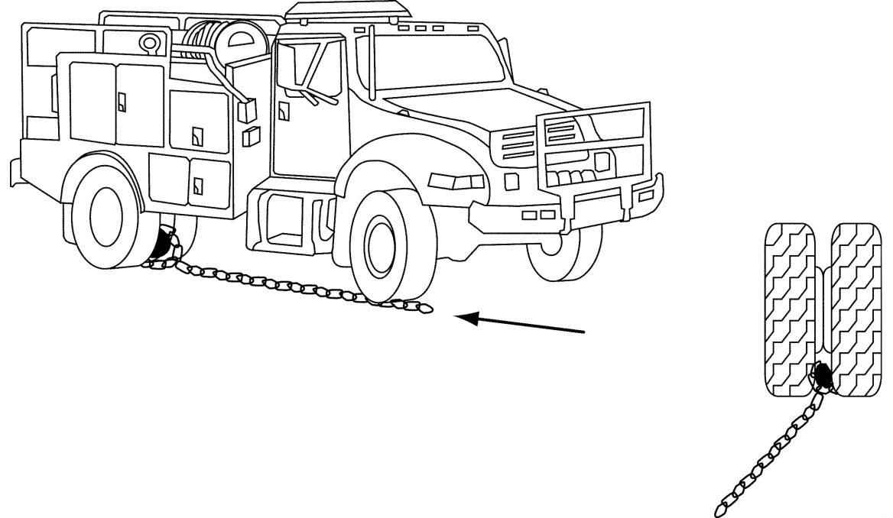

Evaluator/Facilitator Information
- Assign one engine captain-qualified instructor to the station. The instructor/evaluator should have knowledge and experience in field repair of tires and field removal of rocks between the duals.
- This exercise will be performed as a group exercise. Each module will perform the exercise and all module members will participate.
- Brief students on the exercise objectives and evaluation criteria.
- The instructor/evaluator will have the module remove and then properly place a tire back on the engine.
- The instructor/evaluator will also lead a group discussion on vehicle recovery using dozers, tow trucks, other engines and lowboys.
- After the modules have all completed the exercises, conduct a post-exercise debriefing.
- Sign off on the “Engine Operator Training Evaluation” forms, as appropriate. Instructors will evaluate student performance of numbered tasks 15 and 26.
Allow time for engine refurbishment.

Discussion Points
- Towing of disabled vehicle with front axle elevated and rear axle on the ground:
  - Relay the disabled vehicle’s GVW to the dispatch/recovery company.
  - Vehicle needs to be relocated to an area accessible by the tow truck.
  - Water tank must be emptied away from the vehicle.
  - Rear drive line needs to be disconnected from differential and transfer case.
  - In case of a broken axle, the axle needs to be pulled from the hub.
  - Air brakes need to be released. Most tow trucks will plumb the air brakes into the tow truck.
  - Front axle needs to be secured to tow truck.
- Towing of disabled vehicle with no axles on the ground (lowboy operation):
  - Relay the disabled vehicle’s GVW to the dispatch/recovery company.
  - Vehicle needs to be relocated to an area accessible by the tow truck.
  - Water tank must be emptied away from the vehicle.
  - Vehicle needs to be secured to lowboy or tow truck.
The module will remove a rock between the duals using the chain method in the field.

Evaluation Criteria
- The module will remove a tire from the fire engine according to the truck owner’s manual on tire changing.
  - Engine turned off.
  - Pump package turned off.
  - Flat and planed surface for the hydraulic jack.
  - Lug nuts loosened before truck is jacked up.
  - Fire apparatus tires are chocked.
  - Ensure the jack is properly placed. (Refer to the vehicle owner’s manual.)
- The module will put the tire back on the fire engine according to the vehicle owner’s manual on tire changing.

- The module will have all the necessary equipment to change a tire.
  - Proper tonnage weight hydraulic jack
  - Cribbing material
  - Tire iron and wrench
  - Air impact wrench
  - Torque wrench
- The module will discuss safety concerns when changing a tire.
  - Tires are heavy and need to be lifted correctly.
  - Cribbing material and jack can slip.
  - Uneven ground can cause jack to tip.
  - Never work under a vehicle when the tire is off.
  - Lug nut torque specifications
- The module will discuss proper procedures for recovering a disabled vehicle.
  - Attachment point on both vehicles should be a secure spot recommended by the manufacturer.
  - Ensure the chain/cable will not potentially damage any parts.
  - Parking and air brake needs to be released.
  - Water tank must be emptied away from the vehicle.
  - Recovery vehicle needs to be on firm ground.
  - Recovery vehicle needs to be in four-wheel drive.
  - Slack in chain/cable needs to be taken up before attempting recovery.
  - After recovery, check for vehicle damage on both vehicles.
The module will discuss proper procedures for preparing a vehicle for towing.

area 2 – Day One
station 5 – SIMPLE Progressive HOSE LAY

Exercise Intent
The intent of the simple progressive hose lay station is to introduce students to the use of hose lays and fittings to perform pumping operations from an engine.

Personnel/Materials/Equipment
- At least one ENOP-qualified instructor/evaluator
- One engine per module
- Hose packs
- Flagging for fireline, etc.
- Full PPE
- Additional hose for replacement of broken hose on engines
- Prepared briefing (prepared by the instructor/evaluator)
- Clipboard and pen for each evaluator

“Engine Operator Training Evaluation” forms

Time Allotment
Allow 30 minutes per engine module.

Station Setup
Identify an assembly point area that is a short distance from the simulated fireline.
Flag the exercise area from start to finish.
Create a target (flag or smoke) that students will hit with water that flows through the hose lay.

Evaluator/Facilitator Information
- Assign one ENOP-qualified instructor to the station.
- This exercise will be performed in module configurations.
- Select one ENOP for each module.
- Brief students on the exercise objectives and evaluation criteria.
- Encourage modules to use hose packs.
- Allow the module five minutes to conduct an inter-crew briefing before the exercise begins.
- After the module has completed the exercise, conduct a post-exercise debriefing.
  - Were the methods used safe, effective, and efficient?
  - What could have been done better? (student point of view)
- Sign off on the “Engine Operator Training Evaluation” forms, as appropriate. Instructors will evaluate student performance of numbered tasks 17, 18, 19, 20, 22, 23, and 24.
Allow time for engine refurbishment.

Evaluation Criteria for the Simple Mobile Attack Station
- The ENOP will safely deploy engine personnel on the fireline in a timely manner.
  - All module personnel will have knowledge of their assignments.
- The ENOP will properly position the engine to allow time to organize personnel and hoses, start the pump, and activate the foam system.
- Module members will demonstrate the proper procedures for setting up a charged simple progressive hose lay (carrying water with you as you go) using 300 feet or more of 1½” trunk, 100 feet of 1” lateral, gated wyes, reducers, and a nozzle in a timely but safe manner.
  - Module members will use the correct fittings during the exercise.
  - Module members must understand the use of booster lines during hose lay operations.
  - The ENOP will select the appropriate pressure to supply water to the hose lay.
- The ENOP will maintain communications with the crew.
  - Verbally (radio or face-to-face) or through water use hand signals.
- Module members will demonstrate team work and organization during the exercise.
Module members will demonstrate knowledge and documentation of engine NUS at the exercise’s conclusion.

area 2 – Day One
Station 6 – foam equipment

Exercise Intent
The intent of the foam equipment station is to introduce students to the use and maintenance of various types of foam equipment that will be used on wildland or prescribed fires.

Personnel/Materials/Equipment
- At least one instructor/evaluator with a good understanding of foam equipment
- One engine with complete NUS (refer to the NFEP website)
- Foam concentrate
- Bucket
- Foam proportioner—engine mounted or portable
- Various aspirated nozzles used in the geographical area
- Full PPE
- Clipboard and pen for each evaluator

“Engine Operator Training Evaluation” forms

Time Allotment
Allow 30 minutes per engine module.

Evaluator/Facilitator Information
- Assign at least one knowledgeable instructor to the station.
- Brief students on the exercise objectives and evaluation criteria.
- Demonstrate the proper start-up and shut-down procedures for the proportioner.
- Demonstrate the proper way to flush the proportioner and refill pump.
- Demonstrate the proper way to refill the proportioner with foam concentrate.
- Demonstrate the various aspirated nozzles used in their geographical area.
- Discuss with students the pros and cons of various aspirated nozzles used in their geographical area.
- Discuss winterization.
- After the demonstrations on the proportioner and the discussion about various aspirated nozzles, have students perform the various procedures on their specific proportioner.
- After all modules have completed the exercise, conduct a post-exercise debriefing.
  - Were the methods used effective and efficient?
  - What could have been done better (student point of view)?
Sign off on the “Engine Operator Training Evaluation” forms, as appropriate. Instructors will evaluate student performance of numbered tasks 22 and 23.

Evaluation Criteria for the Foam Equipment Station
- The student will safely and efficiently use foam equipment.
- The student will properly start up and shut down the foam proportioner.
- The student will properly flush the proportioner and refill pump.
The student will properly refill the proportioner with foam concentrate.
area 2 – Day two
Overview

Stations
- Station 1 – Complex Mobile Attack (multiple engines)
Station 2 – Complex Hose Lay (multiple engines)

Time Allotment
Activity | Allotted time
Pre-exercise briefing for each station | 10 minutes
Actual time per rotation | 1 hour 30 minutes
Spacing between drivers | Minimal
Accumulated station running time after Rotation 1 | 2 hours
Refurbish engines between rotations | 15 minutes
After Action Review | 15-20 minutes
Total time for both stations | 4 hours

Time Fillers
Employ the use of time fillers as needed when module members complete stations before the allotted times.
- Attempts should be made to avoid repetition of time fillers at the various stations.
- In order to maintain the time schedule, students should drop out of time fillers when it is their time to perform a station activity.
Each evaluator should have reviewed the time fillers before the field exercises. Some of these require certain supplies or props to run the time filler exercises.
Time does not include driving to and from the field exercise site.

Station Rotation

Day Two – Strike Team A
Time | Engines 1, 2, & 3 | Engine 4, 5, & 6
0800 - 0805 | Pre-Exercise Briefing | Pre-Exercise Briefing
0805 - 0935 | Station 1 | Station 2
0930 - 0950 | After Action Review | After Action Review
0950 - 1120 | Station 2 | Station 1
1130 - 1145 | After Action Review | After Action Review

Day Two – Strike Team B
Time | Engines 7, 8, & 9 | Engine 10, 11, & 12
1300 - 1305 | Pre-Exercise Briefing | Pre-Exercise Briefing
1305 - 1435 | Station 1 | Station 2
1435 - 1450 | After Action Review | After Action Review
1450 - 1620 | Station 2 | Station 1
1630 - 1645 | After Action Review | After Action Review

area 2 – Day Two
Station 1 – Complex Mobile Attack

Exercise Intent
The intent of the complex mobile attack station is to introduce students to a complex mobile attack situation in which they will have to make decisions regarding how to deploy their engine with other engines during initial attack, encountering break outs, spot fires, spotter use, blacklining, engine breakdowns, etc.

Personnel/Materials/Equipment
- One Engine Captain-qualified instructor/evaluator
- Two instructors/evaluators to work with the Engine Captain
- Engines with complete NUS
- Tactical frequency (i.e., not one that is being used already) for communication between the ENOP and the evaluator
- Programmable radio
- Full PPE
- Well-defined site location
- Flagging
- Prepared briefing (prepared by the instructor/evaluator)
- Clipboard and pen for each evaluator

“Engine Operator Training Evaluation” forms

Time Allotment
- Allow 1½ hours.

Station Setup and Discussion Points
Conduct complex mobile attack station in module formation with one evaluator for the station; utilize additional cadre members as needed.
Modules will work in cooperation with one another.
Encourage module members to work on and become familiar with another module’s engine.
As the module deploys and starts the mobile attack, the instructor/evaluator needs to throw various problems at the module.
Identify an assembly point area that is a short distance from the simulated fireline.
Flag the exercise area from start to finish.
The area chosen for this exercise needs to have varying terrain features.

Evaluator/Facilitator Information
- Assign one engine captain-qualified instructor to the station.
- Assign two instructors/evaluators to work with the engine captain.
  - The instructors/evaluators should have knowledge and experience in role playing situations.
- Select one ENOP for each module.
- This exercise will be performed in module configurations. Each module will perform the exercise and all module members will participate.
- Brief students on the exercise objectives and evaluation criteria.
- This is not a timed event. The evaluator is looking at how the module reacts to various inputs.
- Give about 10 minutes of time for the group of modules to talk about how they want to run this exercise.
- All personnel should be inside the engine when the exercise starts.
- At the fireline, the modules will deploy for mobile attack.
- The modules will then start a direct and/or indirect mobile attack with water/foam, heading along simulated fireline to the end.
- During the exercise the evaluator will call out different situations such as breakouts, spot fires, wind shifts, engine entrapment, hazards (sink holes, rocks, etc.), established escape routes, and safety zones to the module. (See input prompts on the next page for more details.) The modules need to react to these inputs in a timely manner. See the evaluation criteria below.
- Designate a site away from the fireline as a water source so an input can be made about refill operations.
- Designate a site away from the fireline as a fueling area so an input can be made about a refueling operation.
- Evaluators should use handheld radios to communicate these problems/situations to the module, role playing the part of Incident Commander/division group supervisor/strike team leader, etc.
- After all modules have completed the exercise, conduct a post-exercise debriefing.
  - Were the methods used effective and efficient?
  - What could have been done better (student point of view)?
- Sign off on the “Engine Operator Training Evaluation” forms, as appropriate. Instructors will evaluate student performance of numbered tasks 11, 12, 13, 16, 20, 22, 23, and 24.
Allow time for engine refurbishment.

Evaluation Criteria for the Complex Mobile Attack Station
- The ENOP will safely deploy engine personnel on the fireline in a timely manner.
  - All module personnel will have knowledge of their assignments.
- The ENOP will properly position the engine to allow time to organize personnel and hoses and start the pump before the “fire” overtakes the engine.
- The ENOP will maintain communications with the crew and supervisor/instructor.
  - Verbally (radio or face-to-face) or through water use hand signals.
- How well does the module react to simulated situations?
  - Utilizes the “black” as a safe approach.
  - Communicates situations with module members.
  - Was safety compromised (e.g., turning into the head of a break out, spotters not being used for backing)?

Input Prompts
These prompts are just a few that the instructors can use during this exercise. However, the instructor can and should come up with his/her own. The module actions are not necessarily the correct questions, but they give the instructor an idea of what the modules should be thinking about during the exercise.
Starting the Attack
- Time: N/A
- Module Actions:
  - Did they communicate that they were beginning the attack?
  - Did they have their pump running before they entered the fire zone?
  - Did they anchor their line in?
  - Did they talk about the origin of the fire?

Flat Tire on Engine
- Time: 5 minutes actual time out of engine to fix tire
- Module Actions:
  - Whom do they communicate with?
  - What do they tell the various parties?
  - What is the modules plan of action?
  - Has the module identified escape routes and safety zones?
Engine Runs Low on Fuel
- Time: Actual travel time to fuel truck; 2-minute actual timeout once they reach fuel truck; actual travel time back to assigned area.
- Module Actions:
  - Whom do they communicate with?
  - What do they tell the various parties?
  - Has the module identified escape routes and safety zones?
  - Does the module stay together and go and fuel up?
  - Does the module split up and the driver goes and fuels up while the other members stay and patrol the line they have put in?
Engine Runs Out of Water
- Time: Actual travel time to water tender; 2-minute actual timeout once they reach the water tender; actual travel time back to assigned area.
- Module Actions: Whom do they communicate with?
  - What do they tell the various parties?
  - Has the module identified escape routes and safety zones?
  - Does the module stay together to go refill the engine?
  - Does the module split up and the driver goes and to refill the engine while the other members stay and patrol the line they have put in?
Breakout Occurs Behind the Last Engine
- Time: Actual travel time to the breakout location
- Module Actions
  - Whom do they communicate with?
  - What do they tell the various parties?
  - How do they turn back to the break out?
  - Has the module identified escape routes and safety zones?
  - How does the module distribute their members to attack the break out?
Spot Fire
- Time: Actual travel time to the spot fire location
- Module Actions:
  - Whom do they communicate with?
  - What do they tell the various parties?
  - How do they approach the spot fire?
  - Does the module drive the engine to the spot fire?
  - Does the module use their booster line?
  - Has the module identified escape routes and safety zones?
  - How does the module distribute their members to attack the spot fire?
Indirect Line along Two-track Road
- Time: Actual travel time
- Module Actions:
  - Whom do they communicate with?
  - What do they tell the various parties?
  - How does the module tool up for this operation?
- The module(s) should have a capped firing device(s) in hand and simulate a burnout operation.
- How does the module distribute their members to support this operation?
- Does the module use their booster line?
- Has the module identified escape routes and safety zones?
Ranchers Inquire About the Status of Their Cattle on the Allotment
- Time: Actual time
- Module Actions:
  - Whom do they communicate with?
  - What do they tell the ranchers?
Engine Breaks Down and Wind Shifts Fire Towards the Engine
- Time: Actual time
- Module Actions:
  - Whom do they communicate with?
  - What do they tell the various parties?
  - Does the module work in a coordinated way?
  - How does the module tool up for this operation?
  - How does the module distribute their members to support this operation?
  - Does the module use their engine protection line?
  - Does the module simulate clearing vegetation around the engine?
Has the module identified escape routes and safety zones?
Many other inputs can be used to create a more challenging training experience. The instructor needs to be creative but not go overboard.

area 2 – Day two
Station 2 – COMPLEX HOSE LAY

Exercise Intent
The intent of the complex hose lay station is to introduce students to a complex pumping operation on a wildland fire using engines to draft water, refill other engines and pump a long, progressive hose lay. Students will utilize teamwork, the required skills and knowledge of fittings, and the principles of hydraulics during pumping and hose deployment operations.

Personnel/Materials/Equipment
- One engine captain-qualified instructor/evaluator
- Two instructors/evaluators to work with the engine captain-qualified instructor/evaluator
- At least three engines with full complement NUS—Engines 2 and 3 should be ¼ full of water
- Printed engine NUS so equipment can be returned to proper engines after the exercise
- Flagging
- 10 each – lengths of 1½” hose
- 6 each – lengths of 1” hose
- Static water supply (portable tank with water)
- Full PPE
- Friction loss calculators and the Principles of Hydraulics – “Rule of 5s” guide
- Knife
- Instructor-prepared friction loss calculation for the exercise
- Instructor-prepared briefing
- Clipboards and pens for each evaluator

“Engine Operator Training Evaluation” forms

Time Allotment
Allow 1½ hours to complete the station.

Station Setup and Facilitation information
Station Setup
Identify an assembly point area that is a short distance from the simulated fireline.
Flag the exercise area from start to finish.
Create a target (flag or smoke) that students will hit with water that flows through the hose lay.
Identify a spot for a static water supply (portable tank with water tender).
Facilitation Information
Conduct complex hose lay station in module configuration with one evaluator for the station; utilize additional cadre members as needed.
Modules will work in cooperation with one another.

Evaluator/Facilitator Information
- Assign one engine captain-qualified instructor/evaluator
- Assign two instructors to work with the engine captain.
- Prior to the beginning of the field exercises, the three instructors need to prepare a friction loss calculation for the exercise area using the Principles of Hydraulics – “Rule of 5s” guide. This calculation will be used as the answer sheet to check the student’s answers.
- This exercise will be performed in module configuration with three modules working together in a group (this number will change depending on group size).
Brief students on the exercise objectives and evaluation criteria.

Friction Loss Calculation Exercise
- The group will complete a friction loss calculation using the Principles of Hydraulics – “Rules of Thumb” on the area where the hose lay will be.
- After the group has finished the friction loss calculation, the instructors will check for completeness. The instructors will work with the group to make sure everyone has a firm grasp of this skill.
Calculations between the students will differ by variations in estimation of distance and elevation. The instructors should put emphasis on correct calculations, not on correct estimations of distance and elevation.

Complex Hose Lay
- The instructors will need to assign Engines 1, 2, and 3 to specific locations in the station area. One engine should be at a water source where it can draft water. This engine will pump water (refill) to the other two engines. These two engines will pump water to the hose lay that the module member group is building. If there are more than three engines, the instructors need to find places for these engines. An engine may shuttle water to the draft site or another engine may use its booster line to directly support the hose lay being put in.
- This is not a timed exercise, but all personnel will drive up to the station in their engines and disembark IA-ready.
- The modules at this point will be given about 10 minutes to discuss how they want to plan out the operation and assign module members and engines to the various tasks needed for the plan to succeed. Students should also determine how they want to communicate and organize a chain of command.
- At the instructor’s direction, each module starts their assigned tasks.
- While the hose lay is being constructed, the instructors need to add realism to the drill by cutting the hose or simulating a broken hose by flagging a section of the hose. Inform students of a slopover near one of the laterals. Kick open a gated wye in the trunk line. Pull a module member out of the process to do a recon for the IC, etc.
- To add additional complexity to this exercise, instructors may wish to incorporate pumping operation scenarios to this station.
  - Utilize engines in series and/or parallel pumping.
  - Shift emphasis to pumping operations. (Trainees need to see the effects of different pump valve setups—pressure drops, pressure gains—during stage, parallel, and series pumping operations, matching pump performance during parallel pumping, communicating with other pump operators, and adapting to various firefighting situations.)
  - To accomplish these pumping operation scenarios, consider removing/adding an engine(s) from the hose lay operation.
- After the modules have all completed the exercise, conduct a post-exercise debriefing.
  - Were the methods used effective and efficient?
  - What could have been done better? (student point of view)
- Sign off on the “Engine Operator Training Evaluation” forms, as appropriate. Instructors will evaluate student performance of numbered tasks 11, 16, 18, 19, 20, 21, 22, 23, 24, and 25.
- Allow time for engine refurbishment.

Evaluation Criteria for the Complex Mobile Attack Station
- ENOPs will safely deploy engine personnel on the fireline in a timely manner.
  - All module personnel will have knowledge of their assignments.
- Module members will demonstrate team work and organization during the exercise.
- All ENOPs will properly position the engines to allow time to organize personnel and hoses, start the pump, and activate the foam system on the engine.
- ENOPs will maintain communications with the crew and supervisor/instructor.
- Verbally (radio or face-to-face) or through water use hand signals.
- Students will respond to various inputs (broken hose, slopover, open gated wye, etc.) in a timely, efficient manner.
- Module members will document their engine NUS throughout the exercise since hose and fittings from all engines will be used.
- Modules will be evaluated on how they react to the simulated inputs.

Hose Lay Specifications

Engine 1
- Module members will select the proper engine pressure to sufficiently supply Engines 2 and 3 with water and also draft water from a static source.
- Module members will use the correct fittings during the exercise.
- Module members will set the correct valve configuration to provide water directly from draft, bypassing the tank, and supplying water to Engines 2 and 3 by top refill.
Module members will lay out the supply lines (1½” hose) from Engine 1 to Engines 2 and 3.

Engines 2 and 3
- Engine 2 and 3 module members will start the exercise with ¼ tank of water to effectively incorporate Engine 1 into the exercise.
- Module members will apply the correct pressures (friction loss calculations).
- Module members will use the correct fittings during the exercise.
- Module members will pump water into a 200’ of 1½” parallel hose lay to a Siamese fitting.
Module members will construct additional hose lay. The length is sight-dependent; but it is recommended that at least 1,000’ of 1½” trunk line be used, with 1” laterals every 100’ after the Siamese fitting.

Time filler #1 – fire shelter deployment

Type of Activity
- Performance

Materials/Equipment
- Practice fire shelters
- PPE (gloves, line gear, practice fire shelter, hard hat, etc.)
- Hand tools
- Timer/stop watch
Handheld radio

Evaluator/Facilitator Information
- Present the scenario and task to students.
- Time the students as they perform this task.
Discuss with students what could have been done differently during the deployment.

Scenario
You have become entrapped by a fire and must deploy your fire shelters. The direction of fire spread is ________________.

Task
Pretend this is an actual deployment. Properly place your fireline gear, prepare the ground, set up and use your practice fire shelter, and communicate with module members and fireline supervisor while in your shelters. You will be timed on the whole process.
Time filler #2 – Map reading

Type of Activity
- Performance

Material/Equipment
- 3 or 4 topographic maps (1:24,000) of the exercise area
- Tape measure or chain
Optional: Avenza Maps®, Collector for ArcGIS, or other commonly used map applications

Evaluator/Facilitator Information
- Prepare answers to Tasks 1, 2, 3, and 5 prior to the facilitating the exercise.
- Be able to calculate chains and measure a firefighter’s pace.
Present the tasks to students.

Tasks
Task 1: Identify features around the exercise area and have the students locate them on their maps.
Task 2: Identify features on their maps and have the students locate them around the exercise area.
Task 3: Select several points on the map and have students determine each point’s legal description.
Task 4: Have students line up at a starting point. Have students pace off one chain of line (66 feet) and mark their ending points. After all students have marked their ending points, measure a distance of 66 feet using a tape measure to see which student is closest to the 66 feet or 1 chain.
Task 5: Draw a mock fire perimeter on the map and have students determine potential access for the fire. Ask students
- Is the fire is accessible for mobile attack?
- What is the potential for hoselay construction?
- Can a handcrew hike in?
- What is the potential for a crew shuttle?
time filler #3 – Parking Vehicles near the Fire

Type of Activity
- Discussion

Material/Equipment
- None

Evaluator/Facilitator Information
- Present the scenario to students.
- Facilitate discussion.
As time permits, reflect on real-life events or past assignment to add “what-ifs” to the situation.

Scenario
You are on a fire with your engine, support vehicle, and crew. You have been told to have your crew tooled and fireline ready. The group will walk the black line that leads off a two-track dirt road and meet the IC to receive his/her briefing. This section of line is already too congested to bring in your engine and support vehicle.
Your mission will be to provide manpower for two heavy engines already on the line. You have good radio communications with personnel on the fireline.

Discussion
Before your crew sets off on foot to meet the IC, what should the ENOP and other driver do with their vehicles? Answers may include:
- Park vehicles in the black off the two-track road.
- Water down hot areas that could impact the tires.
- Park vehicles so that they have good egress and ingress.
- Roll up vehicle windows.
- Unlock vehicles and leave keys so others can move vehicles if need be.
- Implement LCES, if not already done.
Notify the IC that the group is moving up the line.
time filler #4 – Parking Vehicles and Structure Protection

Type of Activity
Discussion

Material/Equipment
None

Evaluator/Facilitator Information
- Present the scenario to students.
- Ensure every student thoroughly understands how to properly triage a structure. Discuss the criteria needed to categorize the structure appropriately and potentially utilize photos to facilitate discussion. Utilize the IRPG or the Wildland Fire Incident Management Field Guide (PMS 210) as reference guides. Also, consider combining this exercise with Time Filler #14 – Structure Triage and Assessment on page 96, if time permits.
As time permits, reflect on real-life events or past assignments to add “what-ifs” to the situation.

Scenario
The IC has determined that a pole barn up a congested two-track road may be threatened by the fire. He informs the engine captain to go and stand by at the pole barn. The engine captain informs the ENOP to set up the engine for structure protection while he takes the support vehicle to recon the area.

Discussion Question
What should the ENOP to do to set up for structure protection?
Answers may include:
- Back the engine into the area of the pole barn.
- Implement LCES.
- Determine defensible space and safety zones at pole barn site.
- Develop a plan of action for the module to secure the pole barn site.
- Deploy 100 or 150 feet of 1½-inch line with 1½-inch nozzle off the rear discharge port of the engine.
- Ready the booster line to support a burn out operation around pole barn site.
- Prepare area around barn site for burn out operations if necessary or time permits.
- Begin structure assessment documentation – address, lat/long, structure type, number of structures, triage category, hazards, accessibility, estimated mitigation time, resources needed, photos, etc.
- Inform the engine captain of your accomplishments and what remains to be done.
time filler #5 – Fire Sizeup

Type of Activity
Discussion

Material/Equipment
None

Evaluator/Facilitator Information
- Present each scenario to students.
As time permits, reflect on real-life events or past assignments to add “what-ifs” to the situation.

Scenario
You have been dispatched to a fire. En route to the incident you travel from the fire yard via a highway that passes through a small town. Forty five miles outside the town, you turn left off the highway onto a dirt road and drive another 25 miles. At this point you are able to see the smoke column off to the left. There has been no lightning in the last five days.

Discussion Questions
Discussion Question 1: While en route to the fire what should the ENOP be considering/doing?
Answers may include:
- Obey all speed limits on the highway and in the town.
Note vehicles that they pass.
Discussion Question 2: While on the dirt road en route to the fire what should the ENOP be considering?
Answers may include:

- Vehicles that they pass
- Fuels and terrain
- Weather
- Smoke column
- Access routes
- Road conditions
- Bridges
- Potential water sources
Public safety concerns

Discussion Question 3: Upon arrival at the fire what information is the ENOP relaying to dispatch for a fire sizeup?
Refer to the IRPG:

- Incident name
- Incident Commander
- Incident type
- Incident status
- Legal description
- Jurisdiction
- Radio frequencies
- Incident size
- Fuel type
- Wind speed and direction
- Slope and aspect
- Spread potential
- Flame lengths
- Best access
- Special hazards or concerns
Additional resource needs

After doing the sizeup and passing the information to dispatch, what would be some of your next steps in managing this fire?
Answers may include:
- Implement LCES, if not already done.
- Implement the risk management process.
- Determine organization and command structure.
- Determine location and type of line.
- Determine how (plan) to attack the fire (direct, parallel, indirect attack).
- Protect point of origin if known.
- Determine if additional help is needed.
- Suggest calling in an arson investigator (five days is a long time for holdovers).
Brief module on the plan of action.

time filler #6 – After Action Review (AAR)

Type of Activity
Performance

Material/Equipment
- Incident Response Pocket Guide (IRPG)
- “Unit Log” (ICS 214), one per student
Pen or pencil

Evaluator/Facilitator Information
- The evaluator/facilitator will lead the AAR.
- Assign one of the students to act as the AAR scribe to capture student thoughts on “Unit Logs.”
- Notify students that respectful disagreement is acceptable.
- Keep students focused on the “what,” not the “whom.”
- Ensure that everyone participates.
- End the AAR on a positive note.
- Possible outcomes:
  - Allows students to conduct an AAR in a controlled environment
  - Provides ENOP cadre feedback on how the field exercises are going
  - Provides feedback to the ENOP cadre on how to improve a station for next course
  - Provides ENOP cadre fixes to problems that they may not see
Optional variation – Utilize the PLOWS (Plan, Leadership, Obstacles, Weaknesses, and Strengths) acronym in place of the IRPG AAR format to conduct the AAR.

Task
Following the AAR process in the IRPG, conduct an AAR of one of the field stations. Focus on the following questions:
- What was planned?
- What actually happened?
- Why did it happen?
What can we do next time? (Correct weaknesses/sustain strengths)

time filler #7 – Noxious Weeds

Type of Activity:
Performance and discussion

Material/Equipment:
- “Unit Log” (ICS 214), one per group
- Pen or pencil
Local noxious weed identification guide, one per group

Evaluator/Facilitator Information:
- The evaluator/facilitator for this topic session must know and be able to identify noxious weed species in the exercise area.
- Break students into small groups.
- Facilitate an open discussion on how the engine module can mitigate the spread of weeds. Some topics for discussion include:
  - “How” and “whys” of engine washing and cleaning.
  - Local weed reporting process.

Task
Using a weed identification guide for the local area, locate five weed species in the field exercise area. Document the weed on a piece of paper and show the evaluator/facilitator the weed’s location.

Discussion Question
How can the engine module mitigate the spread of weeds?
- Clean and washing the engine.
- Mark weed-cleaning areas.
- Camp in weed-free areas.
- Clean gear and clothing.
- Report weed-infested areas.
time filler #8 – Spot Request

Type of Activity
Performance and discussion

Materials/Equipment
- Topographic map (1:24,000) of the exercise area
- 2 or 3 belt weather kits
- “Spot Request” (WS Form D-1), one per group
Pen or pencil

Evaluator/Facilitator Information
- The facilitator must understand the “Spot Request” process.
- Form students into small groups.
- Facilitate a group discussion. Topics may include:
  - “Spot Request” submission methods to the National Weather Service (NWS) and local procedures
  - “Spot Request” trigger points
  - Stress the importance of submitting field weather observations to the NWS, so they can have inputs to compare the “Spot Forecast” they provided and make adjustments as needed.

Task
Prepare a “Spot Request” for the field exercise area.

Discussion Questions
Question 1: What are the methods for submitting a “Spot Request”?
Internet, hardcopy, or phone
Question 2: What are your local “Spot Request” standard operating procedures?
For example, the ENOP collects the information; the local dispatch center submits to NWS.
Question 3: How does the NWS get the information back to the ENOP?
For example, the NWS develops a spot forecast and sends it back to the local dispatch center. The center then relays this information to the ENOP.
Question 4: Under what conditions should you ask for a “Spot Request”?
- Fire has potential for active fire behavior or may exceed initial attack.
Fire is located in areas where Red Flag Warnings have been issued.

time filler #9 –Vehicle Damage
En route to and on a fire

Type of Activity
Discussion

Materials/Equipment
- Consult the National Operations Center – Fleet Management website (https://blmspace.blm.doi.net/oc/sites/property/operations/Pages/Fleet.aspx) for guidance.
- “Unit Log” (ICS 214), one per group
Pencil or pen

Evaluator/Facilitator Information
- The facilitator must understand Working Capital Fund (WCF) charges, vehicle/purchase credit card procedures, and the S-number requests for fire procurement.
- Facilitate a group discussion. In addition to the discussion questions below, topics may include:
  - Exceptions to the rules and extenuating circumstances can come into play.
  - Contact the Fleet Manager when you are in doubt about repair costs.
  - Expenditure of funds for driving accidents.
- These examples show typical solutions. “What-if” discussions may arise during the discussion; avoid too many deviations.
If time permits, add your own real-life events or past assignments as “what-ifs.” Time Filler #11 – Incident Replacement Procedures on page 91 can be used in conjunction or as a reference.

Scenario 1
While en route to a fire outside Burns, Oregon, your engine blows a tire. The crew changes the tire and proceeds to the fire.
Discussion Question: Who is responsible (fire or home unit) for the cost of a new tire?
- The home unit is responsible for paying for the new tire. The crew should use the fleet card for payment on the new tire and it should be charged to WCF. Keep in mind the condition and model of tire that is purchased to replace the old tire. If the current tires have minimal wear and are the same model, it might be feasible to purchase the one tire but on most occasions two or more tires will need to be replaced. (Refer to G-1520-3 Fleet Management Guide)

Scenario 2
While en route to a fire outside Cedar City, Utah, your engine’s transmission fails. You are towed 20 miles to Cedar City to have repairs made.
Discussion Question: Who is responsible (fire or home unit) for the cost of towing and transmission repair?
- The home unit is responsible for paying for the towing and transmission repair.
- The crew should use the fleet card assigned to that vehicle and coded to the WCF fund on their reconciliation.

Scenario 3
You are performing fire suppression activities on a Type 2 fire on the Grand Junction Field Unit. A stob punctures the side wall of a tire on your engine. The crew changes the tire and continues with suppression activities.
Discussion Question: With whom should you interface when you return to camp? Who is responsible for the cost of a new tire?
- Inform your fireline supervisor and upon return to camp interface with the Ground Support and Supply Unit Leaders. Ground Support may have a tire service account set up; if not, the Supply Unit should give you an S-number for tire replacement when you get back to your home unit. This incident should be written up in a “Unit Log.”
- The fire is responsible for paying for the replacement of the tire. This is not a WCF fund issue.

Scenario 4
You are performing fire suppression activities on a Type 1 fire in Montana. While supporting a burnout operation on a dozer line, a large rock partially tears off your engine’s rear bumper. The engine is still drivable and all lights work.
Discussion Question: With whom should you interface? Who is responsible for the cost of the repair?
- Inform your fireline supervisor.
- Upon return to camp, interface with the Ground Support Unit Leader and the Finance Section. The Finance Section will have the ENOP fill out a “Claim for Damage, Injury, or Death” (SF-95).
- Obtain an S-number from the Supply Unit for bumper repair.
- The supervisor will complete the accident report on SMIS.
- The fire is responsible for paying for the repair of the bumper. This is not a WCF fund issue.

Scenario 5
During the last few fires, your engine’s air conditioner has not been cooling properly. While supporting fire suppression operations on a Type 2 fire in Nevada, the air conditioner stops working.
Discussion Question: What should the ENOP do? Who is responsible for the expense?
- Continue using the engine for fire operations.
- Report the malfunction to your fireline supervisor. Notify Ground Support Unit to see if there is a mechanic on the incident. It could potentially be a field repair situation. If it cannot be repaired in the field, ensure the air conditioner gets fixed at a repair shop after demobilization.
The home unit is responsible for this normal wear and tear expense—a WFC item. Advise the Fleet Manager when the cost of the repair exceeds the $2,500 purchase card threshold. No S-number will be issued for this repair.

time filler #10 – Maps/GPS
Coordinate Location/Area Calculation

Type of Activity
Performance

Materials/Equipment
- 2 or 3 GPS units
- 2 or 3 compasses
- 2 or 3 topographic maps (1:24,000) of the exercise area
- Flagging
Optional – Use device applications for comparison (e.g., Avenza Maps®, Collector for ArcGIS, etc.)

Evaluator/Facilitator Information
- The evaluator/facilitator must understand the use of GPS units and compasses.
- Prior to facilitating or during task introduction:
  - Task 1: Sketch a fire perimeter on a map of the exercise area.
  - Task 2: Mark/Identify a simulated fire area on the ground using flagging, roads, fence line, etc. Know the approximate size of this simulated fire.
  - Task 3: Mark/Identify simulated drop points, water sources, and structures near the simulated fire.
  - Task 4: Choose a location for a simulated smoke column and convey location to students.
  - Task 5: Determine and relay to students the GPS coordinates for a spot in the exercise area.

Tasks
Task 1: Using a topographic map, its associated features, and a simulated fire perimeter, calculate the approximate fire size.
Task 2: Walk the perimeter of the simulated fire with your GPS unit. Calculate the approximate fire size.
Task 3: Determine the location of a simulated drop point(s), water source(s) and/or structures near the fire.
Task 4: Identify the approximate legal location of a simulated smoke column. Hint: Take an azimuth reading with a compass using a known point (intersection, landmark, etc.) relative to the smoke as a guide. Plot the azimuth line on a topographic map.
Task 5: Enter coordinates obtained from the evaluator/facilitator into your GPS unit. Using the coordinates and your GPS unit, walk to the correct spot.

time filler #11 – INCIDENT Replacement Procedures

Type of Activity
Discussion

Materials/Equipment
- NWCG Interagency Incident Business Management Handbook, Chapter 30 (Optional)
- “Property Loss and Damage” (OF-289)
- “General Message” (ICS 213)
- Optional – “Incident Replacement Requisition” (OF-315)
Optional – Interagency Standards for Fire and Fire Aviation Operations, Chapter 20

Evaluator/Facilitator Information
- The evaluator/facilitator must have read and understands the NWCG Interagency Incident Business Management Handbook, Chapter 30, which addresses government property/equipment damage/ replacement.
- The evaluator/facilitator must understand fire camp supply issues and the “Incident Replacement Requisition” (OF-315) form.
- Facilitate a group discussion. In addition to the discussion questions below, topics may include:
  - Exceptions to the rules and extenuating circumstances can come into play.
- These examples show typical solutions. “What-if” discussions may arise during the discussion; avoid too many tangents.
If time permits, add your own real-life events or past assignment as “what-ifs.”

Discussion Questions
Question 1: Why is it important to have an up-to-date normal unit stocking (NUS) inventory for your engine?
This documentation is used by the IMT or incident agency to determine items that were stocked on the engine prior to arriving at the incident when it comes time to replace equipment and supplies used on the incident. Should items become lost or damaged, this documentation will also be used to authorize legitimate replacement as a fire expense.
Question 2: What items should be listed on the NUS?
In addition to items listed on the NFEP website, ENOPs should record specialty or non-cache items that were originally procured with preparedness funds by the home unit. These items may include brand name tents, sleeping bags, IA packs, Kevlar pants, headlamps, goggles and GPS units.
Question 3: What form(s) are used to request replacement items? To whom should you submit this form(s)? Where will restocking/replacement occur?
- Type 1 and 2 incidents use the “Incident Replacement Requisition” (OF-315). Follow local agency SOPs for Type 3 and 4 incidents.
- The Supply Unit will be responsible for dealing with the ENOP; however, the ENOP may have to interface with their on the fireline supervisor and/or Ground Support Unit.
Generally speaking cache items will be replaced at the incident if available. Cache items that are not available at the incident may be authorized for restocking at the home unit. S-numbers from the incident will be assigned to items on the OF-315 that were not available at the incident cache. Specialty or non-cache items originally provided by the home unit through the use of preparedness funds will not be given S-numbers for replacement as stated in the NWCG Interagency Incident Business Management Handbook, Chapter 30. If specialty or non-cache government property is damaged on the incident due to a specific event (e.g., wind event damages tent), the incident may, upon receipt of required documentation and proof of damage, authorize replacement. Under this situation the Finance Section, Supply Unit, and ENOP will be involved.
Question 4: When a crew member loses his/her prescription eye glasses on a fire, who is responsible for the cost of replacement?
The crew member is responsible for the costs of replacing the eye glasses. The IMT or incident agency may use their resources to help the crew member get a new pair of eye glasses; however, government dollars will not be expended.
Question 5: A crewmember’s tent is damaged due to a wind event on a Type 4 fire. Fill out the proper documentation to replace the damaged tent.
- A property loss and damage form will need to be completed by the ENOP along with a general message requesting the tent to be replaced. The required forms will need to be approved and signed by fireline supervisor.

time filler #12 – Unit Log (ICS 214)

Type of Activity
Performance

Materials/Equipment
- “Unit Log” (ICS 214), one per student
Pen or pencils

Evaluator/Facilitator Information
- Use this exercise as a refresher for completing “Unit Logs.”
- Stress to students “Unit Logs” should be completed daily on fire assignments.
Collect the forms after students complete them.

Task
Complete a “Unit Log” for one of the field exercise station that you have finished.
- Box 1 – ENOP Field Exercise (where the class is being held)
- Box 2 – Date of field exercise
- Box 3 – Time of field exercise
- Box 4 – Field exercise station
- Box 5 – Evaluator/Facilitator running the station
- Box 6 – Day 1 or 2 of field exercise
- Box 7 – Names of students in the group
Box 8 – Notes on things that happened at the station

time filler #13 – Structure Triage and Assessment

Type of Activity
- Discussion

Materials/Equipment
- “Unit Log” (ICS 214), one per student
- Pens or pencils
- Optional – IRPG, pages 12 through 16
- Optional – Wildland Fire Suppression Tactics Reference Guide, pages 181 through 201

Evaluator/Facilitator Information
- The evaluator/facilitator for this topic session needs be familiar with structure triage and assessment practices.
- Facilitate a group discussion. In addition to the discussion questions below, topics may include:
  - “Wildland-Urban Watch Outs”
  - “Power Line Safety for Wildland Fires”
  - “Structure Assessment Checklist”
  - “Structure Protection Guidelines”

Discussion Questions
Question 1: Define structure triage.
The basic definition for structure triage is sorting and setting priorities for structures requiring protection from wildland fire.
Question 2: The goal of structure triage is to do the most good with what you have and not waste limited resources or time. What are four general categories of threatened structures?
- Prepare and hold
- Stand-alone
- Prepare and leave
Rescue drive-by
Question 3: Develop a list of factors that affect triage decisions.

- Firefighter safety
- Structure construction features
- Road access
- Surrounding fuels
- Fire behavior
Available resources

Question 4: Develop a list of considerations about the factors that affect triage decisions.
Firefighter Safety

- Safety zones or areas
- Escape routes
- Defensible space
- Power lines
- Smoke/visibility
- Hazardous materials
- LPG tanks and overhead fuel storage
- Irate or disgruntled home/land owners
Pets and livestock

Structures Construction Features

- Roof
- Siding
- Heat traps
Windows
- Size of building
- Shape of Building
Position on slope

Road Access

- Ingress/egress routes
- One way or two way
- One lane or two lane
- Turnouts
- Shoulders
- Paved, gravel, dirt, 4x4 only
- Slope and steepness of road
Bridges

Surrounding Fuels

- Size and arrangement
- Loading
- Age
- Proximity to structure
- Types
Landscaping

Fire Behavior

- Rate of spread and direction
- Topographic influences
- Weather influences
- Flame length
- Spotting
Natural or other barriers

Available resources
- Kind and type of equipment available
- Capabilities and limitations of equipment
Water sources

time filler #14 – Radios

Type of Activity
Discussion and performance

Materials/Equipment
- Handheld radios
- Optional – National Interagency Incident Communications Division website (https://nifc.gov/NIICD/index.html)
- Optional – Cloning cable and recommended handouts (cheat sheets) for programming

Evaluator/Facilitator Information
- The evaluator/facilitator for this topic session needs be familiar with handheld radios and issues related to programming, narrow banding and frequency management.
- Refer to the NIICD website (https://nifc.gov/NIICD/index.html) for more specific details on radio programming.
- Notify students they can download information about radios at the NIICD website.
- Facilitate a group discussion. In addition to the discussion questions below, topics may include:
  - Programming
  - Narrowband usage
  - Types of radios used in the field

Discussion Questions
Question 1: As professional firefighters we have the responsibility to understand the tools we use for communication: What must the ENOP do with radios to reach this responsibility?
- Establish reliable communications before entering the field.
- Know where to go to have your radio maintained.
- Know how to program your radio.
- Ensure that annual maintenance is performed on your radio.
- Know and understand frequencies. Simply getting a frequency is not enough.
Utilize proper radio etiquette—brevity, clarity, and common terminology.
Question 2: What are some tips to improve radio coverage for your handheld radio?
- Hold the radio vertical, with antenna straight up and not bent.
- Do not speak directly into the microphone; hold it off to the side about two inches. When you speak directly into the microphone, you hear wind noise from your breath.
- Hold it as high as possible.
Avoid obstacles between you and the person with whom you want to talk.

TaskS
Task 1: Using a couple of frequencies from the local area, have the student program these frequencies into their radios making sure there are no bandwidth mismatches.
Task 2: Once the required frequencies are programmed in have the students clone frequencies to another handheld or mobile radio

time filler #15 – Jump Starting Vehicles

Type of Activity
- Discussion

Materials/Equipment
- Fire Engine Maintenance Procedures and Record (FEMPR)

Evaluator/Facilitator Information
- Present the scenario to the students.
- Facilitate a group discussion.
Have students discuss the process of jump starting their vehicle that has a dead battery.

Scenario
While away from your vehicle the lights were left on. When you return, you find that the battery is dead and the engine will not start.

Discussion Questions
Question 1: What will be the process for jump starting the engine?
- Notify another engine to come to your location.
- Position the engines so that they can be jumped, taking into consideration the length of the jumper cables.
- Connect jumper cables in the proper sequence.
Perform the jumping operation to get the stranded engine back in service.
Question 2: What is the proper sequence for attaching the cables and starting the stranded engine?
- Refer to the FEMPR for this process.

ENGINE OPERATOR TRAINING EVALUATION
Date of Evaluation:
Engine Operator Student and Vehicle Information
Engine Operator Student Name:
Duty Station:
District:
Vehicle Type: TYPE 6 TYPE 4 TYPE 3
Evaluator Information
Evaluator’s Name (Printed) | Evaluator’s Initials
Lead Instructor Information
Lead Instructor’s Name:
Telephone Number:
Address:

The code ratings:
S = Satisfactory: Performance meets expectations.
NI = Needs Improvement: Element performance does not meet expectations.
NR = Not Reviewed: Element was not reviewed because it was determined to be inappropriate for the review objectives.
Code |  | Description | Initials | Remarks
 | 1. | Perform a pre-trip inspection on an engine and can correct deficient pre-trip items or make necessary adjustments or arrange for maintenance repairs as needed.
 | 2. | Conduct a thorough daily vehicle inspection and record the results in the Fire Engine Maintenance Procedure and Record.
 | 3. | Perform a proper start-up and shut-down procedure on an engine.
 | 4. | Complete a basic vehicle troubleshooting analysis that can include; fuel type and source problems, electrical problems and changing of fuses, battery and start-up problems, procedures for jump-starting, engine gauges, visual indicators of problems, and tire or wheel problems.
 | 5. | Complete necessary pump system preventative maintenance check and correct deficient items, fluid levels, or make necessary adjustments.
 | 6. | Complete a pump system troubleshooting analysis, which could include: nozzle/pump pressure loss, pump heat build-up, pump cavitation, pump/seal problems, and pump priming problems.
 | 7. | Perform a pump performance check and record the results.
 | 8. | Demonstrate proper winterization procedures for pump package.
 | 9. | Demonstrate basic knowledge of driving skills including: vehicle pre-trip equipment adjustments, general vehicle start-up procedures, move-out procedures for driving, use of vehicle controls, entering traffic/street maneuvering, vehicle speed control, vehicle parking and site selection, etc.
 | 10. | Demonstrate appropriate highway driving skills and knowledge of state vehicle driving regulations.
 | 11. | Demonstrate appropriate off-road driving skills and application of vehicle handling/maneuvering that could include: navigation along two-track road areas, navigation through rocky areas with use of spotter, maneuvering through washout and draw areas, maneuvering through heavy fuels/brush areas, side-hill maneuvers, and/or maneuvering through rough steep up/down slope areas.
 | 12. | Demonstrate the appropriate start-up procedure for an engine on a steep hill.
 | 13. | Demonstrate proper skills in backing down steep slopes.
 | 14. | Demonstrate appropriate highway night driving skills and application of state vehicle driving regulations.
 | 15. | Demonstrate proper method for changing a flat tire in the field.
 | 16. | Perform a mobile attack operation with two module members.
 | 17. | Demonstrate the proper procedures in setting up a charged progressive hose lay.
 | 18. | Remove and replace a defective hose during a pumping operation.
 | 19. | Demonstrate knowledge of various water handling fittings.
 | 20. | Demonstrate knowledge of valve configurations for various pumping and drafting operations.
 | 21. | Complete a water refill operation using the correct fittings.
 | 22. | Complete a flushing operation of the foam proportioner according to manufacturer’s procedures.
 | 23. | Demonstrate the proper procedures of starting up the foam proportioner and shutting it down.
 | 24. | Demonstrate the knowledge of pre-connected hose for IA of spot fires and vehicle protection.
 | 25. | Demonstrate the ability to perform effectively as an organized team during a complex hose lay, utilizing two or more engines for water delivery.
 | 26. | Demonstrate the proper procedures for disabled vehicle recovery and towing operation preparation.

