ENGINE OPERATOR (ENOP)

Student Pre-Course Work

The intent of this pre-course work is to test your knowledge of course prerequisites, agency policy, and the engine with which you will be working. As outlined in the course announcement, your understanding of the exercises is paramount to successful completion of ENOP training.

You should expect to spend approximately five (5) hours to complete the required reading and exercises in the pre-course work. You are encouraged to work independently to complete this package. Feel free to consult with a mentor or other resource at your area. However, you will be expected to demonstrate your knowledge of this material during the course.

When completing the pre-course work, use the spaces provided for your answers. **Be sure to show all your work for the exercises.**

Use current reference materials when completing the pre-course work. The following documents may be helpful:

* *Fire Equipment Maintenance Procedure and Record* (FEMPR) for your engine. (<http://web.blm.gov/internal/fire/fire_ops/nfep_fempr.htm>)
* *BLM Engine Operator Position Task Book* (<https://www.nwcg.gov/publications/agency-taskbooks>)
* *Interagency Standards for Fire and Fire Aviation Operations* (https://www.nifc.gov/policies/pol_ref_redbook.html)
* *Incident Response Pocket Guide* (<https://www.nwcg.gov/publications/461>)

***Return the completed pre-course work to the course coordinator by the due date. See the course acceptance letter for submission instructions.***

Make note of any questions or problems you experienced while completing the pre-course work; bring your notes to class. Your corrected pre-course work will be returned to you during the course.

**Bring the following items to class:**

* *Fire Engine Maintenance Procedure and Record* (FEMPR) **with the Vehicle Data, Pump Package Data, and Fire Engine Weights sections completed for your engine**
* Manufacturer’s maintenance manuals for the engine and pump package you are bringing to the course or will be working on
* *Interagency Standards for Fire and Fire Aviation Operations* (Redbook)
* *Incident Response Pocket Guide* (IRPG)
* BLM Engine Operator Position Task Book (if available and for reference only)
* Fire Equipment Fire Stream/Friction Loss Calculator

ENOP Student Pre-Course Work

**Student Name _______________________ District _______________________________**

1. Do you have a commercial driver’s license (CDL) or training permit?

____ Yes (CDL) ____ Yes (training permit) ____ No

2. What type of engine will you be assigned to this season?

Type 3 Type 4 Type 6 Other _____________________

3. Complete the following items for the engine you will be assigned to:

Pump head make, model, and GPM rating? ____________________________________

Pump engine make and model? ____________________________________

Foam proportioner make and model? ____________________________________

4. What is your district’s policy on emergency code-3 driving (red lights and siren)?

Where did you find this information?

Does this policy apply when you travel off-district?

5. What is the maximum speed limit allowed when driving your engine?

What are your tires maximum speed ratings?

Where did you find this information?

What, if any exceptions exist? (Explain you answer.)

6. What is you district’s policy regarding frequency of preventative maintenance checks on engines?

a. Daily

b. Weekly

c. Monthly

d. Post-fire

e. Other (explain) ________________________________________

Explain, in narrative format, what you do during your preventative maintenance checks.

7. List the typical engine crew configuration (chain of command) in your district.

8. What does the acronym NUS stand for? How does it apply to the Engine Operator position?

9. Does your district have a policy for noxious weed prevention? If so, what is the policy?

10. Does your vehicle use book contain a signed *Proof of Insurance* form? *(If not, see your district Fleet Manager.)*

PRINCIPLES OF HYDRAULICS

# INTRODUCTION

“Hydraulics” is the science and engineering that deals with fluids at rest and in motion. In the wildland fire service, this simply means the right amount of water at the right place in the right form.

As an engine operator (ENOP), you must supply the nozzle operator with the proper amount of water at adequate pressures in order to ensure an effective stream at the nozzle. You must rely upon experience and quick and effective guides to perform this vital function. Many times you will not be allowed sufficient time to perform long and exacting slide rule hydraulics calculations on the fireline.

The majority of engine pump operations are performed through a time-consuming process of trial and error; this can result in increased fire size, damage to expensive equipment, and most importantly, jeopardize firefighter safety! As an ENOP, you will have a limited time to react to the ever-changing situation during fires.

The intent of this pre-reading is to make you aware of hydraulics, and hydraulics calculations. This pre-reading will reacquaint you with the concepts presented in **Portable Pumps and Water Use, S-211**, and assist you in determining pump discharge pressure, which is necessary to supply water in proper amounts and pressures to the fire.

*It should be emphasized that the method used for determining pump discharge pressure within this lesson is only one of many possible methods that may be used.* Other methods are just as accurate for the fireground situations for which they were designed. The method presented here is quick, flexible, easy to remember, and well suited for the type of hose lays used in the wildland fire arena.

For the exercises presented in this course, you will be allowed a ± 5 PSI confidence interval. In real life, no two gauges read exactly the same. There may even be slight differences between various manufacturers’ friction loss calculations. This also holds true for the individuals reading the same gauge. **For your computations to the exercises, always round up to the nearest whole number when determining PSI on the friction loss calculator.**

*The current version of this course utilizes the “green slide-rule calculator”, NFES 0897. Any other version of the slide-rule calculator may have slightly different values, which will affect your answer.*

Remember, close only counts in horseshoes, hand grenades, and hydraulics!

# Determining Pump PRESSURE

## Pump Discharge Pressure Formula

PDP = N ± H + FL

Given: **PDP** = Pump Discharge Pressure

Inputs: **N** = Nozzle Pressure

**H** = Head Pressure (gain or loss)

**FL** = Friction Loss

## Pump Discharge Pressure (PDP)

“Pump discharge pressure” is the amount of pressure in pounds per square inch (PSI) as measured at the discharge side of the pump.

## Nozzle Pressure (N)

Nozzle pressure is the pressure that must be delivered to the nozzle to produce an effective stream. Nozzles are divided into two categories:

* Straight streams (includes Forester nozzles); effective working pressure – **50 PSI**
* Variable pattern or fog nozzles; effective working pressure – **100 PSI**

A straight stream is used to supply large amounts of water in one specific area, or in cases where a long reach is required. Variable pattern/fog nozzles produce the most water surface area per a given flow. This not only provides for increased heat absorption and water conservation but also a shorter reach and less penetration. When computing hydraulics calculations, the nozzle pressure must be considered and added.

The straight stream and variable pattern nozzles will work at higher and/or lower pressures than stated previously but are designed to work most effectively at 50 and 100 PSI.

When calculating your hydraulics exercises, you may find setting up your problem like this helpful:

N

± H

+ FL

PDP

## Head Pressure - gain or loss (H)

Also known as head pressure, lift, back pressure, and gravity loss or gravity gain. Basically, this is the weight of water. If a hose lay goes uphill from the pump, then increase the pump discharge pressure by the amount necessary to push the weight of the water uphill. The reverse is also true: If the hose lay goes downhill from the pump, subtract the weight of the water going downhill from calculations. If there is basically no change in elevation, then this is not a factor in calculations.

Head pressure is measured in terms of feet of water; one foot of head is equivalent to the weight of a column of water one foot high. One foot of water exerts a pressure of .434 pounds per square inch (PSI) at the base. **For wildland fire service hydraulics, round up to 0.5 PSI.**

Basically, every 2.3 feet of water develops a pressure of one pound per square inch. **For wildland fire service hydraulics, round off and use 2 feet of water = 1 PSI.**

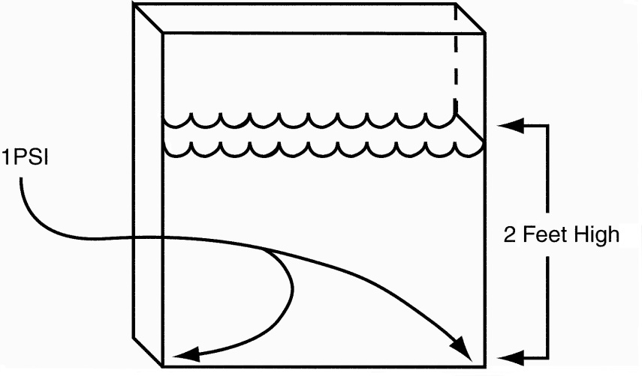

*Head Pressure*

0.5 PSI will push water 1 vertical foot

1.0 PSI will push water 2 vertical feet

AND

0.5 PSI will be gained for each foot loss of elevation

1.0 PSI will be gained for each 2-foot loss of elevation

**Example:** 25 pounds of pressure is required to lift water 50 feet

50.0 elevation gain

x 0.5 PSI for one foot of head pressure

25.0 PSI

A column of water 50-feet high has a 25 PSI head pressure at the base of the column. The most difficult task in computing head pressure **(H*)*** for wildland hose lays is estimating elevation changes either above or below the pump. Remember, for each 2-foot rise in elevation you add 1 PSI. For each 2-foot drop in elevation you subtract 1 PSI.

***HINT:* In the field estimate the elevation change in feet, then divide by 2 to get the PSI that is added (going uphill) or subtracted (going downhill) to your calculations.**

The next section addresses calculating Friction Loss **(*F*)** using a friction loss calculator. This is a good skill to learn as the calculator utilizes the theory behind the more practical “Rules of Thumb” that will be covered in the classroom lecture.

This computation is accurate enough for field use.

## Friction Loss (FL)

When two objects rub together, there is a loss of energy. This loss of energy is caused by friction. As water is forced through and rubs on the interior lining of a fire hose, energy is lost.

The figure below shows the eddy effect. Water flowing on the outer edges is slowed down due to the loss of energy caused while rubbing against the lining of the hose (turbulent flow). The water in the center flows faster due to no surface contact (laminar flow).

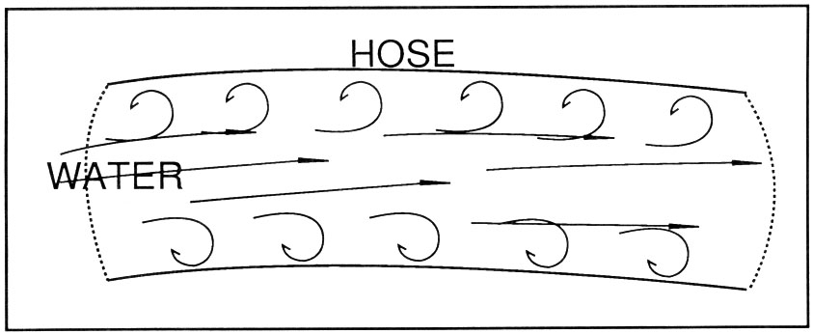

In order to determine the amount of friction loss in a hose lay, you must know:

* The gallons per minute (GPM) flowing (determined by the size of the smooth bore nozzle tip or GPM rating of a variable pattern nozzle)
* The diameter of hose (usually 1½-inch and/or 1-inch in wildland fire)
* The length of the hose lay

Remember, the greater the amount of water forced through a given sized hose, the greater the friction loss. Since hose lays vary in length, consider friction loss in terms of a common unit or length of hose. Therefore,

**Friction loss is expressed in pounds per square inch (PSI) per 100 feet of hose.**

### Friction Loss Facts

* The smaller the diameter of the hose, the greater the friction loss, given the GPM’s being flowed are the same.
* Friction loss factors are computed in 100-foot lengths of hose. For each length of hose added, whether uphill or downhill, the friction loss of each length added must be determined.
* ¾-inch hardlines have approximately four times the friction loss of 1-inch hose.
* 1-inch hose has approximately seven times the friction loss of 1½-inch hose.

### Methods of Overcoming Friction Loss

* **Increase the hose diameter.** Increasing the hose diameter while flowing the same GPMs will reduce friction loss because the water is flowing through a larger area, creating a less turbulent flow.
* **Reduce the size of the nozzle tip and maintain the same nozzle pressure.** Reducing the tip size and maintaining the same nozzle pressure reduces the discharge. (This is like putting your thumb over the end of a garden hose.) **Caution:** The quantity of water being discharged may not be sufficient to cool and extinguish the fire.
* **Lay parallel hose or increase the hose size.** With all other factors remaining constant, two parallel lines of hose will have ¼ the friction loss of a single line of the same diameter, length, and GPM flow. Three lines will have 1/9 the loss of a single line and four lines will have 1/16 the friction loss.
* **Eliminating unnecessary appliances.** Fewer appliances in the hose line reduces friction loss.

# THE FIRE STREAM CALCULATOR

There are many fire stream calculators used by the fire industry today. Almost all were designed for the structural firefighting community (large flows). Within the wildland firefighting community, small flows are generally used. It is a known fact that all calculators used will give slightly different answers to a friction loss calculation if compared against one another. With this said, the firefighting equipment fire stream/friction loss calculator (**NFES# 0897**), which is stocked in the NIFC warehouse, will be used for the textbook calculations.

The Cascade Fire Equipment Company calculator has two sides—Side 1: English and Side 2: Metric. We will only use Side 1 which has two sections—the Nozzle Discharge Calculator and the Friction Loss Calculator.

***Nozzle Discharge Calculator: Step 1***

Set the nozzle pressure at arrow.

* Use 50 PSI for straight stream or Forester nozzles or when given a fraction during the pre-course exercises.
* If using a variable pattern or fog nozzle, go directly to *Friction Loss Calculator: Step 1* and enter the rated GPM flow of the nozzle under the arrow.

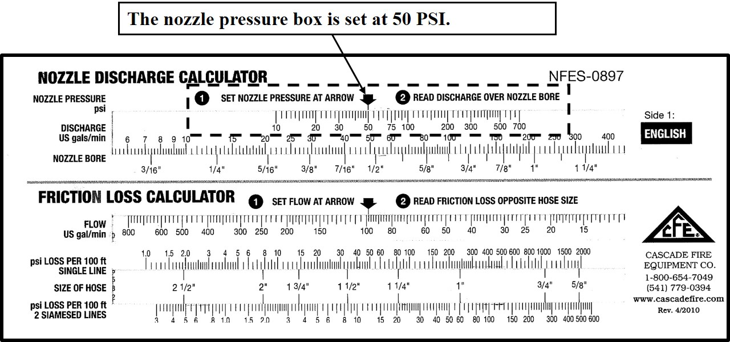

***Nozzle Discharge Calculator: Step 2***

After nozzle pressure has been set on the nozzle discharge calculator, read the discharge amount on the slide scale that corresponds to a particular nozzle bore size. This GPM flow reading will be what you input into the friction loss calculator.

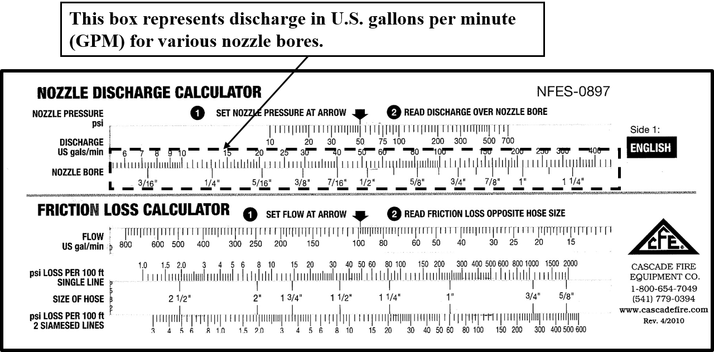

Note that with the set nozzle pressure at arrow set at 50 PSI and a straight bore nozzle size of 1/4 inch, the flow is 13 GPM. With a nozzle bore size of 3/8 inch, the flow is 30 GPM.

***Friction Loss Calculator: Step 1***

Once the GPM discharge has been determined with the nozzle discharge calculator, set flow at arrow on the friction loss calculator to 30 GPM (in this case, utilizing a 3/8” tip).

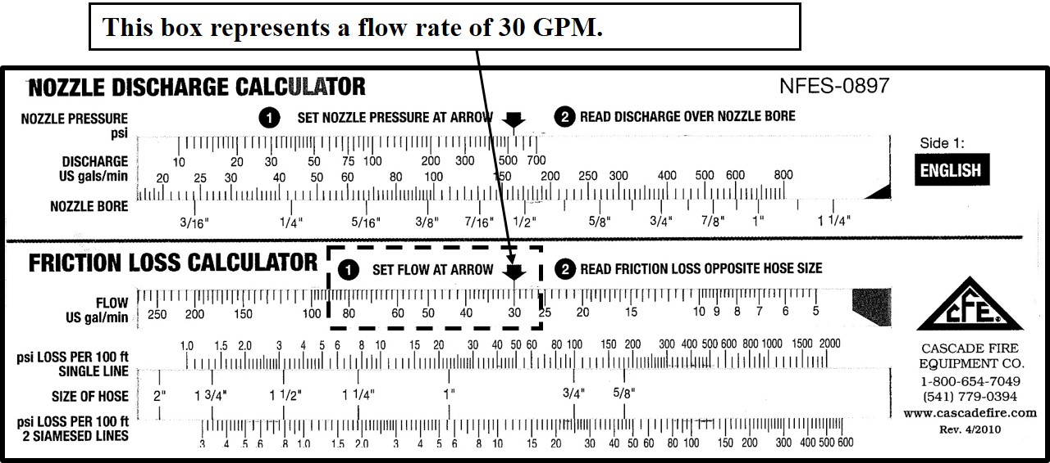

***Friction Loss Calculator: Step 2:***

Locate the proper hose size and number of lines on the friction loss calculator. A flow of 30 GPM and a single line of 1-inch hose, the friction loss calculator should read approximately 22 PSI per 100 foot. With a single line of 1½-inch hose, the calculator reads approximately 3 PSI.

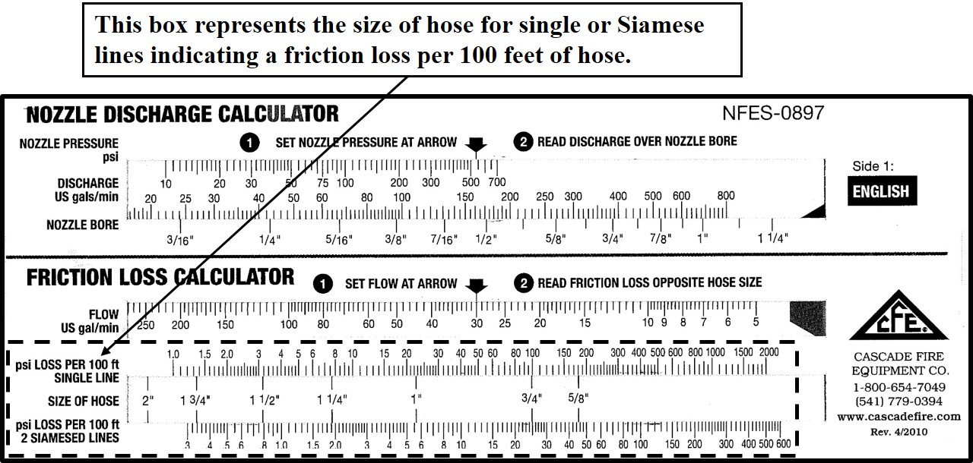

SAMPLE EXERCISE A

**Try this:**

1. On the nozzle discharge calculator, set the nozzle pressure at arrow to 50 PSI.

2. Read the discharge over nozzle 3/8-inch nozzle bore. The discharge should be 30 GPM.

3. On the friction loss calculator, set the flow at arrow to 30 GPM.

4. Read the friction loss opposite a 1½-inch single line hose. The friction loss per 100 feet of 1½-inch single line hose is 2.2 PSI. Round up to the nearest whole number which is 3. Put this figure in the pump pressure formula with your other variables.

F = 3 PSI friction loss per 100’ of 1½” hose

± E = 0 no elevation change

+ N = 50 nozzle pressure required for straight stream tip

PDP = 53 PSI

# FRICTION LOSS CALCUATIONS

When performing hydraulics calculations, always:

* Determine the GPMs that each nozzle is discharging, either by using the friction loss calculator for straight stream tips or the variable pattern/fog nozzle’s rating.
* Start at the most distant nozzle and work towards the pump.
* Pump to the highest pump discharge pressure (***PDP***) required. Gate down any laterals that require substantially less pressure.
* **Complete the exercises below and on the following pages using your friction loss calculator and pump discharge pressure formula.**
* **If a fraction is given as a nozzle size, use 50 PSI as the nozzle pressure. If a flow is given, use 100 PSI as the nozzle pressure.**
* **Show all your work.**

## Exercise 1

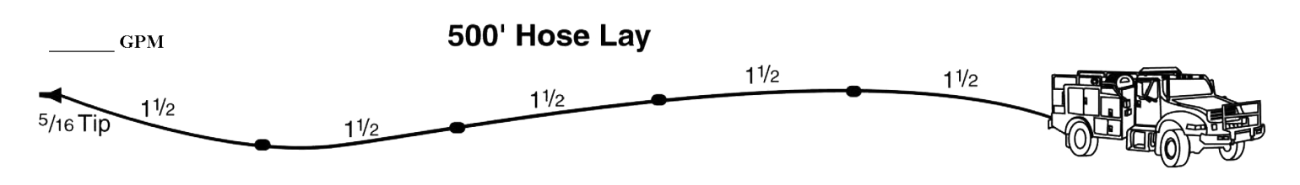

You are pumping a 1½” hose lay 500’ long with a 5/16” tip.

What is the GPM?

What is the PDP?

+ NP =

**±** H =

+ FL =

PDP =

## Exercise 2

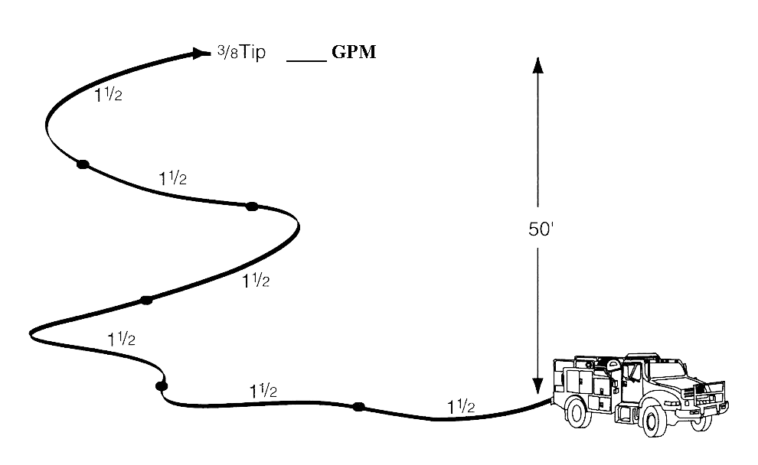

You are pumping 600’ of 1½” hose 50’ above the pump with a 3/8” tip.

What is the GPM?

What is the PDP?

+ NP =

**±** H =

+ FL =

PDP =

# Calculating Friction Loss on Progressive Hose Lays

GPM: __________

## Laterals

**When calculating lateral line friction loss, calculate the friction loss for only one line**—usually computed on the lateral that produces the largest GPM because the greater the amount of water forced through a given sized hose, the greater the friction loss. The friction loss for that line is calculated only once and added into the formula regardless of the number of lateral lines involved. **For a progressive hose lay, if all laterals are flowing at approximately the same GPM, always start at the most distant nozzle and work towards the pump.**

Nozzle pressure will be added only once in the formula regardless of how many nozzles are being used. **You will add either 50 or 100 PSI only once.**

**Remember to set the pump discharge pressure (*PDP*) for the lateral that requires the highest pressure.** All other laterals that require the same or less pump discharge pressure will be supplied with adequate pressure by pumping to the highest required pump discharge pressure. If laterals closer to the pump require substantially less pressure, you can gate them down at the wye or tee.

## Trunk Line

Starting from the most distant nozzle and working towards the pump, the GPMs increase after each lateral because the trunk line is supplying multiple laterals. In the example, there is 13 GPM flowing beyond the second wye, 26 GPM flowing beyond the first wye (supplying 2 laterals flowing 13 GPM each), and 39 GPM flowing from the pump (supplying 3 laterals flowing 13 GPM each). As the GPMs increase closer to the pump, the greater the friction loss will be for those sections of trunk line. As the flow decreases at the end of the hose lay, friction loss decreases. The 1½-inch hose (trunk line) has to supply all of the nozzles in use.

SAMPLE EXERCISE B

**Try this:**

Using the information presented in “Trunk Line” on the previous page, find the friction loss for each section of hose starting at the end of the hose lay and working back towards the pump. The trunk line is 1½ inch hose.

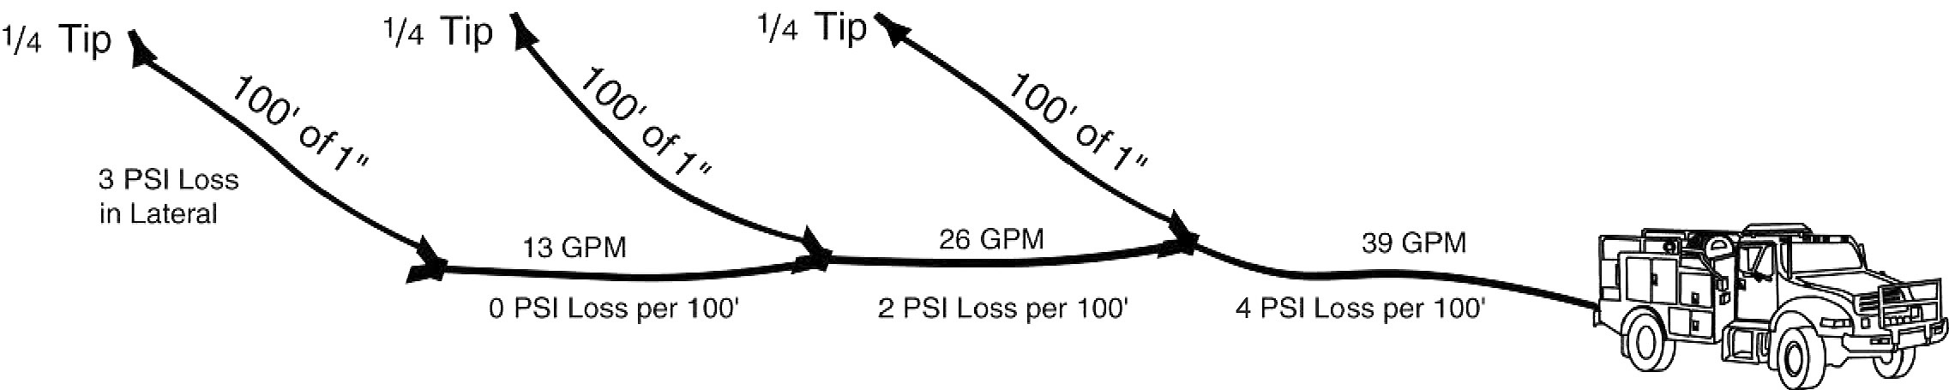

Step 1 Set the flow at arrow slide ruler to 13 GPM (as determined with your calculator) under the arrow in the U.S. GPM Flow section. The friction loss does not register on the calculator for 1½ inch hose; therefore, friction loss is insignificant.

Step 2 Set the flow at arrow slide ruler to 26 GPM (26 GPM is required to supply the last 2 laterals with 13 GPM each—13 GPM + 13 GPM = 26 GPM) under the arrow of the flow section. The friction loss per 100 feet of hose should read 2.3 PSI—round up to 3 PSI.

Step 3 Set the flow at arrow slide ruler to 39 GPM (39 GPM is required to supply all 3 lateral lines with 13 GPM each—13 GPM + 13 GPM + 13 GPM = 39 GPM) under the arrow of the flow section. The friction loss is 5.3; therefore, round up to 6 PSI per 100 feet of hose.

Step 4 Calculate the friction loss for the 1½-inch supply/trunk line. Add the friction loss for each section—0 + 3 + 6 = 9 PSI.

| Activity icon | **Using the friction loss calculator, work Exercises 3-4 on the following pages.** |
| --- | --- |

## Exercise 3

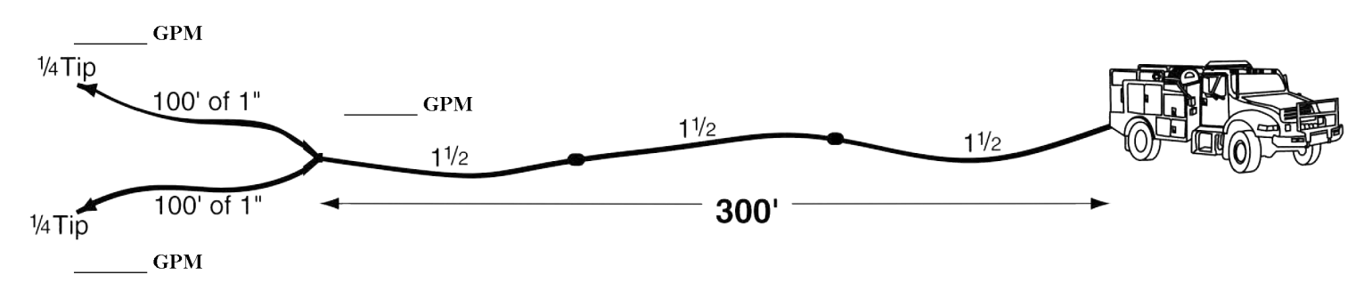

You are pumping 300’ of 1½” hose through a wye to 2 sections of 1” hose, each 100’ long with ¼” tips (remember tips are 50 PSI).

What are the GPMs?

What is the PDP?

+ NP =

**±** H =

+ FL =

+ FL =

PDP =

## Exercise 4

GPM: _______

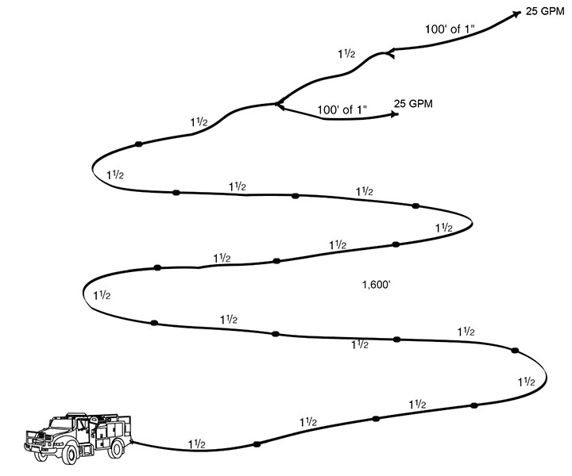

You are pumping to a hose lay with the first lateral at 1,500’. You have another 100’ of 1½” hose to another lateral. Both laterals are flowing 25 GPMs out of variable flow nozzles.

What are the GPMs?

What is the PDP?

+ NP =

**±** H =

+ FL =

+ FL =

+ FL =

PDP =

# DRAFTING PRINCIPLES

Gravity’s pull on the atmosphere causes air to have weight. The weight of air is called atmospheric pressure. Atmospheric pressure is measured in pounds per square inch (PSI). At sea level on a standard day (59 degrees Fahrenheit) the atmospheric pressure is 14.7 pounds per square inch, or 29.92 millimeters of mercury. **For wildland fire service hydraulics, round up to 15 PSI.**

When a vacuum is created, atmospheric pressure is decreased within the vacuum. This allows the outside pressure to push water up a vertical column. While pumps cannot create a total vacuum, water can theoretically be forced 33.8 vertical feet (14.7 ÷ .434) by atmospheric pressure if a total vacuum is created. A realistic assumption for a pump in good condition would be the ability to lift (draft) water 20 feet at sea level. **Portable pumps create a partial vacuum which allows atmospheric pressure to push water up through the suction hose into the pump.**

As elevation increases, the air is less dense and the atmospheric pressure is less. **Atmospheric pressure decreases about one-half pound per square inch (0.5 PSI) for each 1,000 feet increase in elevation in the lower atmosphere.** Pumps have less “suction” or drafting capability at higher elevations due to the decrease in atmospheric pressure. **\*If you remember that head pressure is about 0.5 PSI, then you lose the ability to draft water 1 foot vertically per 1,000-foot elevation gain.**

**Thus, locating a pump as close to the water supply as possible and reducing the vertical distance a pump must draft will increase its pumping capability!**

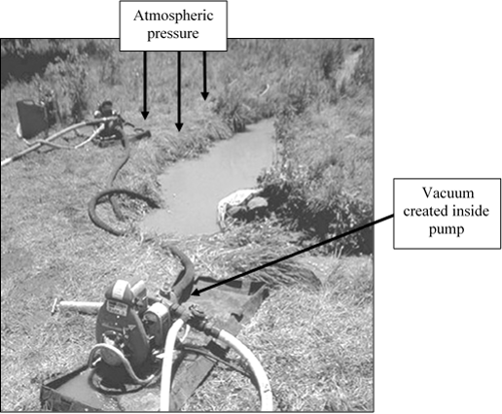

# Principles of Hydraulics – “Rule of 5s”

**Pump Discharge Pressure Formula: PDP** = **NP** ± **H** + **FL**

**N** = **Nozzle Pressure**

**Forester** = **50** PSI **Straight stream tip** = **50** PSI **Variable Pattern** = **100**PSI

**GPM** for nozzles: 3/16 tip = 10 GPM (same as Forester) 1” hose = 30 GPM

¼ tip = 15 GPM 1½” hose = 60 GPM

5/16 tip = 20 GPM

3/8 tip = 30 GPM

**H** = **Head Pressure**

**.5** PSI/foot of elevation (gain or loss)

**FL** = **Friction Loss**

**1½”** hose **< 60** GPM **= 5** PSI**/**100’ **1”** hose = **10** PSI/100’ **¾”** hardline = **40** PSI/100’

**1½”** hose **≥ 60** GPM **= 15** PSI**/**100’

**1½”** hoseSiamesed **= 5** PSI**/**100’

**Gallons of water per 100’ of hose: 1½”** hose = **10** gallons **1”** hose = **5** gallons **¾”** hose = **2** gallons

**Tips to reduce friction loss:**

* Increase hose diameters where possible.
* Reduce the nozzle tip size.
* Lay parallel hose. (Calculate friction loss for one hose then divide by four.)
* Eliminate unnecessary appliances.

**Series pumping increases pressure.**

* Provide at least 30 PSI into each pump
* Discharge GPM must never exceed incoming GPM (cavitation)
* Total PSI of pumps should equal pressure needed.

**Parallel pumping increases volume.**

**Drafting Guidelines:**

* Locate pump as close to the water source as possible.
* Ensure all connections are air tight.
* Keep foot valve submerged and free of debris.
* Maintain adequate supply of water in source.
* Draft to tank: water source to pump > pump to tank
* Draft to fire: water source to pump > pump to overboard discharge
* Atmospheric pressure at sea level = 15 PSI; decreases .5 PSI per 1,000’ elevation gain
* .5 PSI lifts water 1 foot

**Ejector Tips:**

* Need water in tank and enough to fill intake hose and return line.
* Return line needs to be larger diameter than supply line.
* Submerge ejector into water source.
* Use foot valve.
* Potentially can pull water 300’ and lifts water 80’.
* Keep kinks out of line.
* Most efficient water pickup when 100-150 PSI is provided at the ejector.

FRICTION LOSS IN LBS/100’ OF HOSE

HOSE SIZE (ID) TYPE

| **Flow**  **(GPM)** | **¾-inch** | **1- inch**  **CJRL** | **1-½ inch**  **CJRL** | **1½-inch**  **Linen** |
| --- | --- | --- | --- | --- |
| 5 | 3.5 | --- | --- | --- |
| 10 | 13 | 3 | --- | 1 |
| 15 | 25 | 6 | 1 | 2.2 |
| 20 | 42 | 10 | 1.5 | 3.6 |
| 25 | 62 | 15 | 2.5 | 5.5 |
| 30 | 86 | 20 | 3.5 | 8 |
| 40 | 140 | 34 | 5.5 | 13 |
| 50 | 215 | 50 | 8 | 20 |
| 60 | --- | 70 | 11 | 28 |
| 70 | --- | 90 | 15 | 37 |
| 80 | --- | 115 | 19 | 47 |
| 90 | --- | 140 | 23 | 59 |
| 100 | --- | 170 | 30 | 72 |
| 150 | --- | --- | --- | --- |
| 200 | --- | --- | --- | --- |

*Table 1 – Friction loss in pounds/100 feet of hose*

MEASUREMENTS COMMONLY USED IN HYDRAULICS

|  | **U.S. Measurement** | **Metric Equivalent** |
| --- | --- | --- |
| 1 gallon | 4 quarts | 3.78 liters |
|  | 128 fluid ounces |  |
|  | 231.0 cubic inches |  |
|  | 0.1337 cubic feet |  |
| 1 cubic foot | 7.5 gallons (approximately) | 28.3 liters |
|  | 1,728 cubic inches |  |
|  |  |  |
| 1½-inch ID x 100’ | 9 gallons (approximately) | 34.0 liters |
| 1-inch ID x 100’ | 4 gallons (approximately) | 15.1 liters |
|  | **Weight** |  |
| 1 foot of water head (column of water) | .5 PSI (0.434 PSI) | 2.99 kPa |
| 1 gallon | 8 lbs (8.335 lbs) | 3.78 kg |
| 1 cubic foot of water | 62.4 lbs | 28.31 kg |
|  | **Pressure** |  |
| 1 lb per inch2 | 2 feet of water head (2.304) | 6.89 kPa |
| Normal atmospheric pressure | 14.696 PSI at sea level or 29.92 inches of mercury at 32ºF | 101 kPa at sea level |
| 1,000-foot increase in ground elevation | .5 PSI decrease in atmospheric pressure |  |
|  | **Draft** |  |
| 1 inch of mercury | 1 foot of lift (1.134 ft) | 0.3048 meter lift |
| Drafting guidelines |  |  |
| Theoretical lift (max.) | 33.9 ft lift | 10.33 m lift |
| Attainable | 29.4 ft lift | 8.96 m lift |
| Excellent pump | 24 ft lift | 8.53 m lift |
| Realistic | 10-15 ft lift | 3.0-4.5 m lift |

*Table 2 – Measurements Commonly Used in Hydraulics*

HYDRAULIC EXERCISES – ANSWER KEY

## Exercise 1

|  | **Friction Loss Calculator** |
| --- | --- |
| **+ NP** | **+ 50 PSI** Forester nozzle |
| **± H** | **+ 0 PSI** no change |
| **+ FL** | **+ 10 PSI** 1½” hose @ 20 GPM  (500’) 2 PSI per 100’ **(2 x 5)** |
| **PDP =** | **60 PSI** |

Exercise 2

|  | **Friction Loss Calculator** |
| --- | --- |
| **+ NP** | **+ 50 PSI** Forester nozzle |
| **± H** | **+ 25 PSI** 50’ gain  **(50 x .5)** or (**50 ÷ 2)** |
| **+ FL** | **+ 18 PSI** 1½” hose @ 30 GPM  (500’) 3 PSI/100’ **(3 x 6)** |
| **PDP =** | **93 PSI** |

Exercise 3

|  | **Friction Loss Calculator** |
| --- | --- |
| **+ NP** | **+ 50 PSI** Forester nozzle |
| **± H** | **+ 0 PSI** no change |
| **+ FL** | **+ 5 PSI** 1” hose @ 13 GPM  (100’) 5 PSI/100’ **(5 x 1)** |
| **+ FL** | **+ 9 PSI** 1½” hose @ 26 GPM  **(**300’) 3 PSI/100’ **(3 x 3)** |
| **PDP =** | **64 PSI** |

Exercise 4

|  | **Friction Loss Calculator** |
| --- | --- |
| **+ NP** | **+100 PSI** variable flow nozzle |
| **± H** | **+0 PSI** no change |
| **+ FL** | **+15 PSI** 1” hose @ 25 GPM  (100’)15 PSI/100’ **(15 x 1)** |
| **+ FL** | **+3 PSI** 1½” hose @ 25 GPM  (100’)3 PSI/100’ **(3 x 1)** |
| **+ FL** | **+135 PSI** 1½” hose @ 50 GPM  (1,500’) 9 PSI/100’ **(9 x 15)** |
| **= PDP** | **253 PSI** |