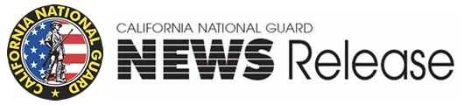
9800 Goethe Road, Sacramento, California 95826
Phone: 916-854-3304 Fax: 916.854.3630

FOR IMMEDIATE RELEASE March 5, 2012
Maj. Kimberly Holman at 805-340-7301 Release # 03-01

California Air National Guard 146th Airlift Wing
Conducts Aerial Firefighting Training

PORT HUENEME, Calif.—The 146th Airlift Wing and the U.S. Forest Service will conduct annual training and certification for MAFFS (Modular Airborne Fire Fighting System) March 5-8 at Channel Islands Air National Guard Station in Port Hueneme.

More than 100 personnel from both agencies will come together to accomplish the weeklong training sponsored by the U.S. Forest Service. The certification event will include classroom sessions and flight training for military flight crews, civilian lead plane pilots and various support personnel. Water drops will be executed in the nearby Angeles National Forest and the Kern County. Rural residents in those areas may see low-flying C-130 aircraft and Forest Service lead planes throughout the week.
The California Air National Guard’s C-130J aircraft are equipped with the Modular Airborne Fire Fighting System II (MAFFS II) which is capable of dropping up to 3,000 gallons of water or fire retardant. The system slides into the back of the aircraft, and water or retardant is released through a nozzle located on the rear left side. MAFFS equipment and aircraft are activated to supplement the Forest Service and the civilian air tanker program during periods of high wildfire activity throughout the nation.
Congress established the authority for the MAFFS program in the early 1970s to support wildland firefighting through an agreement with the U.S. Forest Service. The military aircraft are requested by the National Interagency Fire Center (NIFC) and activated through the U.S. Northern Command, based on an agreement with the Department of Defense.
A media opportunity is scheduled March 7, 2012, at 10 am. A C-130 water drop capability demonstration will take place at 11:00. Please contact Maj. Kimberly Holman, 146th Airlift Wing public affairs officer, at (805) 340-7301 for further information and to arrange base access.
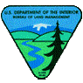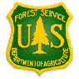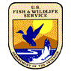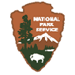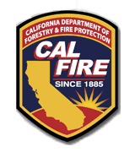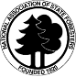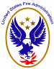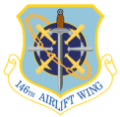

-30-

