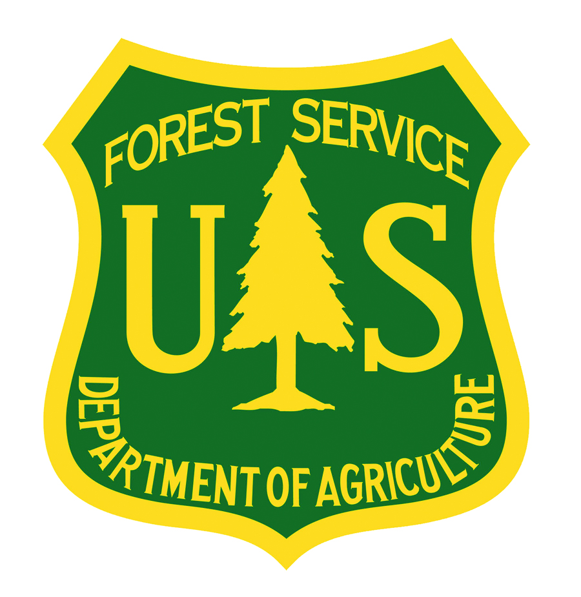
USDA Forest Service Fire and Aviation Management
Modular Airborne Fire Fighting Systems (MAFFS) Facts

*MAFFS are portable fire retardant delivery systems that can be inserted into military C-130 aircraft to convert them into Airtankers when needed.

*The MAFFS program is a joint effort between the USDA Forest Service and Department of Defense (DoD). The USDA Forest Service owns the MAFFS equipment and supplies the retardant, while the DoD provides the C-130 aircraft, flight crews, and maintenance and support personnel to fly the missions.

*Since the program was created in the 1970s, the role of MAFFS has been to provide a “surge” capability that can be used to boost wildfire suppression efforts when commercial airtankers are fully committed or not readily available. The role of MAFFS is based on laws, primarily the Economy Act; policies, such as the Defense Support to Civil Authority (DSCA); and agreements between the USDA Forest Service and the DoD.

*The U.S. Forest Service owns 8 operational MAFFS II systems.

*Military installations in Wyoming, Nevada, California, and Colorado provide C-130s to fly MAFFS missions. Specifically, the 153rd Airlift Wing, Wyoming Air National Guard, Cheyenne; the 152nd Airlift Wing, Nevada Air National Guard, Reno; the 146th Airlift Wing, California Air National Guard, Port Hueneme; and the 302nd Airlift Wing, Air Force Reserve, Peterson Air Force Base, Colorado.

*Military C-130s equipped with slide-in MAFFS units can drop up to 3,000 gallons of fire retardant or water on wildfires. They can discharge their entire load over an area one-quarter of a mile long by 60 feet wide in under five seconds or make variable drops. Once the load is discharged, the MAFFS system can be refilled in less than 12 minutes.

*The USDA Forest Service reimburses the military for all costs associated with MAFFS, per the Economy Act.
* In 2017, MAFFS flew 293 sorties and made 315 drops of a total of about 820,000 gallons of fire retardant on more than 24 wildfires in California.

- Over -

*Over the last 10 years, military C-130s equipped with MAFFS have delivered a total of approximately 8.6 million gallons of fire retardant on wildfires, an average of approximately 860,000 gallons per year, as follows (note: following figures are rounded):

2008 – 1.3 million gallons
2009 – 0 gallons
2010 – 12,000 gallons*
2011 – 1.2 million gallons
2012 – 2.4 million gallons
2013 – 1.4 million gallons
2014 – 250,000 gallons
2015 - 840,000 gallons
2016 - 396,000 gallons
2017 - 820,000 gallons
Total – 8,618,000
*Over the last 10 years, MAFFS have flown a total of approximately 3,691.5 hours, an average of approximately 369.15 hours per year, as follows (note: hours flown are available from 1973 – 2017):

2008 – 970.10
2009 – 0
2010 – 7.7
2011 – 479.7
2012 – 888.7
2013 – 540.5
2014 – 89.6
2015 – 350.9
2016 – 125.5
2017 – 238.8
Total – 3,691.5

