- CREATING AN EFFECTIVE DEFENSIBLE SPACE –
- How much space is needed for "Defensible Space"?
That depends on a few factors such as surrounding vegetation and steepness of slope as explained in the following chart.
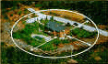 | Defensible Space  Recommended Distances -- Steepness of Slope
Recommended Defensible Space Distance | Flat or Gently Sloping 0 to 20% | Moderately Steep 21% to 40% | Very Steep Slope  + 40%
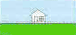  Grass: Wildland grasses (such as cheatgrass), weeds, and widely scattered shrubs with grass understory. | 30 feet | 100 feet | 100 feet
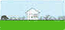  Shrubs: Includes shrub dominant areas (such as sagebrush, bitterbrush, manzanita) and pinyon-juniper. | 100 feet | 200 feet | 200 feet
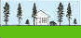  Trees: Includes forested areas. If substantial grass or shrub understory is present, use those values shown above. | 30 feet | 100 feet | 200 feet

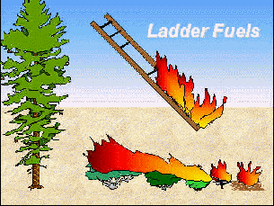  In the Defensible Space, remove limbs and reduce vegetation growing underneath other trees. This will help prevent fire from climbing into the treetops and spreading. | Lean, Clean, and  Green Zone  Lean: Small amounts of flammable vegetation.  Clean: Little or no dead vegetation or debris.  Green: Plants are healthy and green during fire season.

- FIRESCAPE: FIRE SAFE LANDSCAPE DESIGN -
Firescaping is a type of landscape design that reduces a home's vulnerability to wildfire.
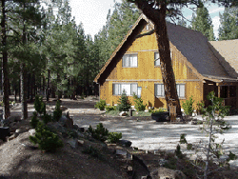  There are no fuels close to this home, protecting it from wildfire, therefore making this home defensible. | 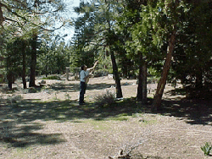  By trimming the lower branches of the trees near your home, fire burning along the ground is less likely to jump into trees.
Proper plant selection, placement, and maintenance can diminish the possibility of ignition, lower fire intensity, and reduce how quickly a fire can spread.
Remember, no plant is fireproof. All will burn in a very intense fire. Firewise plants all have one or more of these firewise characteristics:
- Tissues contain more moisture.
- Tissues contain low amounts of volatile oils.
- They provide less fuel for fire by staying small or producing less littler.
- They are compact or low to the ground.
Below are some examples of fire resistant plants that are adapted to Utah's climate. CLICK HERE for a complete list of Firewise Plants for Utah landscape.
Rye Grass | Maple tree | Birch tree | Red-hot Poker
Blue Fescue | Lilac | Rock-rose | Alum Root
Flax | Virginia Creeper | Geranium | hardy Ice Plant
Poppy | Honeysuckle | Daylily | Columbine
Pinks | English Ivy | Shasta Daisy | Western Wheatgrass
Lavender | Iris | Silvery yarrow | Buffalograss

- OTHER CONSIDERATIONS WHEN MAKING YOUR HOME DEFENSIBLE -
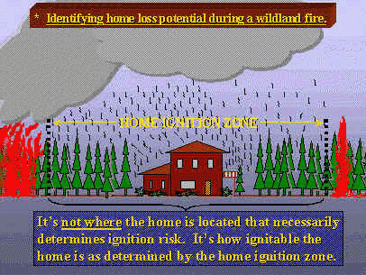
Click on the text in the below picture or on the text links below to learn more about other considerations when making defensible space.
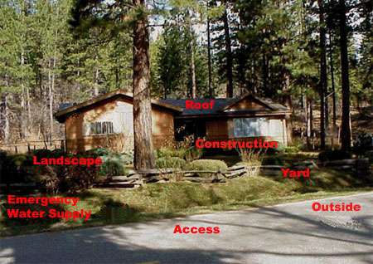
Roof ~ Construction ~ Landscape ~ Yard
Emergency Water Supply ~ Access ~ Outside

- WHEN WILDFIRE APPROACHES -
- Evacuate, if possible, all family members not essential to protecting the house, as well as pets.
- Contact a friend or relative and relay your plans.
- Make sure family members are aware of the prearranged meeting place.
- Tune into a local radio station and listen for instructions.
- Place vehicles in the garage, have them pointing out, and rollup the windows.
- Place valuable papers and mementos in the car.
- Close the garage door, but leave it unlocked. If applicable, disconnect the electric garage door opener so that the door can be opened manually.
- Place combustible patio furniture in the house or garage.
- Shut off propane at the tank or natural gas at the meter.
- Wear only cotton or wool clothes. Proper attire includes long pants, long sleeved shirt or jacket, and boots. Carry gloves, a handkerchief to cover face, water to drink, and goggles.
- Close all exterior vents.
- Prop a ladder against the house so firefighters have easy access to the roof.
- Make sure that all garden hoses are connected to faucets and attach a nozzle set on "spray".
- Soak rags, towels, or small rugs with water to use in beating out embers or small fires.
- Inside, fill bathtubs, sinks, and other containers with water. Outside, do the same with garbage cans and buckets. Remember that the water heater and toilet tank are available sources of water.
- Close all exterior doors and windows.
- Close all interior doors.
- Open the fire place damper, but place the screen over the hearth to prevent sparks and embers from entering the house.
- Leave a light on in each room.
- Remove lightweight and/or non-fire resistant curtains and other combustible materials from around windows.
- If available, close fire resistant drapes, shutters, or Venetian blinds. Attach pre-cut plywood panels to the exterior side of windows and glass doors.
- Turn off all pilot lights.
- Move overstuffed furniture to the center of the room.
- Keep wood shake or shingle roofs moist by spraying water. Do not waster water. Consider placing a lawn sprinkler on the roof if water pressure is adequate. Do not turn on until burning embers begin to fall on roof.
- Continually check the roof and attic for embers, smoke, or fire.

Utah Living With Fire
- OTHER CONSIDERATIONS: ROOF
Check Your Roof:
- The roof is the most vulnerable part of the house.
- Replace flammable wood shingles with fire resistant roofing.
- Remove branches over the roof, under the eaves, and within 15 feet of the chimney.
- Install a chimney spark arrestor.
- Inspect and clean your roof twice a year.
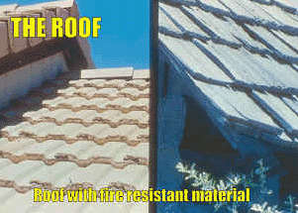 | 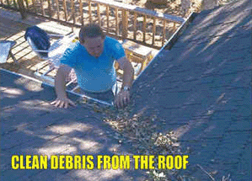

Utah Living With Fire
- OTHER CONSIDERATIONS: LANDSCAPE
What is Firescaping?  Firescaping is landscape design using ornamental plants with fire resistant qualities and low fuel volume and managing existing native or ornamental vegetation to enhance fire safety.  Firescaping reduces house and property vulnerability to wildfire. The goal is to develop a landscape with a design and choice of plants that offers the best fire protection and enhances the property. Surround the house with things that are less likely to burn. Appropriate management of the landscape can make a significant contribution towards wildfire survival. | 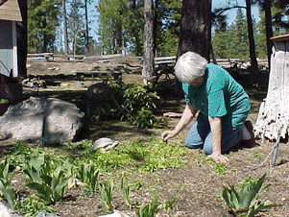
There is no such thing as a plant that will not burn . . .
But some plants are more fire resistant than others.
Lawns Can Be Effective in Firescaping  Extensive areas of turfgrass may not be right for everyone. Some good alternatives include clover, groundcovers, and conservation grasses that are kept green during the fire season through irrigation.  Characteristics of Fire Resistant Plants  - Little accumulation of dead vegetation  - Open, loose branching  - Non-resinous, oily or waxy  - Low volume of total vegetation  - High moisture content  - Slow growing | 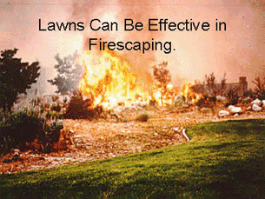

Utah Living With Fire
- OTHER CONSIDERATIONS: EMERGENCY WATER SUPPLY
Maintain an emergency water supply that meets fire department standards through one of the following:
- A community water/hydrant system.
- A cooperative emergency storage tank with neighbors.
- A minimum storage supply of 2500 gallons on your property.
Clearly mark all emergency water sources and notify your local fire department of their existence.
Create easy firefighter access to your closest emergency water source.
If your water comes from a well, consider an emergency generator to operate the pump during a power failure.
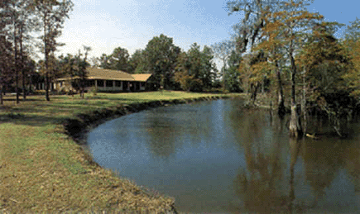
Water from this canal near the house is a good source of water for firefighters to use in case of a fire.

Utah Living With Fire
- OTHER CONSIDERATIONS: ACCESS
- Identify at least two exit routes from your neighborhood.
- Construct roads that allow two way traffic.
- Design road width, grade, and curves to allow access for large emergency vehicles.
- Construct driveways to allow emergency equipment to reach your house.
- Design bridges to carry heavy emergency vehicles, including bulldozers carried on large trucks.
- Post clear road signs to show traffic restrictions such as dead-end roads, and weight and height limitations.
- Clear flammable vegetation at least 10 feet from roads and 5 feet from driveways.
- Cut overhanging tree branches above roads.
- Make sure your street is named or numbered, and a sign is visibly posted at each intersection.
- Make sure that your street name and house number are not duplicated elsewhere in the county.
- Post your address at the beginning of your driveway, or on your house if it is easily visible from the road.
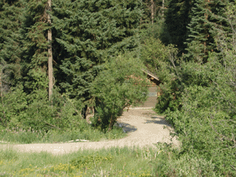  This house has a poor driveway. Driveways should be kept clear of vegetation and should allow emergency personnel easy access to the house in case of an emergency. | 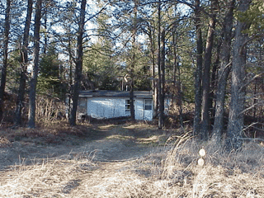  Emergency personnel would find it difficult to respond to this home because of its location and lack of accessibility. If your house isn't accessible, you may not be able to receive assistance in an emergency.

Utah Living With Fire
- OTHER CONSIDERATIONS: YARD
Check Your Yard:
- Stack woodpiles at least 30 feet from all structures and clear away flammable vegetation within 10 feet of woodpiles.
- Locate propane tanks at least 30 feet from any structure and surround them with 10 feet of clearance.
- Remove all stacks of construction materials, pine needles, leaves, and other debris from your yard.
- Contact your local fire department to see if open burning is allowed in your area; if so, obtain a permit before burning debris.
- Where burn barrels are allowed, clear flammable materials at least 10 feet around the barrel; cover the open top with a non-flammable screen with mesh no larger than 1/4 inch.
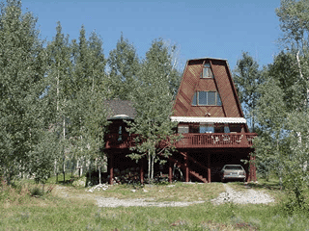  Woodpile under deck. | 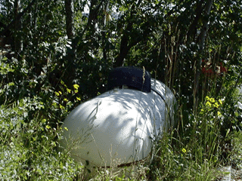  Flammable vegetation surrounding propane tank.

Utah Living With Fire
- OTHER CONSIDERATIONS: OUTSIDE
- Designate an emergency meeting place outside your home.
- Practice emergency exit drills regularly.
- Make sure that electric service lines, fuse boxes, and circuit breaker panels are installed and maintained as prescribed by code.
- Contact qualified individuals to perform electrical maintenance and repairs.
Example of an emergency exit plan with designated meeting places.
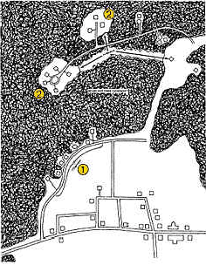

Utah Living With Fire
- OTHER CONSIDERATIONS: CONSTRUCTION
Construction and Building Location  - Building site location is critical to reducing fire danger.  - Locate the building away from ridge tops, canyons, and areas between high points on a ridge.  - Consider installing a sprinkler system within the house to protect your home. | Vents, Eaves, and Soffits  - Vents should be screened with metal wire that has 1/4 inch or less openings.  - Locate vents in the rather than soffit.  - Open eaves are a heat trap. Cover the eave with a soffit, best constructed flat.
Windows  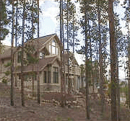  - Tempered glass is best.  - Double pane glass is better.  - Single pane glass offers protection. | Decks  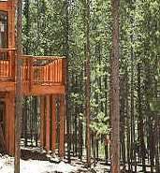  - Open wood decks are highly combustible.  - They trap hot air and have a high surface to volume ratio.  - Decks are often on the downhill side of the house and are susceptible to fire as fire burns uphill.
Exterior Siding  Good to best in descending order:  - Wood panels and boards  - Fiber cement panels and boards  - Synthetic stucco  - Metal with gypsum sheeting  - Stucco, real  - Heavy timber or logs  - Concrete  - Brick, stone, or block | Firewise Deck Construction  - Use non-combustible material.  - Use thicker wood material.  - Fully enclose deck.  - Build over garage.  - Use enclosed area as shed.  - Build a masonry or concrete wall with a stone or concrete patio below and in front.

