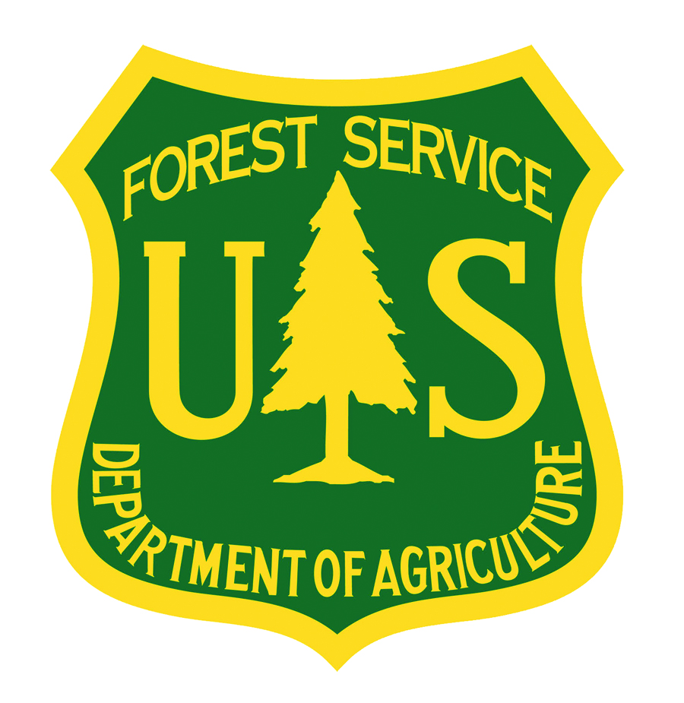

Accessing InciWeb Cheat Sheet
How to get an InciWeb Login Account; Gain Access to a Unit; Get Access for a Unit; and Become a Superuser for a Unit.

For detailed information, see the InciWeb User’s Manual, available online at www.nifc.gov/PIO_bb/background.html
InciWeb is designed to serve the long term communication needs of the unit with jurisdiction over the land that an incident occurs on (i.e. National Forest, National Park, Bureau of Land Management District, etc.). Consequently, to create or update incident records in InciWeb, you must be granted access to the unit with jurisdiction over the land that an incident occurs on by a designated “Superuser” for the unit, often the unit public affairs officer or webmaster.

Note: Superusers can also create and update incident records for their unit(s).

To create or update incident records in InciWeb, you will need:
*An InciWeb Login Account
*Access to the unit with jurisdiction over the land that an incident occurs on

If you do not already have an InciWeb Login Account:
- If you know who the Superuser or account manager is for the unit you are requesting access to, contact them and they can create your account and give you access to the unit.
- If you don’t know who the Superuser or account manager is, contact the Fire Applications Helpdesk by phone at (866) 224-7677 or (360) 326-6002 or by email at fire_help@fs.fed.us The Helpdesk can create your account and help you find the Superuser or account manager for the unit you are requesting access to. You will need to provide the Helpdesk with your email address so that they can send your account login information to you. It is recommended that users provide two email addresses: an agency email address and a public email address (Hotmail, Gmail, Yahoo, etc.) as a backup.
- You will receive an email confirming the creation and activation of your InciWeb Login Account. The email will contain a username and a temporary password.
- Use the username and temporary password to log in to InciWeb (go to www.inciweb.org, scroll down to the bottom of the screen and click “Log In” on the far right).
- Follow the directions on the Log In screen. Note: After you enter your username, you must click the “login” button. If you hit “enter” instead, the username box will clear and you will need to retype your username. After you enter your password, you must click the “submit” button. If you hit “enter” instead, the password box will clear and you will need to retype your password.
- Follow the directions in the next section to gain access to the unit with jurisdiction over the land that an incident occurs on.
If you already have an InciWeb Login Account and you need to gain access to a unit to create and update incident records:
- Log in to InciWeb with your username and password. Note: After you enter your username, you must click the “login” button. If you hit “enter” instead, the username box will clear and you will need to retype your username. After you enter your password, you must click the “submit” button. If you hit “enter” instead, the password box will clear and you will need to retype your password.
- You will be directed to the “Select a Unit” screen.

- All of the units that you have already been granted access to will appear in a drop down menu. If you are going to create or update an incident record for a unit that you have already been granted access to, select it from the drop down menu and proceed.

- If you are going to create or update an incident record for a unit that you have not been granted access to, you will need to contact the Superuser for the unit and ask them to give you access. To find the Superuser, click on “Superuser Lookup” and search by unit name (i.e. Yellowstone National Park, Sawtooth National Forest, etc.). The name, phone number, and email address for the Superuser(s) will appear.

- If you cannot find a Superuser, or if the Superuser is unavailable or can’t grant you access, contact the Helpdesk by phone at (866) 224-7677 or (360) 326-6002 or by email at fire_help@fs.fed.us. A unit line officer will need to speak to a HelpDesk representative to authorize access.
To get access for your unit on InciWeb:
- To use InciWeb to provide information about incidents occurring on land under the jurisdiction of your unit, contact the Helpdesk by phone at (866) 224-7677 or (360) 326-6002 or by email at fire_help@fs.fed.us Note: Units will be added to InciWeb only by their official National Wildfire Coordinating Group (NWCG) identifier.
To become a Superuser for one or more units:
- To become a Superuser, who can grant access to users to create and update records in InciWeb about incidents occurring on one or more units as well as create and update records in InciWeb about incidents occurring on those units, send an email to the Helpdesk at fire_help@fs.fed.us stating that you will be the Superuser that includes:

  - First and last name
  - Email Address
  - Alternate Email address (optional)
  - Phone number
  - Unit(s) you will be the Superuser for
Note: Superusers can expect to receive lots of requests from users for access, so it is recommended that they be designated at the lowest appropriate organizational level (i.e. a National Forest or Ranger District instead of a Regional Office).
- You will receive an email confirming the creation and activation of your account. The email will contain a username and a temporary password.
- Use the username and temporary password to log in to InciWeb (go to www.inciweb.org, scroll down to the bottom of the screen and click on Log In on the far right).
- Follow the directions on the Log In screen. Note: After you enter your username, you must click the “login” button. If you hit “enter” instead, the username box will clear and you will need to retype your username. After you enter your password, you must click the “submit” button. If you hit “enter” instead, the password box will clear and you will need to retype your password.

