For InciWeb Superusers
How to add users into InciWeb

The way that InciWeb superusers and users log in to the application to enter and update incident information is changing. Instead of logging in to InciWeb directly (by clicking the Log In link at the bottom of the InciWeb home page), superusers and users will log in to InciWeb through the Ness Application Portal (NAP). All superusers and users must obtain a NAP username and password to log in to InciWeb through the NAP.

Instructions on how to obtain NAP usernames and passwords, as well as how to log in to InciWeb through the NAP, are available on the NIFC PIO bulletin Board.

These instructions will guide InciWeb superusers through the process of adding users back in to the InciWeb database.

Any superuser can add any user back in to the InciWeb database, which will give them access to the Practice site and which will make them available to be given access to any unit.

Step 1: Obtain the following information from users who want to be added back in to the InciWeb database: NAP username; user’s email address; user’s alternate email address (if available).

Step 2: Log in to InciWeb through NAP, this will take you to the Welcome screen. Click on the “Unit Selection” tab, a list of units that you have access to will appear.
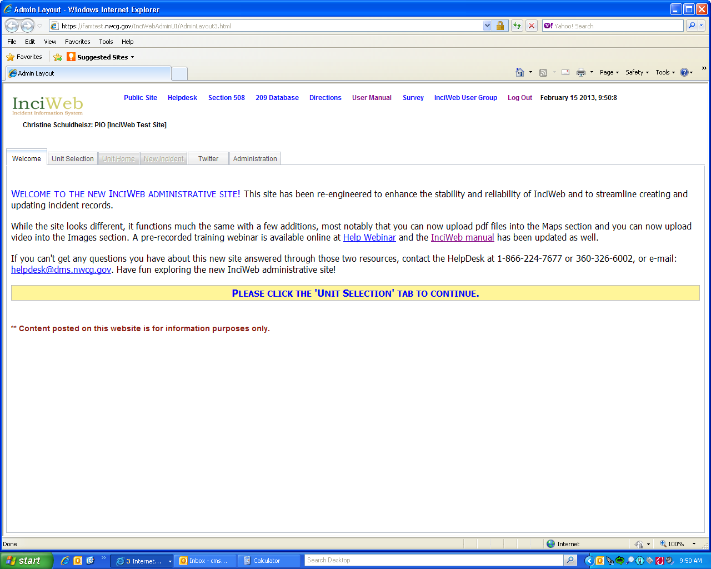
Step 3: Select a unit that you are a superuser for, this will take you to the Unit Home screen. There will be a “yes” in the Unit Super User column in the row for all of the units that you are a superuser for.
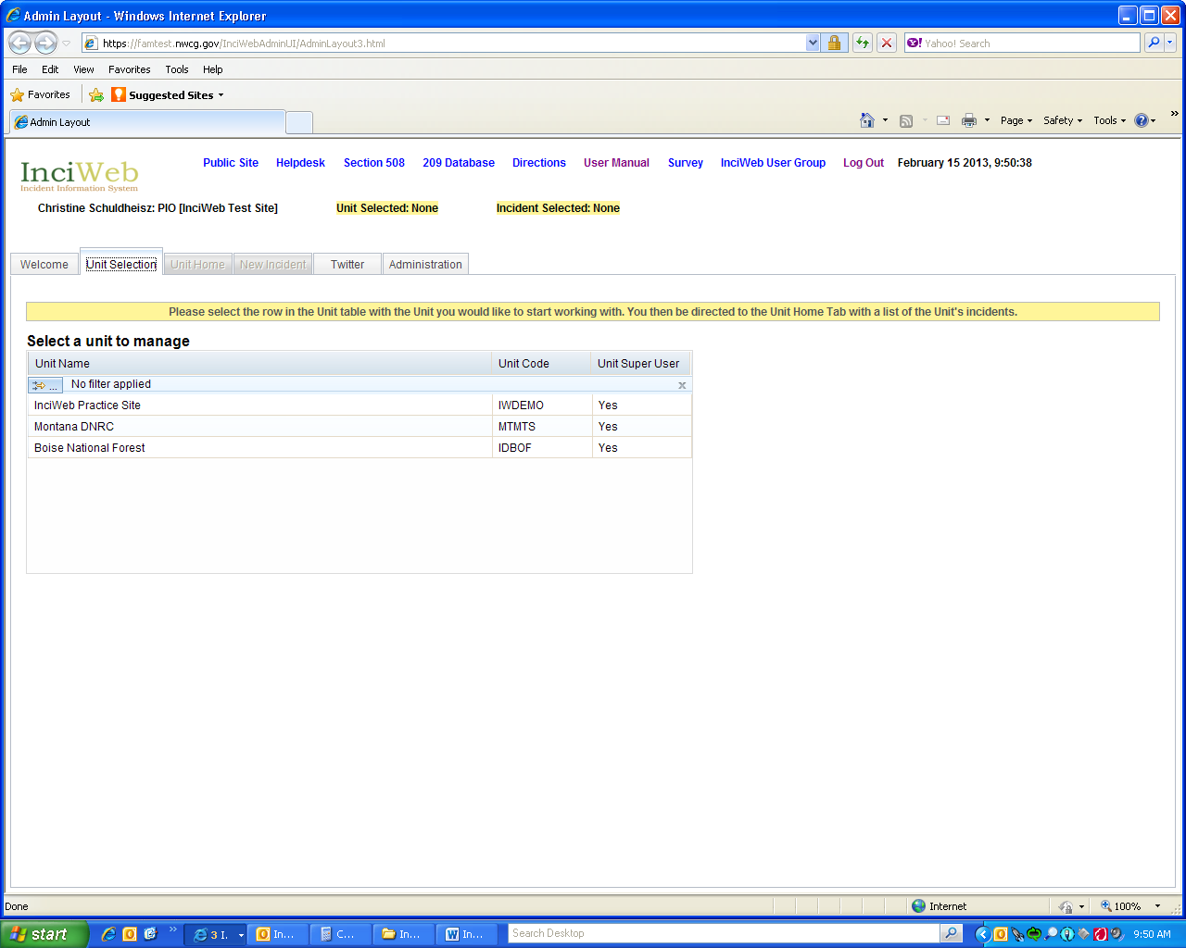

Step 4: On the “Unit Home” screen, select the “Administration” tab, this will open the User Profile screen.
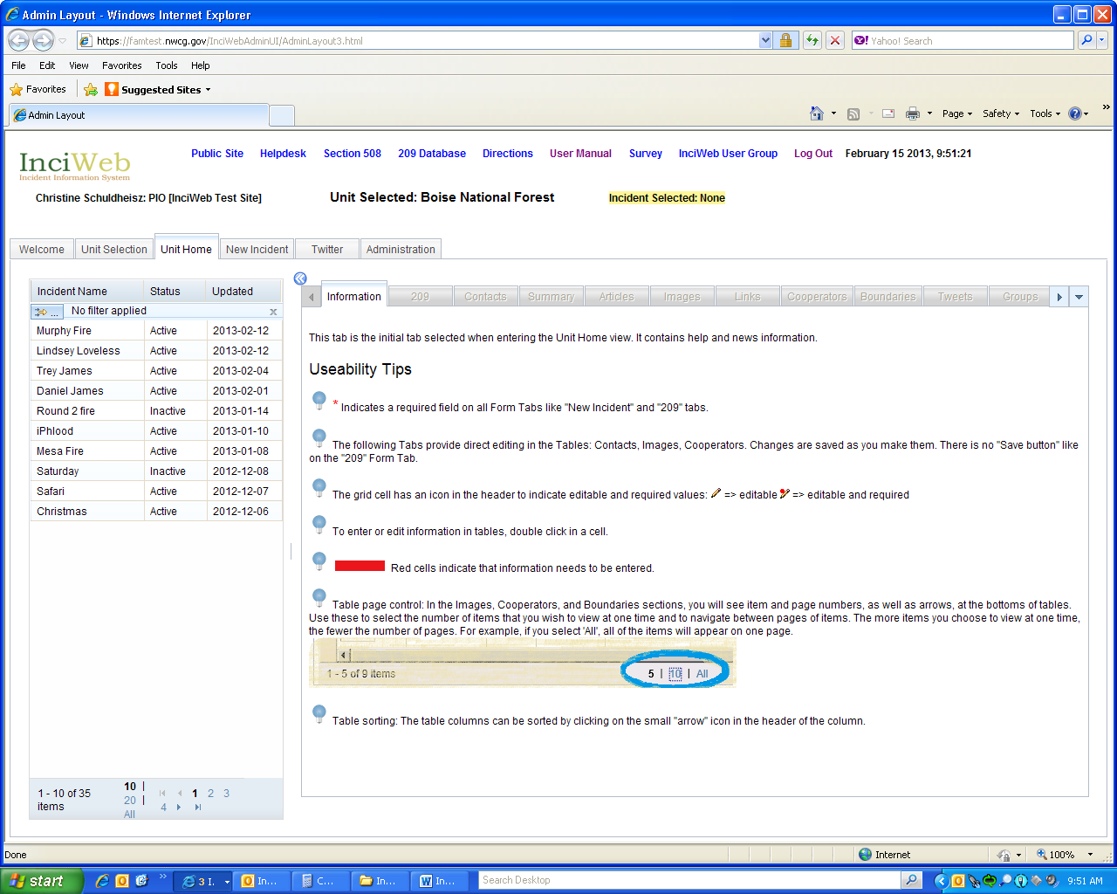

Step 5: Review your user profile and make any necessary changes. Select the “Manage Access” tab, this will open the Manage Access screen.
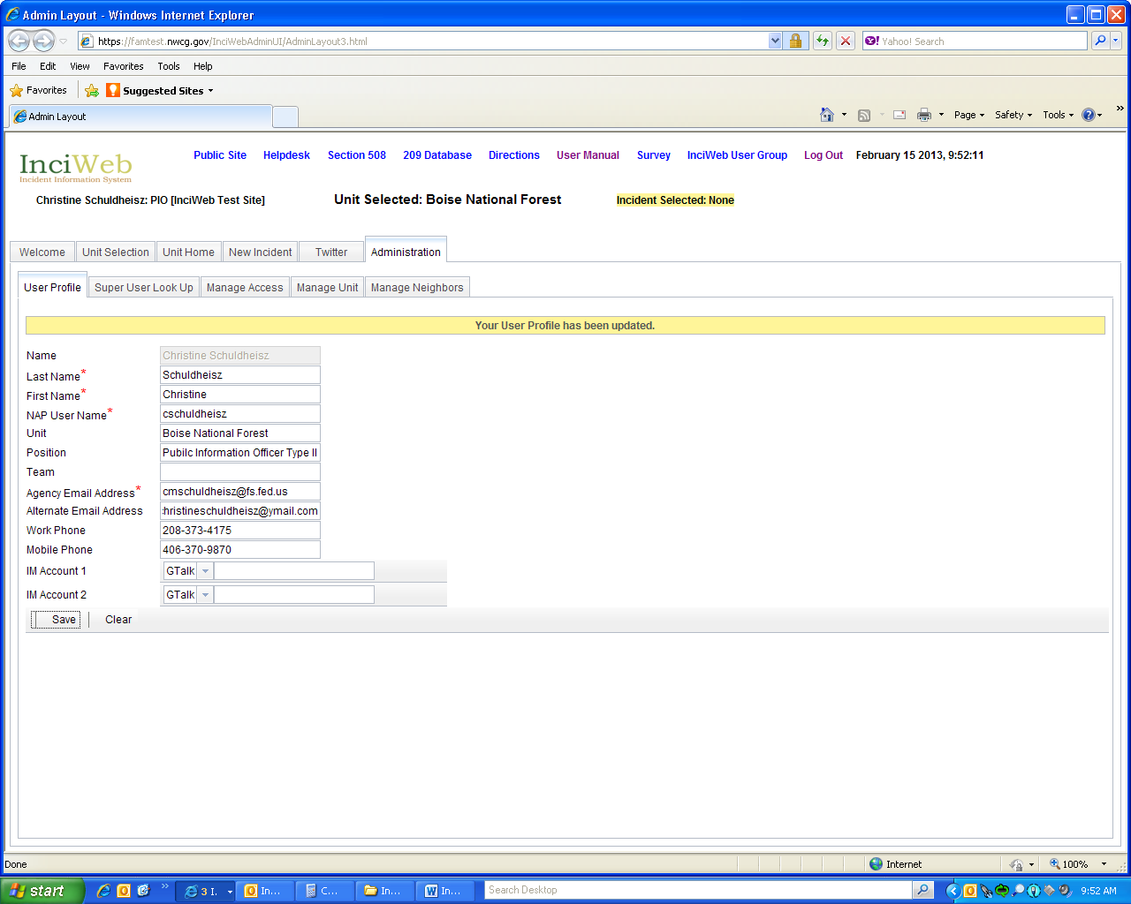

Step 6: Check the “Users Attached to this Unit” and “Available Users” tables to ensure that the user that you are trying to add back in to the InciWeb database has not already been added back in. NOTE: you will see item and page numbers, as well as arrows, at the bottoms of the tables. Use these to select the number of items that you wish to view at one time and to navigate between pages of items. The more items you choose to view at one time, the fewer the number of pages. For example, if you select 'All', all of the items will appear on one page.
To search for users in the “Users Attached to this Unit” or “Available Users” tables, either scroll through the page(s) of users or search for a user by clicking the filter bar under the Name column, where it says “No filter applied”.

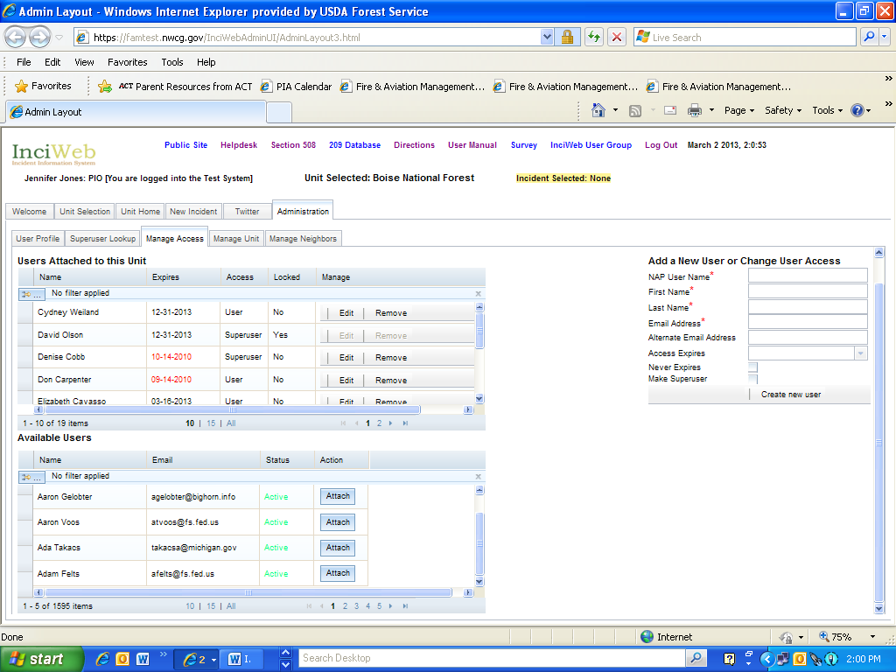

A Filter dialog box will open. Click the arrow next to the column field and select how you want to find a user (by name, email, status or action); set the parameters for the filter by clicking the arrow next to the Condition field and choosing one of the items (i.e. contains, is, starts with, etc.); enter the name of the user you want to find in the Value field; and click the Filter button.
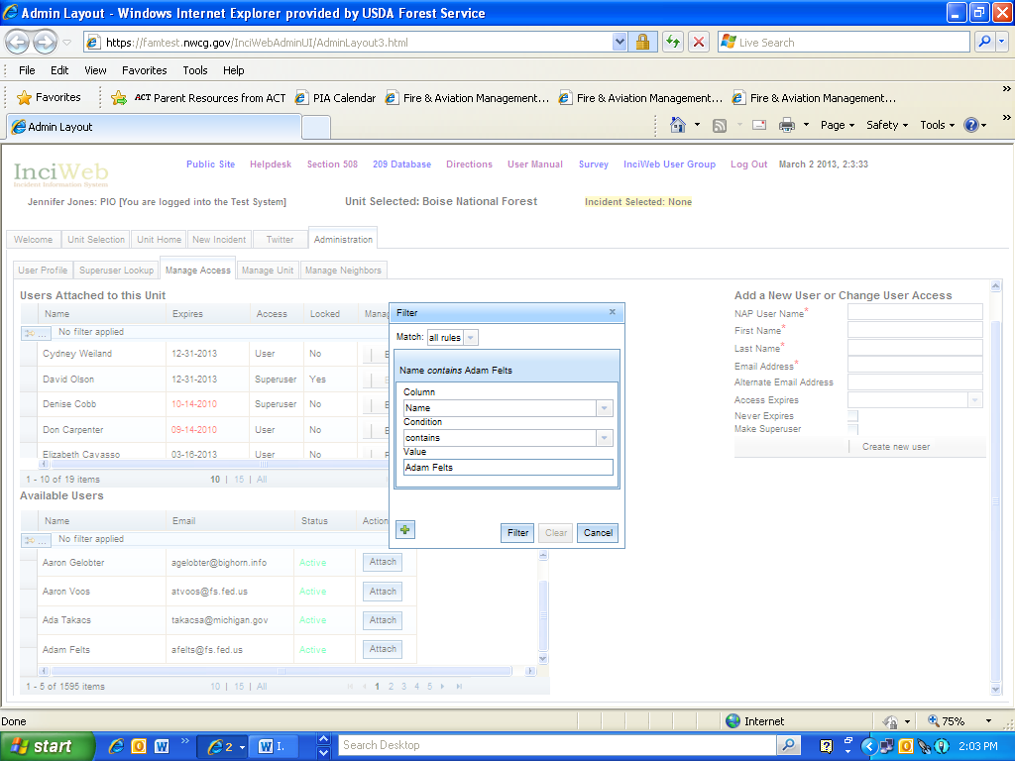

If the user’s name appears in either the “Available Users” or “Users Attached to this Unit” table, they have already been added back in to the InciWeb database. Superusers do not need to take any further action unless they want to give a user who is listed in the “Available Users” table access to the unit they have selected to manage. If that is the case, click “Attach” in the row with the users name.
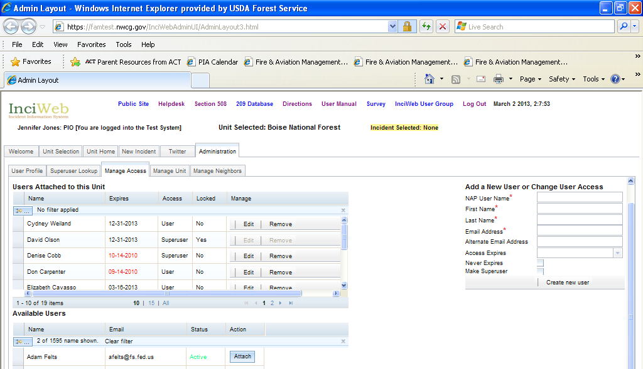
The user’s name will now appear in the “Users Attached to this Unit” table. Click the Clear Filter button to be able to view all of the names in the Available Users table again and to be able to search for additional users.
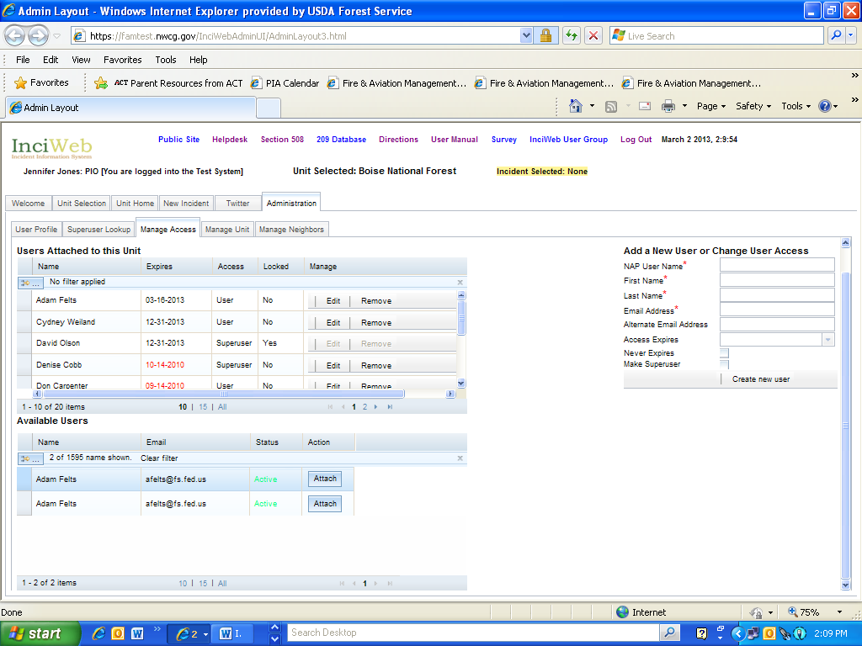
Step 7: If a user is not listed in either the “Users Attached to this Unit” or “Available Users” table, Superusers can add them back into the InciWeb database by using the “Add a New User or Change User Access” table. First, complete the required fields (indicated by the red *). Then, identify when you want the user’s access to expire by selecting a date on the calendar in the Access Expires field or by checking the Never Expires box. If you want to make the user a Superuser, check the Make Superuser box. Then click the “Create new user” button at the bottom of the table.
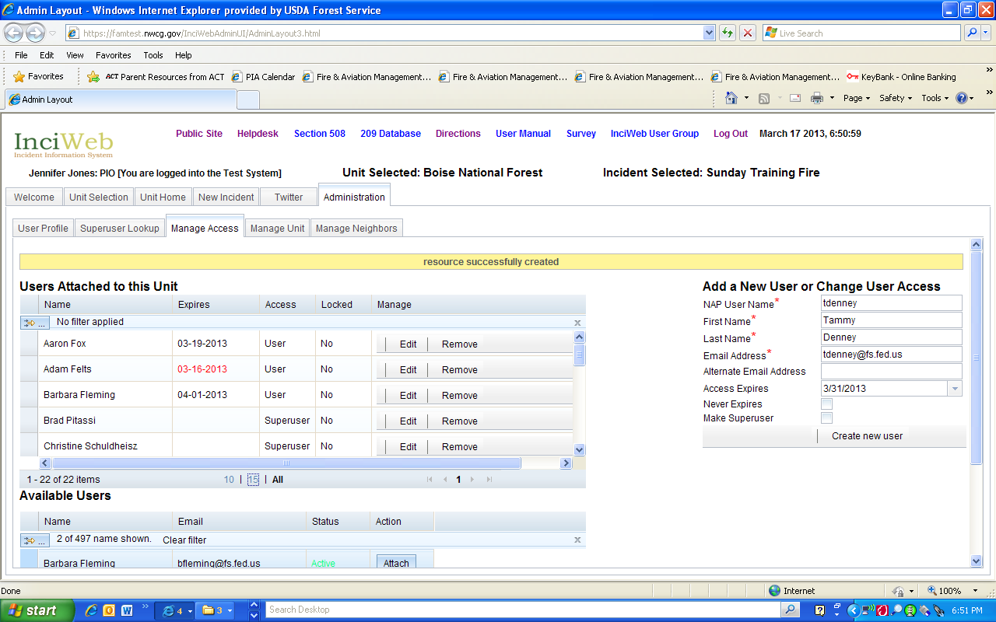

Step 8: If the user is added back into InciWeb, a message that reads “resource successfully created” will appear in the yellow feedback bar and the users name will appear in the Users Attached to this Unit table. If you want the user to have access to the unit that you have attached them to, no further action is required (and they will still be available to be given access to other units as well). If you do not want the user that you have added back in to InciWeb to have access to the unit that you have attached them to, click the “Remove” button.

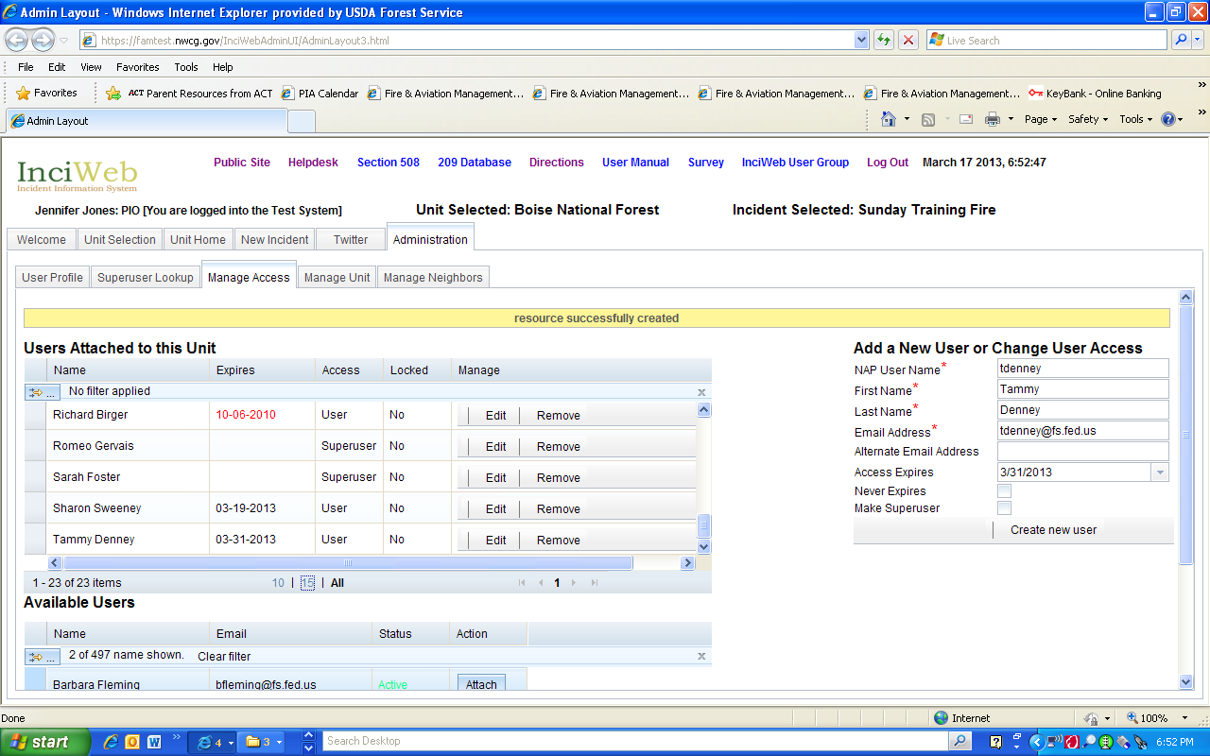

The user will be detached from the unit that you have given them access to and their name will appear in the Available Users table.

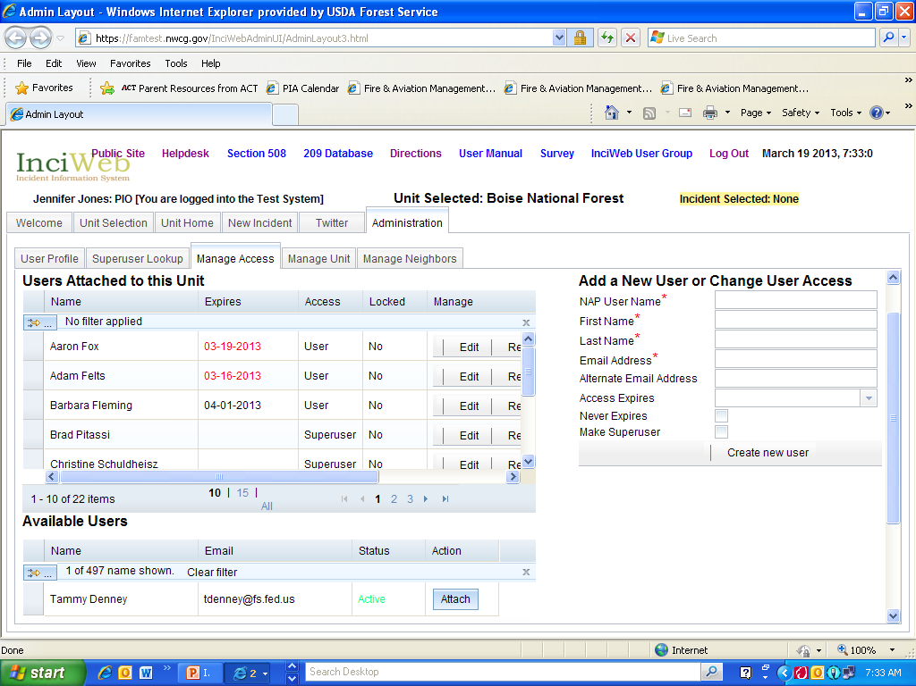

Step 10: Please contact the user and notify them that you have successfully added them back into InciWeb and let them know whether or not you have left them attached to a unit. Encourage them to attempt to log in to InciWeb through NAP. If you have left the user attached to a unit, they should be able to access that unit as well as the practice site. If you have not left them attached to a unit, they will only be able to access the practice site. Users who have been added back into InciWeb but are not able to log in to the application through NAP should contact the Interagency Incident Applications Helpdesk or at (866) 224-7677.

