Resetting Your NAP Password & Retrieving Forgotten Username
Inciweb users can reset their expired or forgotten NAP password without contacting the helpdesk. Users can also retrieve forgotten usernames as well. Follow the steps below for resetting your NAP password and/or retrieving your username. Passwords expire after 60 days.
NOTE: If you don’t have a NAP account please visit the PIO Bulletin Board and read the following documents: “NESS Application Portal (NAP) Account Request Instructions” and “NESS Application Portal (NAP) Log-In Instructions.
- Security Profile Challenge Questions (You must answer your security questions first before resetting your expired or forgotten password or retrieve your username).
- Go to the NAP at NESS Application Portal Website (NAP)
- Enter your username and password on the top right of the page.
- Click on the person shaped icon on the left of the screen. This will take you to Edit MY Standard User Account.
- Your standard user account should list your information. Make sure everything is correct.
- Click on the button labeled at the top right of the pop-up box.
- On the Challenge Questions tab on the Edit MY Standard User Account dialog box, click the 1. Select your first Challenge Question drop-down arrow, and then click the Challenge Question of your choice.
- In the first Answer text box, type the Answer to Your Challenge Question.
- Click the 2. Select your second Challenge Question drop-down arrow, and then click the Challenge Question of your choice.
- In the second Answer text box, type the Answer to Your Challenge Question.
- Click the 3. Select your third Challenge Question drop-down arrow, and then click the Challenge Question of your choice.
- In the third Answer text box, type the Answer to Your Challenge Question.
- When finished setting up all Challenge Questions, click [SAVE]
- When completed, you may return to the Edit MY Standard User Account by clicking on to change your password. NOTE: You must know your current or temporary password to change it.
- Resetting Password
Once you’ve answered your challenge questions and saved the answers to your account you can reset your expired or forgotten password from the NAP log-in screen.
- Go to the NAP at NESS Application Portal Website (NAP)
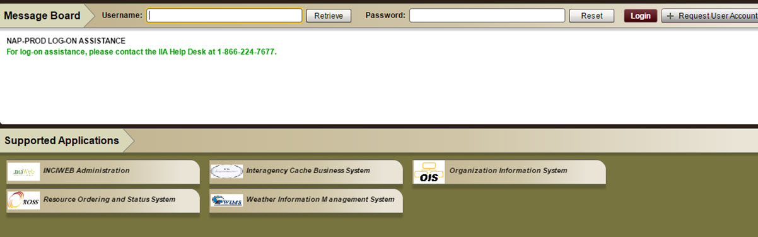

- To request a temporary password, click on the ‘Reset’ button next to the red Login button.

In the pop-up screen enter your NAP username and hit [ENTER]
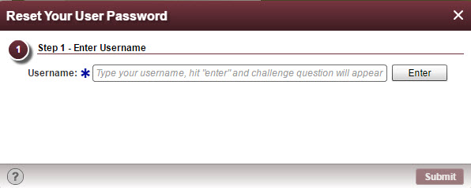
- Answer one of you challenge questions and hit [SUBMIT].
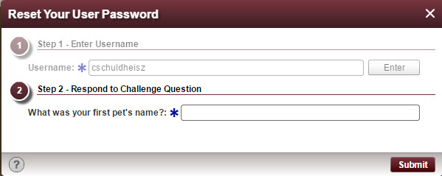
- You will receive an e-mail from donotreply@nwcg.gov with your temporary password.
- Log into NAP using your username and temporary password NESS Application Portal Website (NAP) and click on [LOGIN].
- A pop-up screen appears for you to enter your temporary password, new password and confirm password.

- NAP passwords must meet the following requirements:
    - Minimum Length = 12 characters.
    - Maximum Length = 32 characters.
    - Must contain at least one upper case alpha character (A-Z).
    - Must contain at least one lower case alpha character (a-z).
    - Must contain at least one digit (0 - 9).
    - Must contain at least one special character !@#$%^* (Do not use< > or &)
    - Twenty-four unique new passwords must be created before an old password may be reused.
    - Standard Account Passwords expire after 60 days.
    - Privileged Account Passwords expire after 30 days.
    - "Password will expire in X days" warning is displayed for the 10 days prior to expiration.
    - Accounts are locked after 5 failed login attempts per session. There will be a 15 minute lockout before the user may attempt to log on again.
    - Users must establish security challenge questions by using the steps below.
- After confirming your password hit [SAVE].
- You are now logged into NAP.

- Retrieving NAP Username

- To retrieve your NAP username, click on the ‘Retrieve’ button next to the Username text box

- Enter your email address in the box and hit [ENTER]. Be sure to use lower case when entering your username.

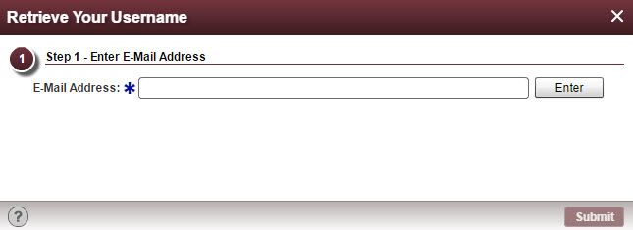

- Next, answer one of you challenge questions.
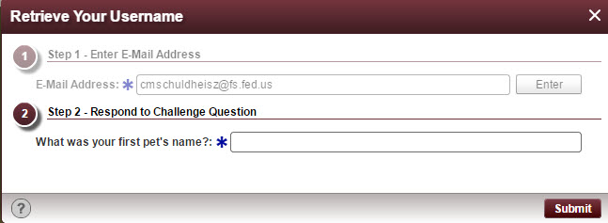
- Click [SUBMIT]
- You will receive your username by email from donotreply@nwcg.gov

If you need further assistance, contact the Interagency Incident Applications Helpdesk at (866) 224-7677/

