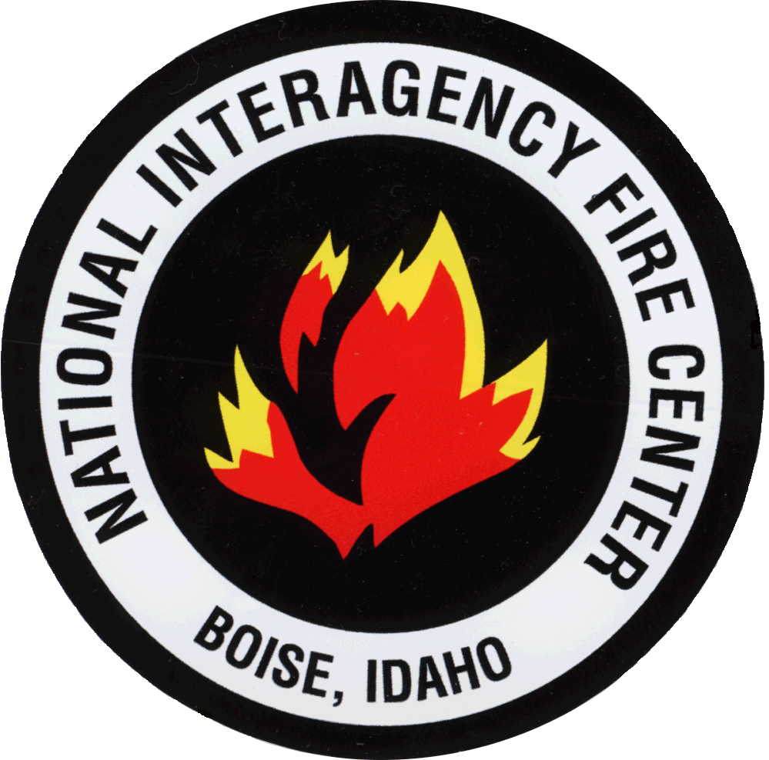
National interagency fire center
Casual payment center
A service first organization
Casual Payment Center MS 270
3833 S Development Ave Boise, Id 83705-5354
Phone: 877-471-2262 Fax: 208-433-6405

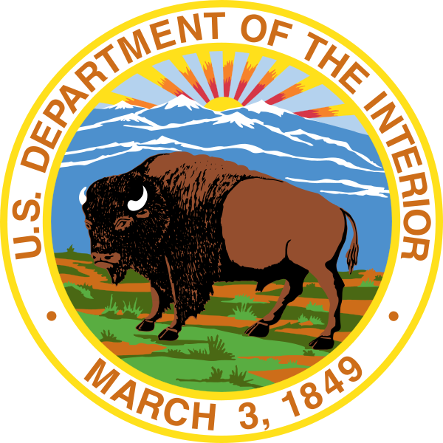

Conditional Offer of
Federal Employee Health Benefits Form

Check one: BIA BLM FWS NPS

NAME: |  | SSN/ECI:
PHONE: |  | E-MAIL:

…………………………………………………………………………………………………………………………………
As an Administratively Determined Emergency Worker (AD/Casual), you will be eligible for Federal Employee Health Benefits (FEHB) when you work 130 hours per month for 90 consecutive days. This coverage includes a 31 day extension of FEHB following employment termination.
More information about the FEHB program is available on the OPM website: https://www.opm.gov/healthcare-insurance/healthcare/plan-information/plans/.
As an AD/Casual, I understand that if I work 130 hours per month for 90 days, I am eligible for FEHB coverage.
I elect FEHB upon meeting the above eligibility criteria.
I decline coverage in a Federal Employee Health Benefits plan.
**I understand if at any time I choose to receive more information, I can contact the Casual Payment Center.
…………………………………………………………………………………………………………………………………
By signing below, I attest I am the person named above and I have read and understand the information presented.
SIGNATURE: Date:

