FBMS Cost Code Example Sheet

- Use the template provided on our website and type in your cost structure minus the items that will change, for example, the fire code.
- Copy the cost structure to the remaining blank label boxes. (Hint: If you can’t see the gridlines, go to the Layout tab and click on “View Gridlines”.
- Print onto self-adhesive label sheets (We use Avery 5161 1”x 4” and Avery 5163 2”x4”)
- Affix to OF-288 in or near the remarks section.
- Fill in any missing information like the fire code or cost center.
A few examples of labels as well as stamps from various agencies are included below:
BIA Suppression
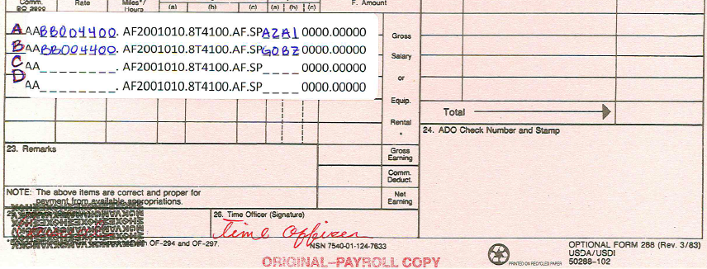
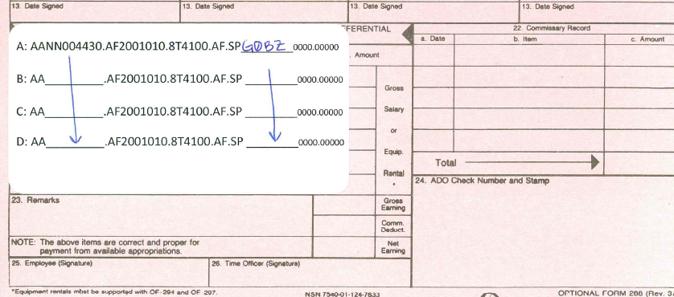
BLM Suppression
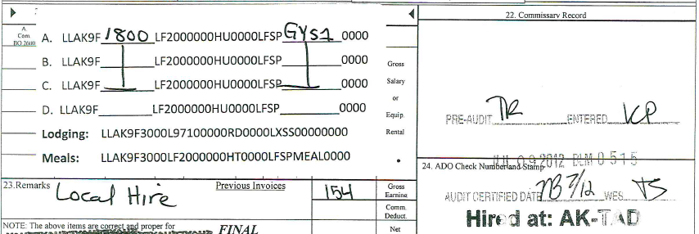
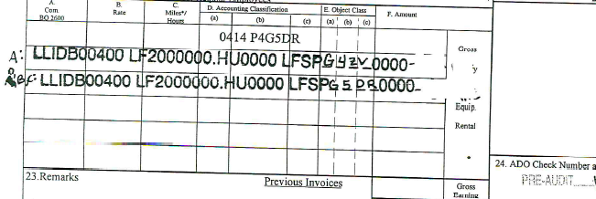
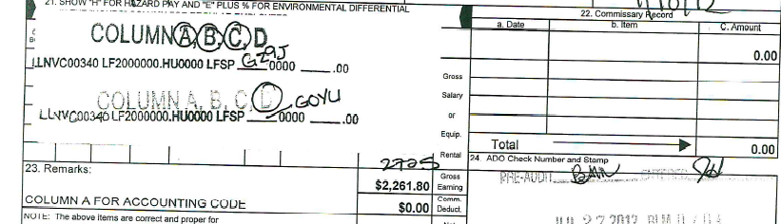

NPS Suppression
